**Linux networking**

ip link ; to list and modify interface for the host

ip address add 192.168.1.10/24 dev eth0 ; set ip address to an interface

ip address show eth0 ; show ip address details for a specific interface

ip address show type bridge ; show ip address details of any interface that has the type is bridge

ip route OR route ; display Kernal IP routing table

ip route add 192.168.2.0/24 via 192.168.1.1 ; add a route through gateway. These changes are valid until reboot the host. Hence, edit ***/etc/network/interface*** file to persist the change

ip route add default via 192.168.1.1 ; add default gateway

ip route add 0.0.0.0 via 192.168.1.1 ; another way to add default gateway

*A 0.0.0.0 entry in the gateway in routing table field indicates that you don't need a gateway.

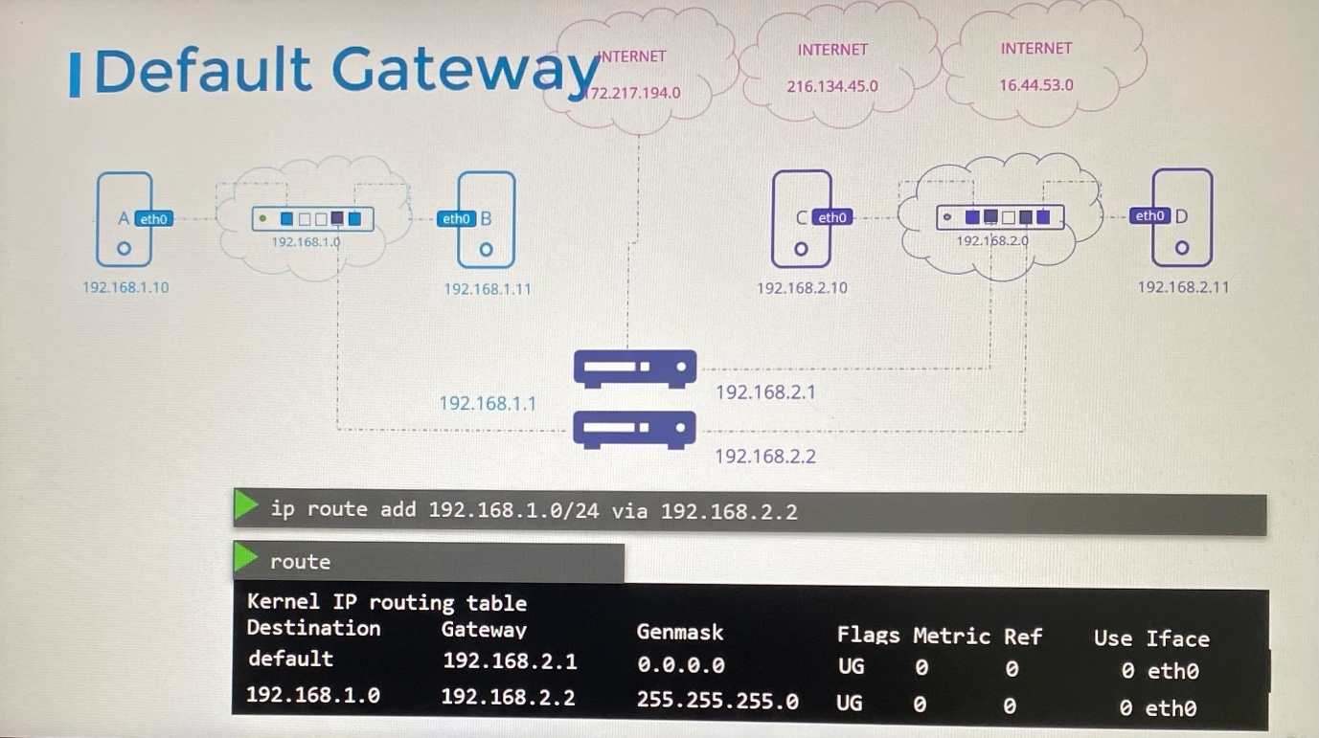

***Set up Linux host as router***

*If we choose to set up Linux host as router even after routes are set up, by default in Linux, packets are not forwarded from one interface to the next interface. This is for security reason. Let assume the host have an interface from private network and an interface from public network. Public network now cannot send message to private network unless you explicitly allow that.

The host can forward packets between interfaces is governed by a setting in this system at file ***/proc/sys/net/ipv4/ip_forward***

cat /proc/sys/net/ipv4/ip_forward ; by default the value here is 0

echo 1 > /proc/sys/net/ipv4/ip_forward ; set the value to 1 to forward the traffic

Simply setting this value does not persist the changes across reboots so that you must modify the same value in the ***etc/sysctl.conf*** configuration file for setting system variables.

/etc/sysctl.conf ; edit the net.ipv4.ip_forward value to 1

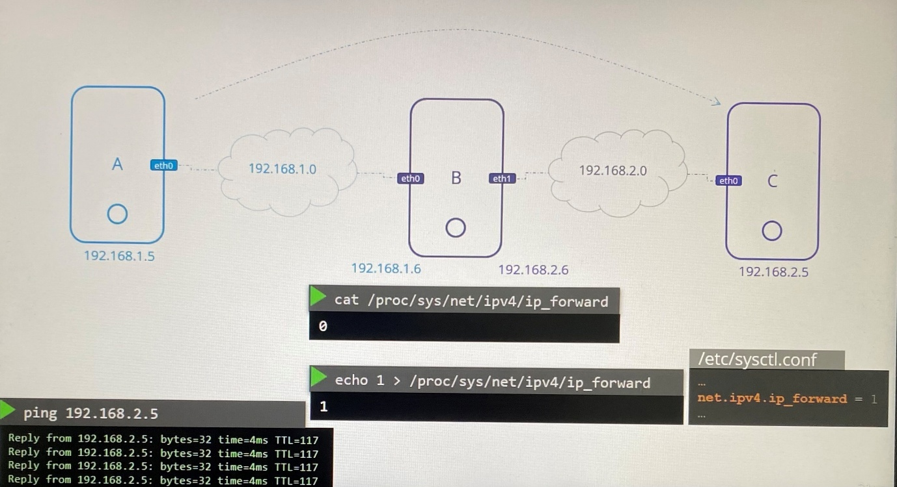

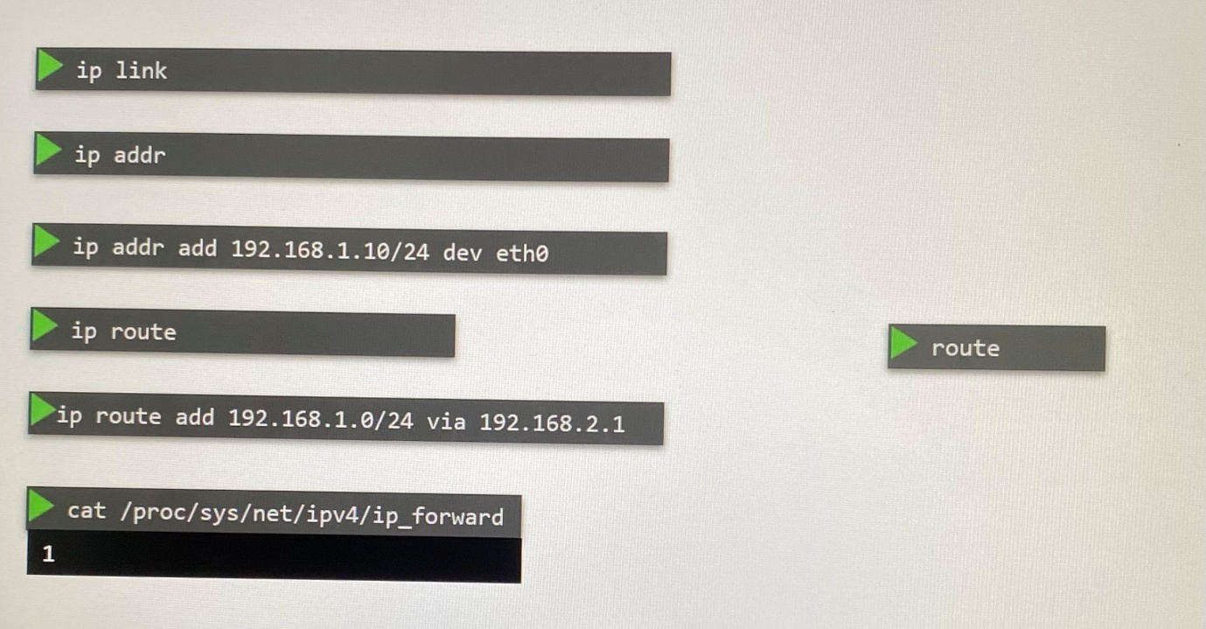

**DNS in Linux**

For DNS resolution, Add dns entry to the host file.

cat >> /etc/hosts ; show the DNS entry and edit this with the DNS entry

192.168.1.10 db

*Whatever specify in the host file(/etc/hosts ) will override the actual hostname of any host.

You can check the DNS entry by following ways.

ping db

ssh db

curl <http://www.google.com>

When the number of hosts increase in the network, hostname of each host should be updated with new DNS entries in host file in all devices where it is not scalable and also not manageable. This is where the need of DNS server comes with to manage all DNS entries centrally.

cat /etc/resolv.conf ; edit the DNS resolution configuration file in the host to point DNS server for lookup

nameserver 192.168.1.100

Thereafter, the host always lookup the DNS server to resolve the DNS unless host file has specific DNS entries.

Normally host first lookup the ***/etc/hosts*** file and later ***/etc/resolv.conf*** file. This order defines in ***/etc/nsswitch.conf*** file where you can modify the order if you need.

cat /etc/nsswitch.conf

….

hosts: files dns

……

files - /etc/hosts

dns - DNS server

If you need to resolve external DNS entry, you should add the public DNS server as nameserver into /etc/resolv.conf.

cat /etc/resolv.conf

nameserver 192.168.1.100

nameserver 8.8.8.8

However, you have to add public DNS server to all hosts in the network. Instead you can add following entry to DNS server itself to forward DNS queries that DNS server iteself cannot resolve.

Forward All to 8.8.8.8

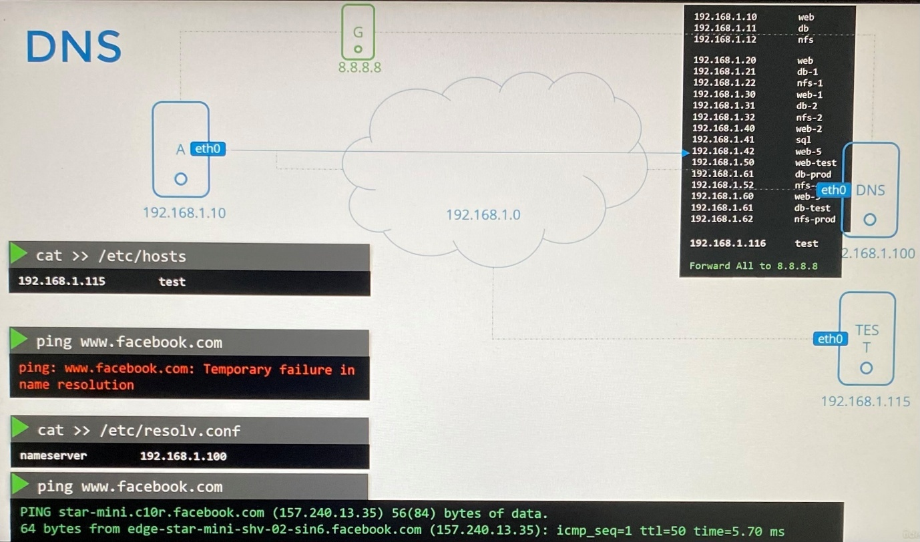

Public DNS server are resolved through by forwarding DNS request through following.

root(.) > top level domain(.com) > second level(google) >subdomain>>>>

In order to speed up all DNS resolution, internal DNS server choose to cache resolved IP for TTL in which it doesn't go through whole process recurringly.

When you want to append the top level domain when you ping from the hostname, add search entry with top level domain name into /etc/resolv.conf

cat /etc/resolv.conf

nameserver 192.168.1.100

nameserver 8.8.8.8

search mycompany.com prod.mycompany.com

*Tools for DNS resolution*

nslookup [www.google.com](http://www.google.com) ; query hostname only from DNS server. nslookup doesn’t find the entries in the local host file but it only queries from DNS server

dig [www.google.com](http://www.google.com) ; to query DNS with more details

*Record type*

A - to store IPV4 to hostname

AAAA - to store IPV6 to hostname

CNAME - to map one name to another name

**CoreDNS - Installation**

CoreDNS binaries can be downloaded from their Github releases page or as a docker image. Extract the file.

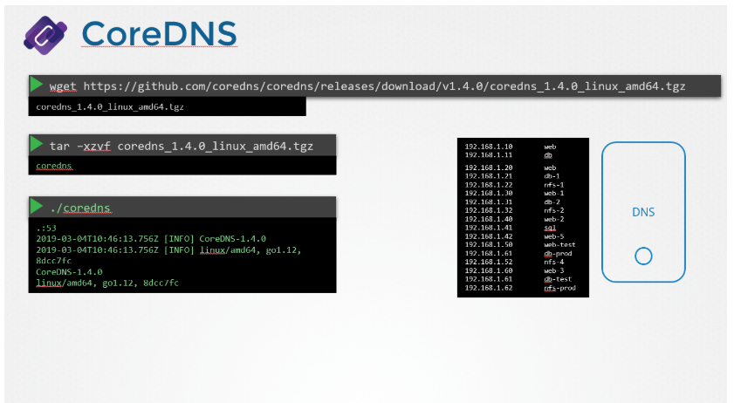

Run the executable to start a DNS server. It by default listens on port 53, which is the default port for a DNS server.

Put all of the entries into the DNS servers /etc/hosts file

Configure CoreDNS to use that file. CoreDNS loads it’s configuration from a file named Corefile.

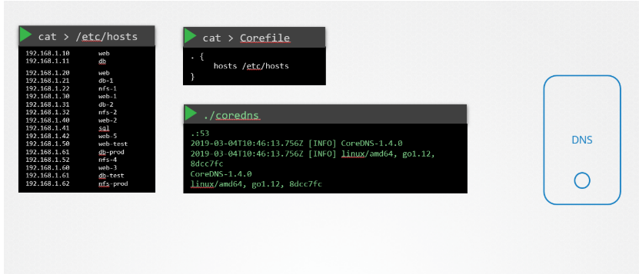

`

CoreDNS also supports other ways of configuring DNS entries through plugins.

<https://github.com/kubernetes/dns/blob/master/docs/specification.md>

<https://coredns.io/plugins/kubernetes/>

**Process namespace**

-The processes running inside container are isolated with namespace in the host. The container doesn't see any other processes running on the host, or any other containers.

-The underlying host, however, has visibility into all of the processes, including those running inside the containers.

-You can list the processes within container. When you list same processes as a root from underlying host, you can see all the processes along with processes running inside the container where same process running with different process ID inside and outside the container.

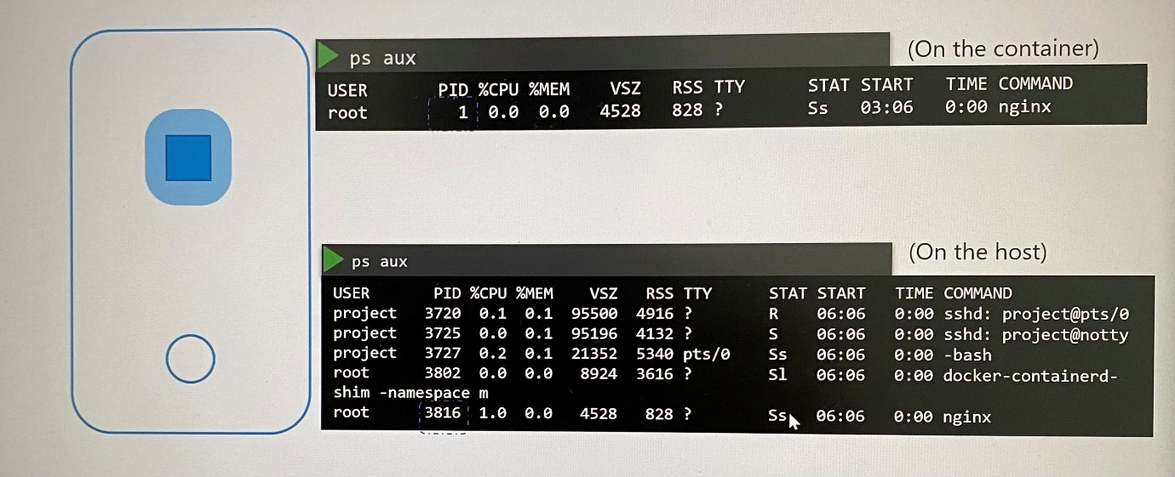

**Network Namespaces in Linux**

-The host has its own interfaces, routing table and ARP table.

-When the container is created, we create a network namespace for it, that way it has no visibility to any network-related information on the host. Within its namespace, the container can have its own virtual interfaces, routing, and ARP tables.

-Thus network namespaces is used by docker to implement network isolation.

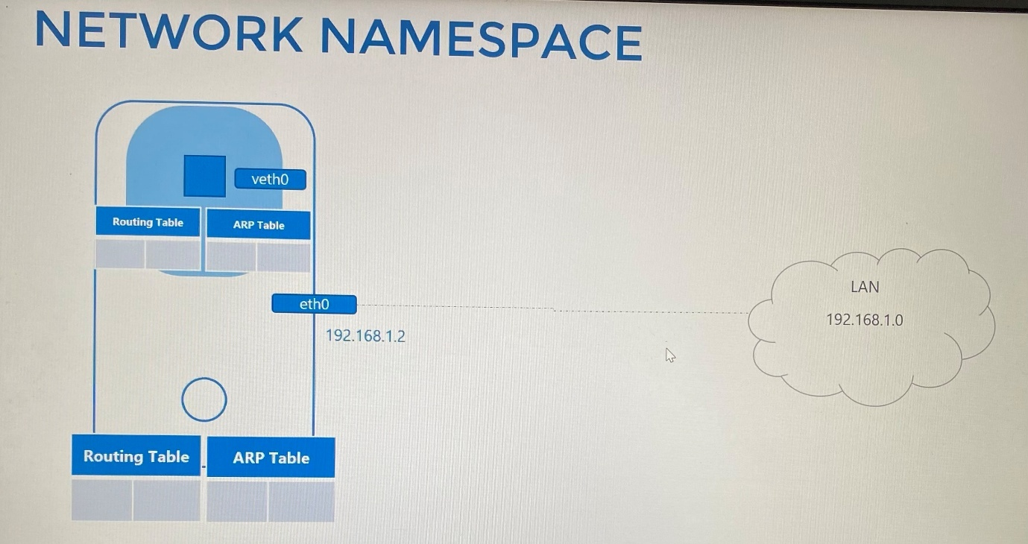

*Create network ns*

ip netns add red ; create a new network namespace with name red on a Linux host

ip netns ; list the network namespaces created on the host

*Exec in network ns*

ip link ; list the network interfaces on the host. This shows loopback and eth0 interfaces

ip netns exec red ip link ; list the network interface in the red network namespace

ip -n red link ; list the network interface in the red network namespace similarly

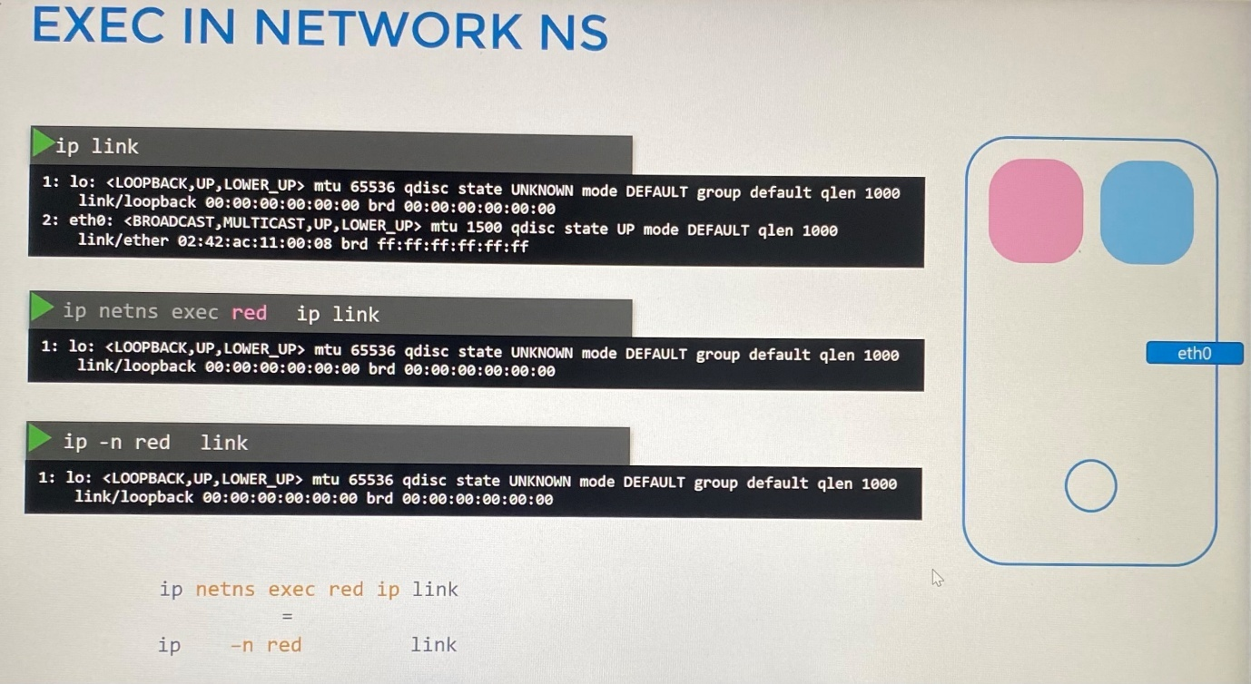

arp ; list entries in the arp table on the host

ip netns exec red arp ; list arp table in the network namespace which has no entries

route ; list the routes on the host

ip netns exec red route ; list routes in the network namespace

-With namespaces, we prevent the container from seeing the network interface, route and arp table on the host.

The network namespaces have network connectivity and they cannot see underlying network on the host. But we can connect two network namespaces using ***virtual ethernet pair*** or a ***virtual cable*(**veth). It is often referred as a ***pipe***.

1. Create a virtual interface pair or virtual cable

ip link add *veth-red* type veth peer name *veth-blue* ; create a virtual cable specifying with two interfaces veth-red and veth-blue

2. Attach the virtual interfaces to each network namespace

ip link set veth-red netns red ; attach veth-red to red network namespace

ip link set veth-blue netns blue ; attach veth-blue to blue network namespace

3. Assign ip address to virtual interfaces

ip -n red addr add 192.168.15.1 dev veth-red ; assign ip address to veth-red interface

ip -n blue addr add 192.168.15.2 dev veth-blue ; assign ip address to veth-blue interface

4. Bring the virtual interface up

ip -n red link set veth-red up ; bring the veth-red up

ip -n blue link set veth-blue up ; bring the veth-blue up

ip netns exec red ping 192.168.15.2 ; ping the other veth-blue interface from veth-red

ip netns exec red arp ; Each namespace identify the neighbors through ARP table

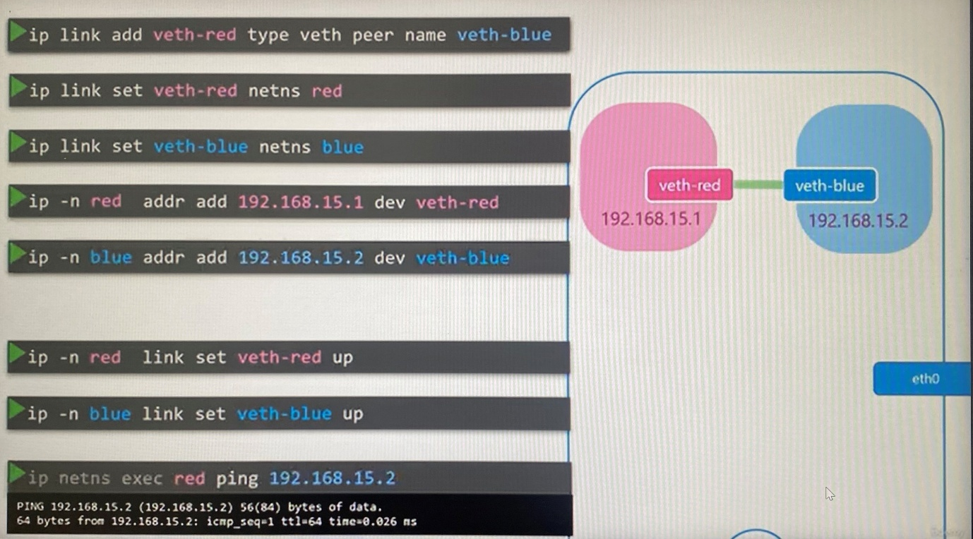

However, when we see the arp table on the host, the host has no visibility on the arp table entries on the network namespaces neither interfaces in namespaces.

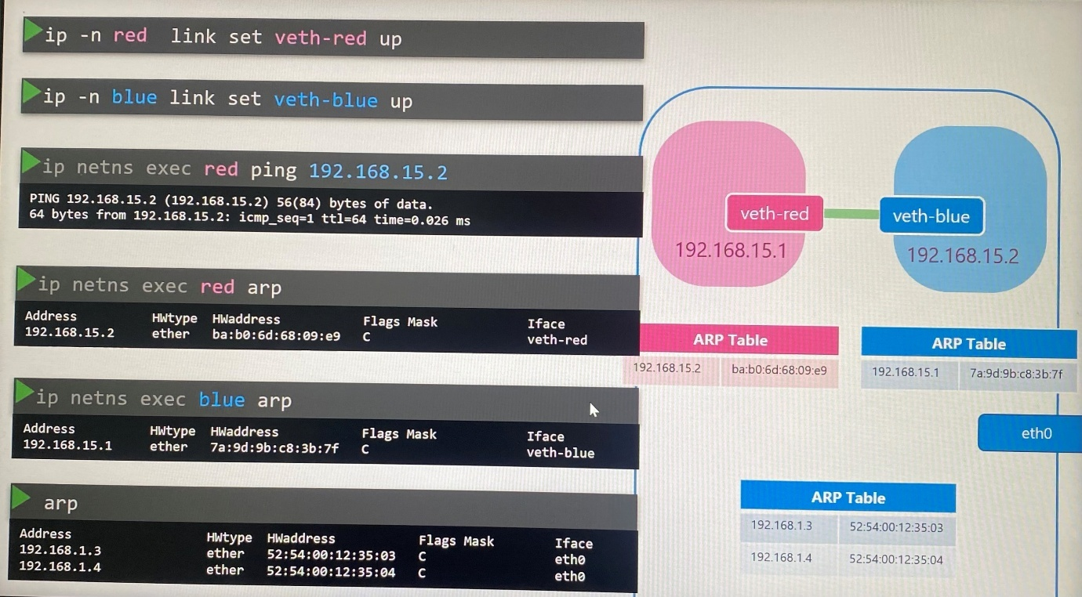

When increase number of network namespaces on the host, we create ***virtual switch*** to communicate network namespaces each other so that there are multiple native solution such as **Linux bridge** and **Open vSwitch.**

***Linux Bridge***

To create an internal bridge network, we add a new interface to the host. This is an interface for the host and a virtual switch to network namespaces.

ip link add v-net-0 type bridge ; create an interface for virtual switch the type set as bridge. This interface appears in ip link command on the host

ip link set dev v-net-0 up ; bring up the interface as it is by default down

Since we are going to make connectivity between network namespaces through bridge interface, no point of having the virtual cable to connect two network namespaces we created earlier. So, it needs to delete the virtual cable.

ip -n red link del veth-red ; delete the veth-red interface which automatically delete veth-blue as they are a pair.

ip link add veth-red type veth peer name veth-red-br ; create new virtual cable to connect red namespace with bridge network

ip link add veth-blue type veth peer name veth-blue-br ; create new virtual cable to connect blue namespace with bridge network

ip link set veth-red netns red ; attach veth-red to red network namespace

ip link set veth-red-br master v-net-0 ; attach veth-red-br to bridge network on the nost

ip link set veth-blue netns blue ; attach veth-blue to blue network namespace

ip link set veth-blue-br master v-net-0 ; attach veth-blue-br to virtual switch on the nost

ip -n red addr add 192.168.15.1/24 dev veth-red ; assign ip address to veth veth-red

ip -n blue addr add 192.168.15.2/24 dev veth-blue ; assign ip address to veth veth-blue

ip -n red link set veth-red up ; bring the veth-red up

ip -n blue link set veth-blue up ; bring the veth-blue up

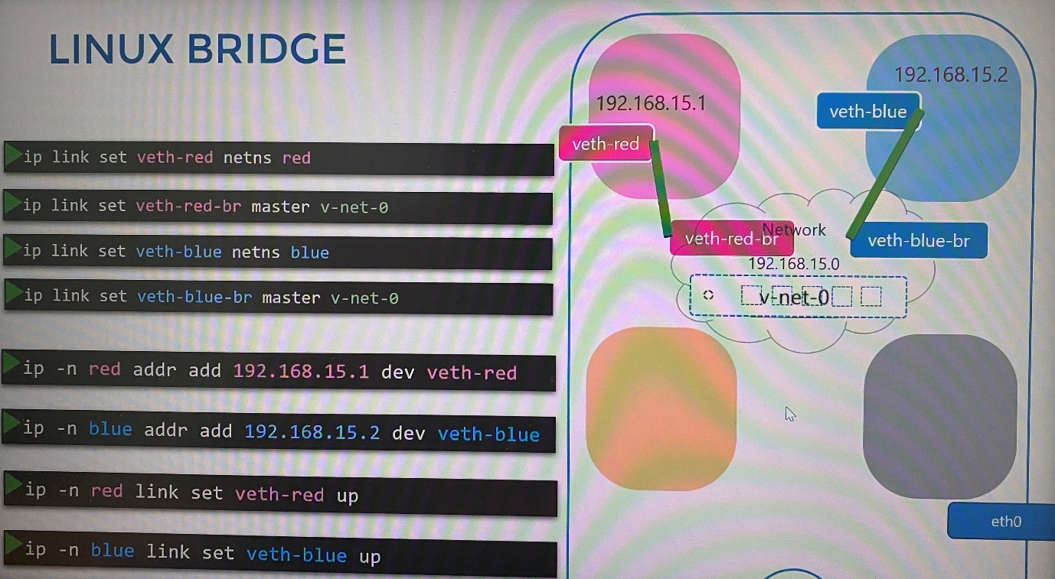

To have connectivity to all network namespaces through the bridge network to the host network, we should assign IP address from internal bridge network to bridge switch interface on the host.

ip addr add 192.168.15.5/24 dev v-net-0

From within the namespaces, you can't reach to outside network nor from outside network.

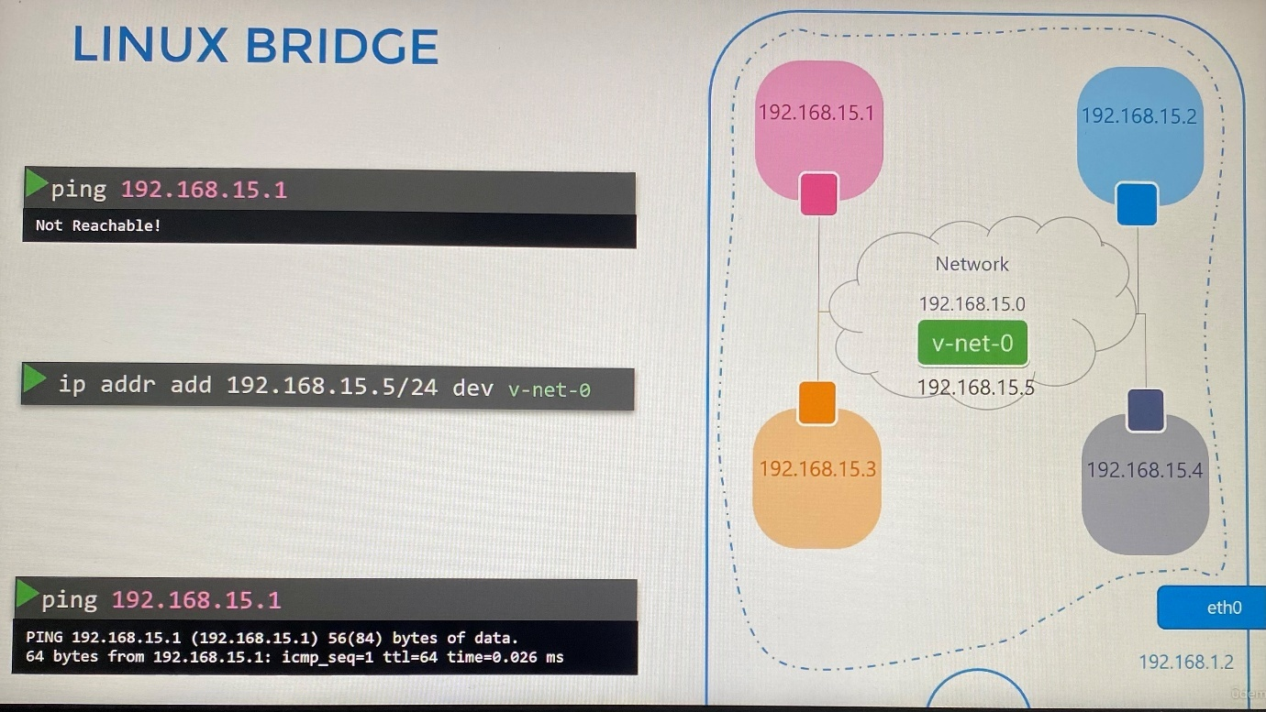

**Make sure you set the NETMASK while setting IP Address. ie: 192.168.1.10/24 to make connectivity between network namespaces.

Thus, the host has 2 ip addresses from different networks

1. Ip address assigned to bridge switch

2. Ip address assigned to the host itself - LAN

If a container in a network namespace need to connect another host in LAN network, we add a route to the namespace setting up gateway through bridge switch.

ip netns exec blue ip route add 192.168.1.0/24 via 192.168.15.5

Another thing to check is FirewallD/IP Table rules. Either add rules to IP Tables to allow traffic from one namespace to another. Or disable IP Tables all together.

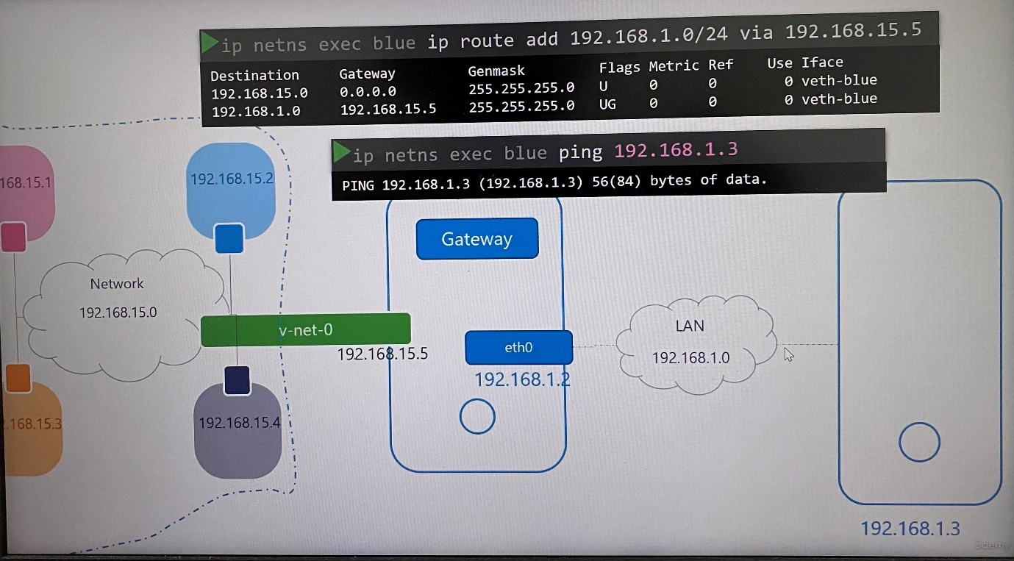

However, our internal network doesn't know how to reach destination network unless enable NAT functionality on the host acting as a gateway.

You should do that using IP tables. Add a new entry into NAT table in the IP tables in the post routing chain to masquerade or replace the from address on all packets coming from the source network to external IP address on the host.

iptables -t nat -A POSTROUTING -s 192.168.15.0/24 -j MASQUERADE

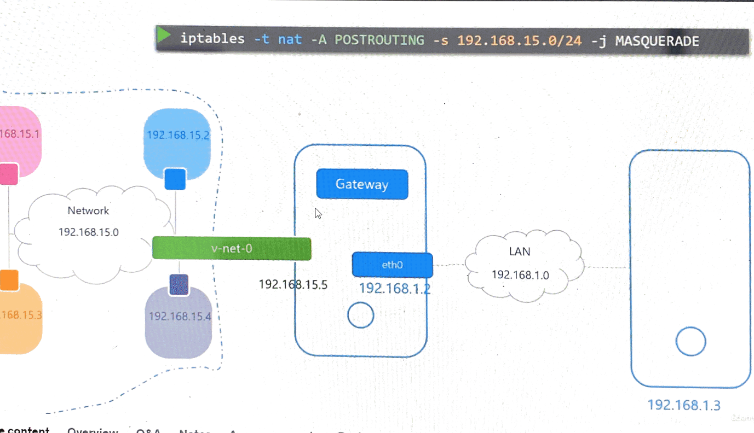

If a container in network namespace need to connect to the internet , we add a route to the namespace setting up gateway through bridge switch

ip netns exec blue ip route add default via 192.168.15.5

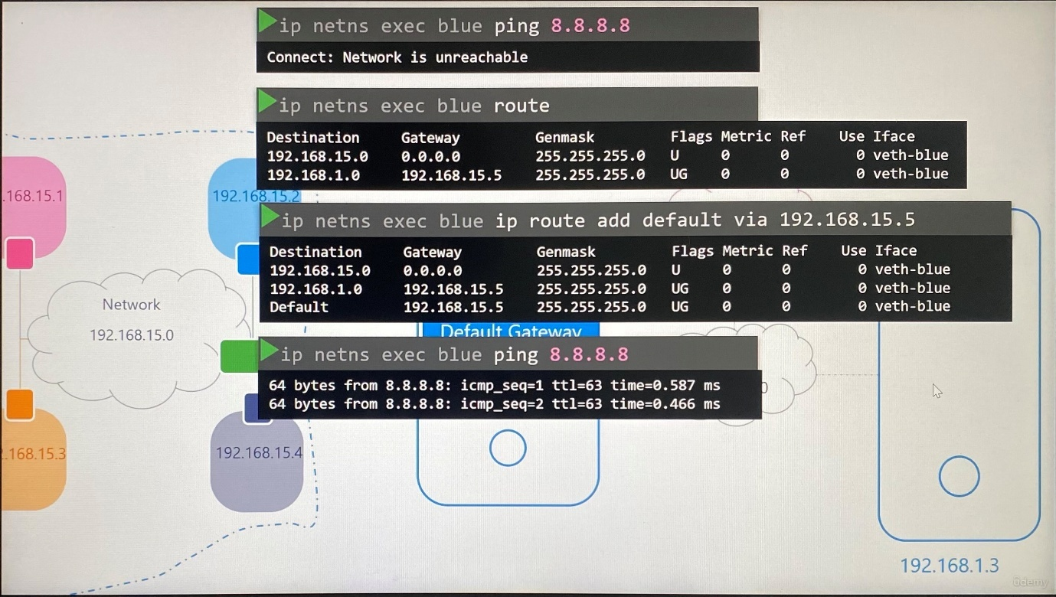

If any outside network need to reach application hosted in the container inside a network namespace on the inside host, we should add an ip route entry onto outside host to reach the inside host or the second option is to add port forwarding rule using iptable in the host.

iptables -t nat -A PREROUTING - -dport 80 - -to-destination 192.168.15.2:80 -j DNAT ; any traffic coming to Port 80 on the local host is to be forwarded to port 80 on the IP assigned to the blue namespace

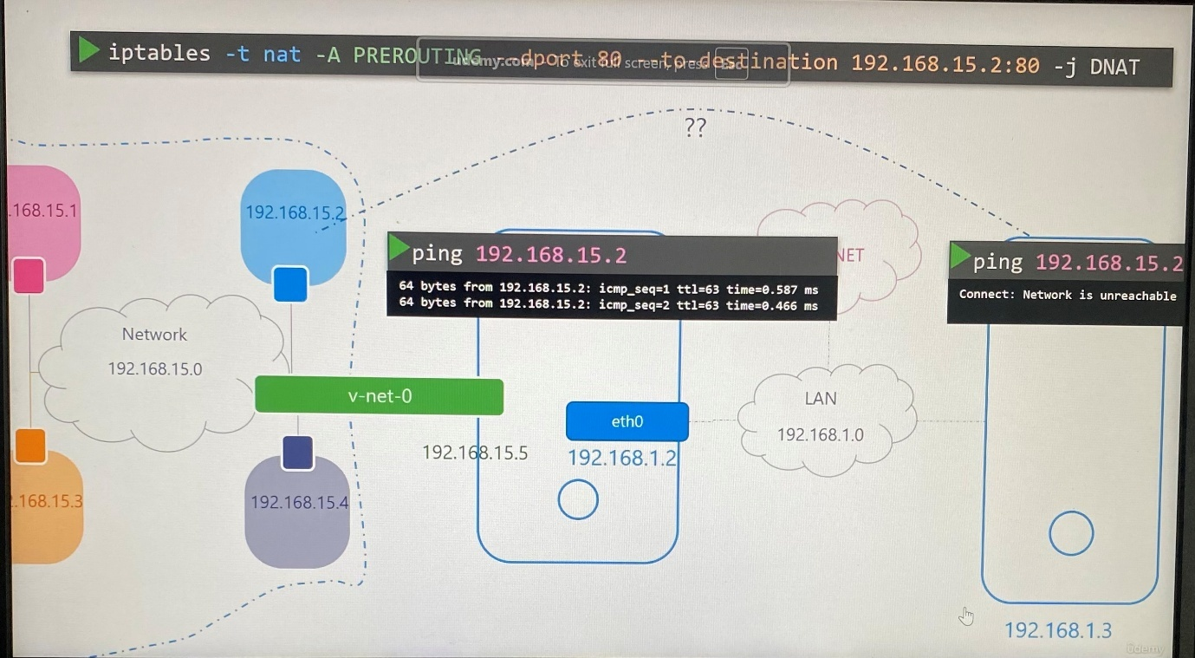

**Docker networking**

***None network***

Containers that don’t attach to any network. If you are on multiple containers on the host, they cannot communicate each other or outside network.

docker run - -network none nginx

***Host network***

Containers are attached to host network. There is no network isolation between the host and the container. The container can be accessed through host IP address.

docker run - -network host nginx

If you run multiple instance of the same container that listens on the same port, it won't work as they share the host networking, because two processes cannot listen on the same port at the same time.

***Bridge network***

When docker installs on the host, it creates internal private network called ***bridge*** by default where the docker host and containers attach to.

docker network ls ; list the networks with network ID, name, driver, scope

But on the host, that network is created by the name ***docker0***.

ip link ; This command shows the docker0 network which is down

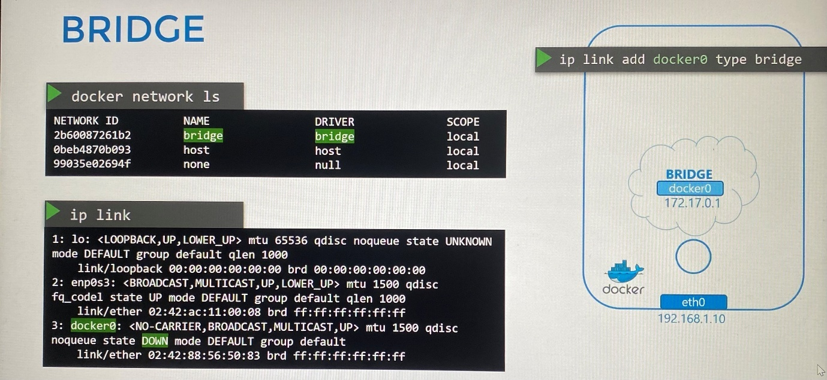

The bridge network is an interface to the host and also it is like a switch to the namespaces or containers within the host.

ip addr ; shows the ip address assign to bridge network docker0

Whenever a container is created, docker creates network namespace for it, create pair of interfaces, attach to one end network namespace and bridge network, assign ip address to veth interfaces, brings up the veth interfaces.

ip link add docker0 type bridge

ip netns ; list network namespace on the host

The namespace has the name starts with b3165, you can see namespace associated with container with **docker inspect <container ID>** command

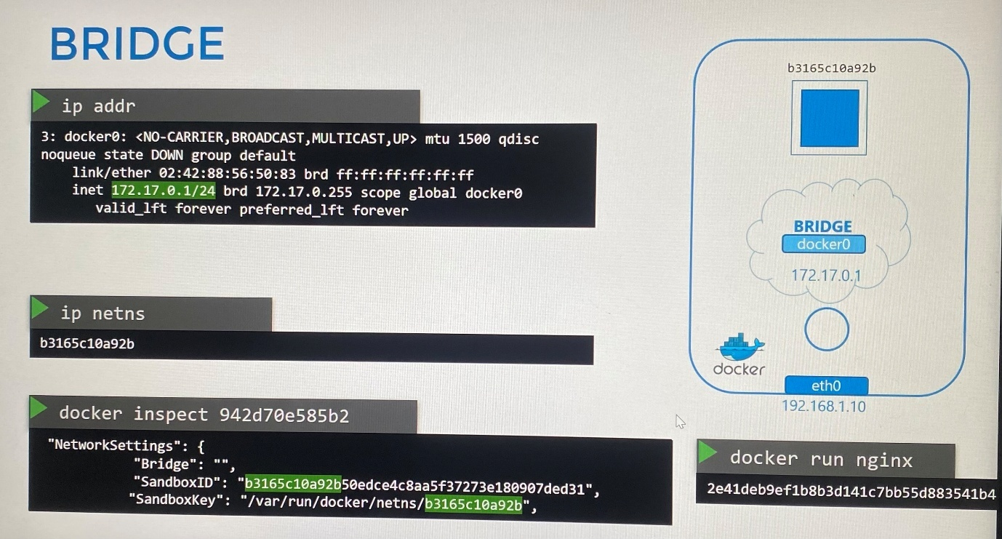

Docker container refers to network namespace. A container and local bridge docker0 connect each other through virtual ethernet pair.

ip link ; shows veth attached to docker0 bridge

ip -n <namespace ID> link ; shows other end of virtual interface on network namespace

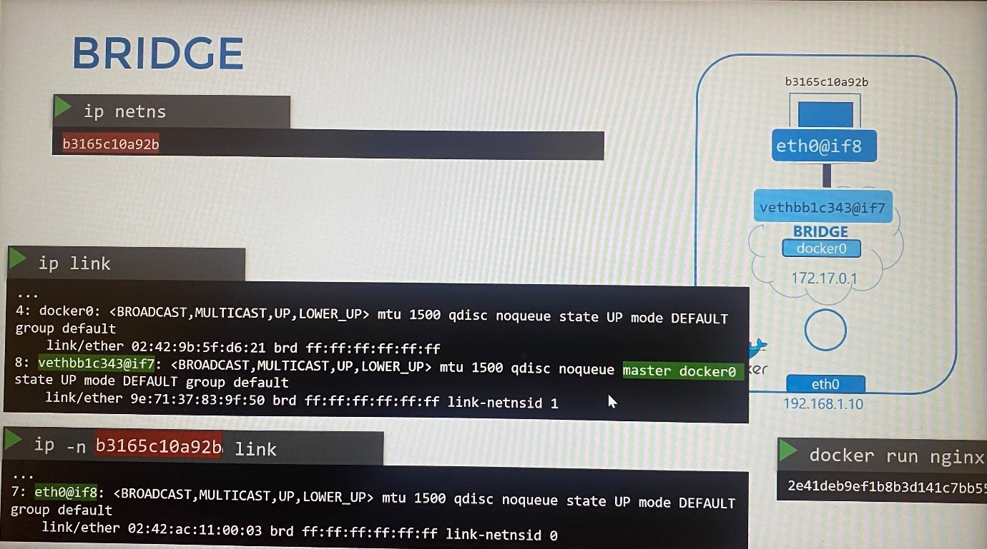

ip -n <namespace ID> addr ; show up address assign to network namespace

Every time a new container is created. Docker creates a namespace, creates a pair of interfaces, attaches one end to the container and other end to the bridge network.

The interface pairs can be identified using their numbers, odd and even form a pair.

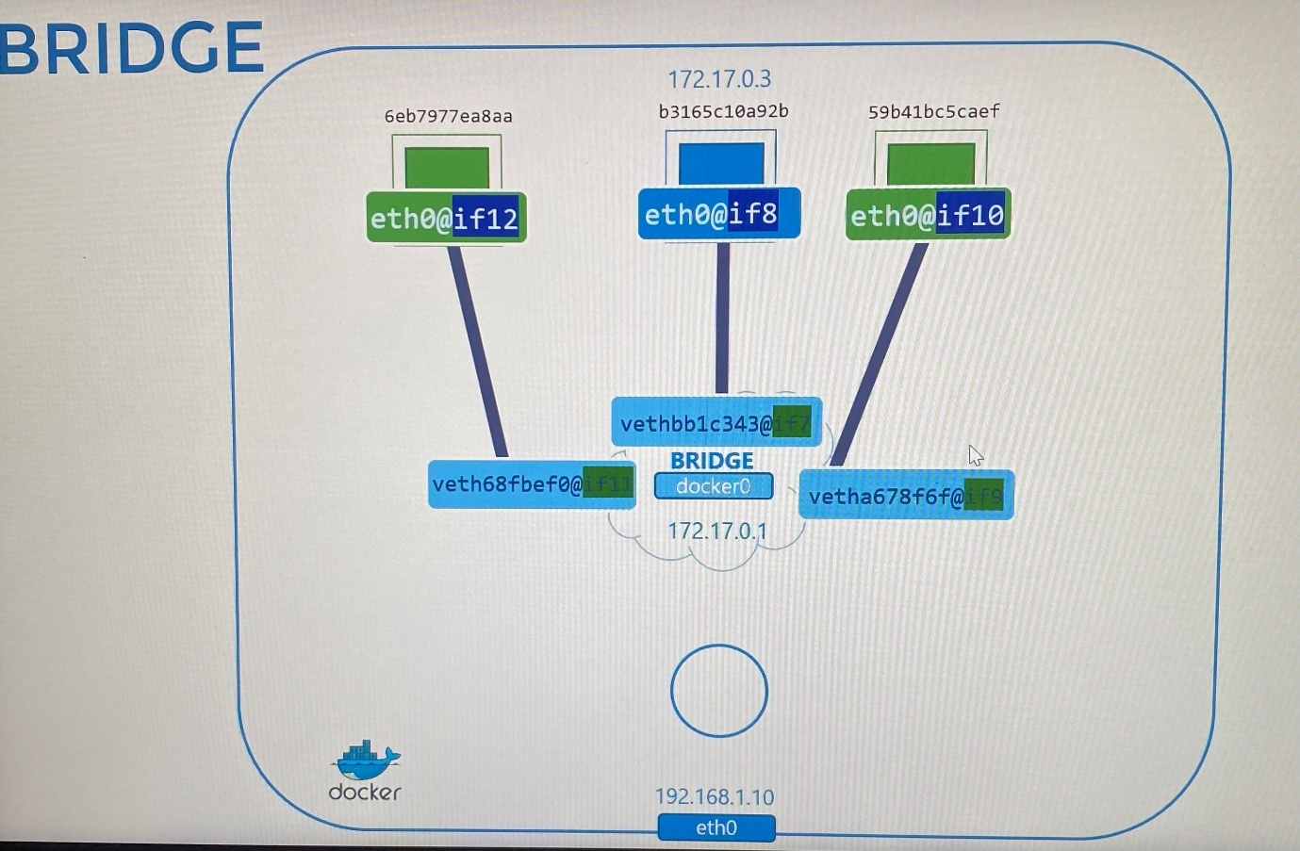

***Port mapping***

Only the containers inside the docker host can access another container through a port.

docker run -p 8080:80 nginx ; configure port mapping from docker host port 8080 to container port 80 to forward the traffic .

Using iptables, we create entry into NAT table to append the rules to the prerouting chain to change the destination port from 8080 to 80.

iptables \

-t nat \

-A PREROUTING \

-j DNAT \

- - dport 8080 \

- - to-destination 80

Similarly, docker create underlying NAT rule in iptables in the host as follows.

iptables \

-t nat \

-A DOCKER \

-j DNAT \

- - dport 8080 \

- - to-destination 172.17.0.3:80

iptables -nvL -t nat ; list the rules that Docker creates in iptables

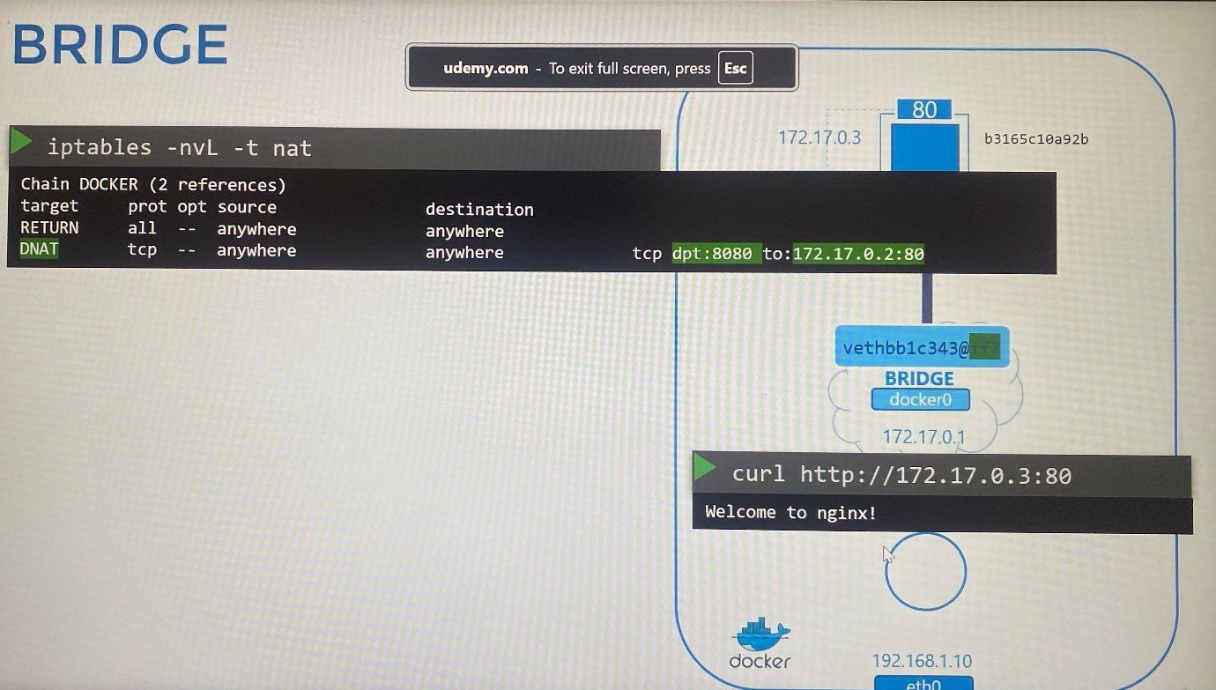

**Container Networking Interface(CNI)**

Connect network namespace to bridge network follows these steps. In the same way, Docker does bridge networking option except it uses different naming pattern.

1. Create network namespace

2. Create Bridge network/interface

3. Create VETH Pairs(Pipe, Virtual Cable)

4. Attach vEth to Namespace

5. Attach Other vEth to Bridge

6. Assign IP addresses

7. Bring the interfaces up

8. Add routes on network namespace for external network

9.Enable NAT - IP Masquerade for external communication

Container runtimes such as Docker, rocket, Mesos follow the same way for bridge networking to configure network between containers with minor changes as similar as network namespace even Kubernetes.

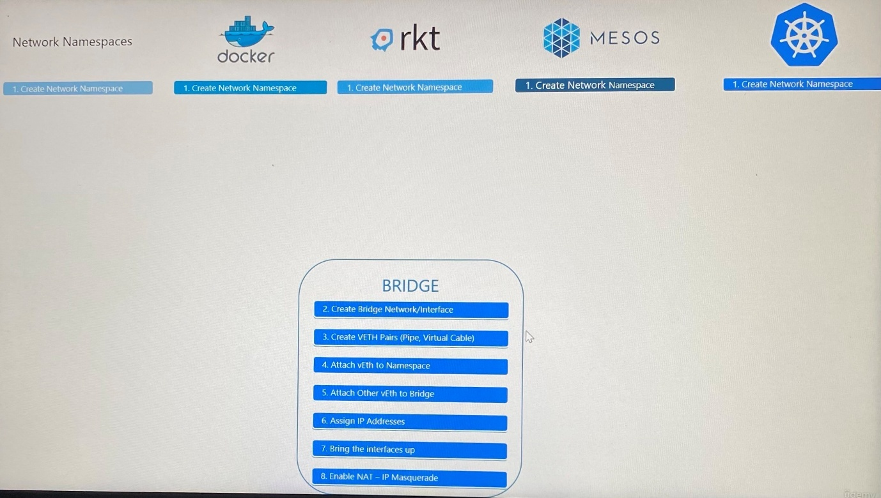

To create a single standard approach for all container solutions, we move all the networking portions of it into single program code/script that performs all required tasks to attach containers to bridge network.

Run this program using its name, bridge and specify that you want to add new container to a particular network namespace.

>bridge add 2e34dcf34 /var/run/netns/2e34dcf34

Similarly, rocket and Kubernetes call the bridge program and pass the container ID and namespace to get networking configured for that container.

bridge add <container id> <path to namespace>

Container Runtime Interface(CNI) is set of standards that define how program(plugin) should be developed to solve networking challenges in a container runtime environment. The program is referred to as plugin. In this case, Bridge program that we referred to is a plugin for CNI.

CNI defines how plugin should be developed and how container runtime should invoke them. CNI defines set of responsibilities for container runtimes and plugin as follows.

@Container Runtime

- Container Runtime must create network namespace for each container

- Identity network the container must attach to

- Container Runtime must invoke Network Plugin(bridge) when container is created using ADD command

- Container Runtime must invoke Network Plugin(bridge) when container is deleted using DEL command

- Specify how configure a network plugin on container runtime using a JSON file

@Plugin side

- Must support command line arguments ADD/DEL/CHECK

- Must support parameters container id, networks ns etc…

- Must manage IP Address assignment to PODs and any associated routes required for containers to reach other containers

- Must Return results in a specific format

CNI comes with set of supported plugins such as BRIDGE, VLAN, IPVLAN, MACVLAN, WINDOWS as well as IPAM plugin such as DHCP, host-local

There are other third party plugins available in these soltions such as weaveworks, flannel, cilium, VMware NSX, calico, infoblox

All container runtimes(rocket, Mesos, Kubernetes) except Docker supports these plugins as Docker does not implement CNI. Only docker maintains Container Network Model(CNM) which is another standard that solve container networking challenges with some differences beyond CNI.

These plugins don't natively integrate with Docker. But that doesn't mean you can't use Docker with CNI. To use Docker with CNI, create a Docker container without any network configuration and then manually invoke the bridge plugin and other CNI plugin. Kubernetes does same way when creates a container.

docker run --network-none nginx

bridge add 2e34dcf34 /var/run/netns/2e34dcf34

**Important Note about CNI and CKA Exam**

**An important tip about deploying Network Addons in a Kubernetes cluster.**

In the upcoming labs, we will work with Network Addons. This includes installing a network plugin in the cluster. While we have used weave-net as an example, please bear in mind that you can use any of the plugins which are described here:

[**https://kubernetes.io/docs/concepts/cluster-administration/addons/**](https://kubernetes.io/docs/concepts/cluster-administration/addons/)

[**https://kubernetes.io/docs/concepts/cluster-administration/networking/#how-to-implement-the-kubernetes-networking-model**](https://kubernetes.io/docs/concepts/cluster-administration/networking/#how-to-implement-the-kubernetes-networking-model)

In the CKA exam, for a question that requires you to deploy a network addon, unless specifically directed, you may use any of the solutions described in the link above.

***However,***the documentation currently does not contain a direct reference to the exact command to be used to deploy a third-party network addon.

The links above redirect to third-party/vendor sites or GitHub repositories, which cannot be used in the exam. This has been intentionally done to keep the content in the Kubernetes documentation vendor-neutral.

**NOTE:** In the official exam, all essential CNI deployment details will be provided.

To clean up the Flannel CNI from the cluster, delete the Flannel DaemonSet, configuration file, as well as the ConfigMap hosting the Flannel configuration:

kubectl delete daemonset -n kube-flannel kube-flannel-ds

kubectl delete cm kube-flannel-cfg -n kube-flannel

rm /etc/cni/net.d/10-flannel.conflist

[Calico quickstart guide | Calico Documentation](https://docs.tigera.io/calico/latest/getting-started/kubernetes/quickstart)

Download and apply the Calico manifest:

kubectl create -f <https://raw.githubusercontent.com/projectcalico/calico/v3.29.3/manifests/tigera-operator.yaml>

Download the custom resource definition yaml:

wget <https://raw.githubusercontent.com/projectcalico/calico/v3.29.3/manifests/custom-resources.yaml> -O

Edit the file to update the CIDR network:

# vi custom-resources.yaml

...

apiVersion: operator.tigera.io/v1

kind: Installation

metadata:

name: default

spec:

# Configures Calico networking.

calicoNetwork:

ipPools:

- name: default-ipv4-ippool

blockSize: 26

cidr: 172.17.0.0/16 # Update this field

encapsulation: VXLANCrossSubnet

natOutgoing: Enabled

nodeSelector: all()

…

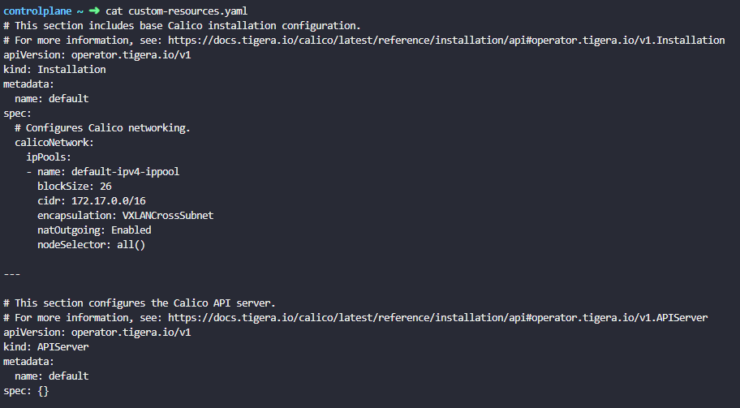

Apply the manifest file:

kubectl apply -f custom-resources.yaml

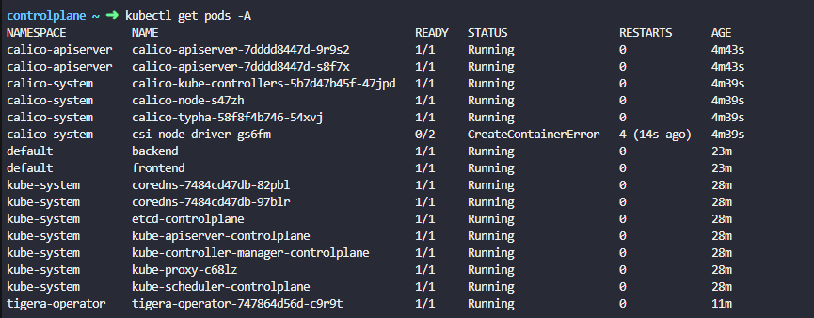

Now, wait until the calico pods are running:

watch kubectl get pods -A

You may ignore errors on the csi-node-driver pod deployed in the calico-system namespace.

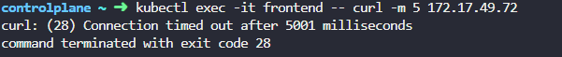

**Cluster networking**

Master and worker nodes should have interfaces assigned with IP address in a network, host must have unique hostname and MAC address.

***Ports***

These ports should be opened for the components in master and worker nodes. The connections on that ports only accepts.

**Kube-API** server : 6443

**Kubelet** on master and worker nodes : 10250

**Kube-scheduler** : 10259

**Kube-controller-manager** : 10257

Worker nodes expose **Services** for external access : 30000-32767

**ETCD** server : 2379

**ETCD** peers: 2380

netstat -nplt command shows all active Internet connections (only servers) with state, local address with port, PID/program name

If you have multiple master node, these ports should be opened on those master nodes as well.

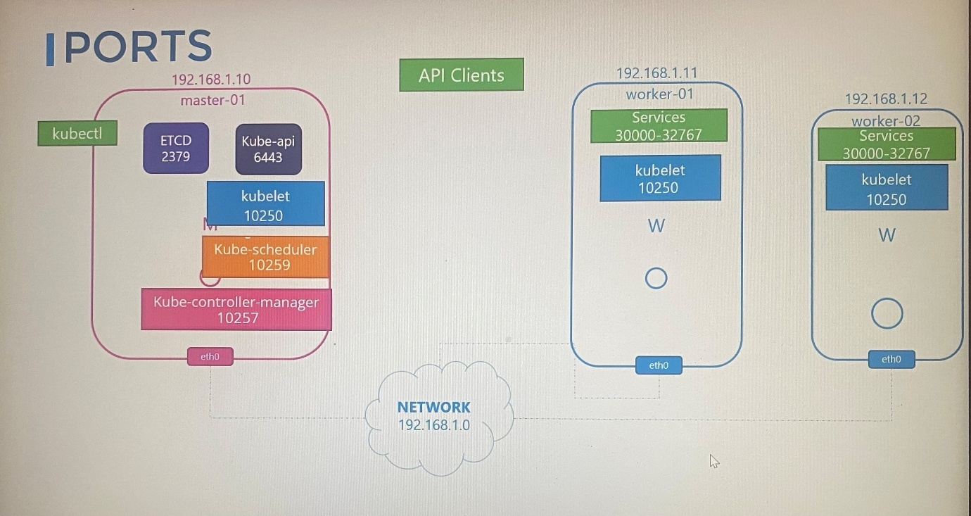

If there are multiple master nodes in the cluster, port 2380 should be opened to communicate ETCD clients each other.

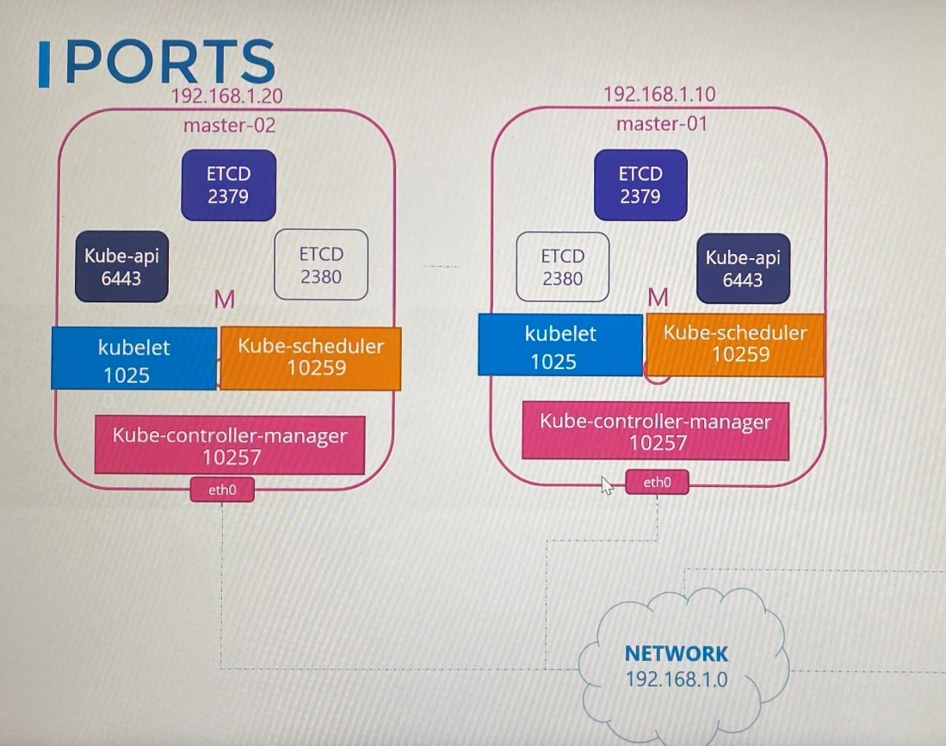

Consider these ports to be opened when you set up networking for nodes in firewalls or IP table rules or network security group in a cloud environment such as Azure, AWS, GCP

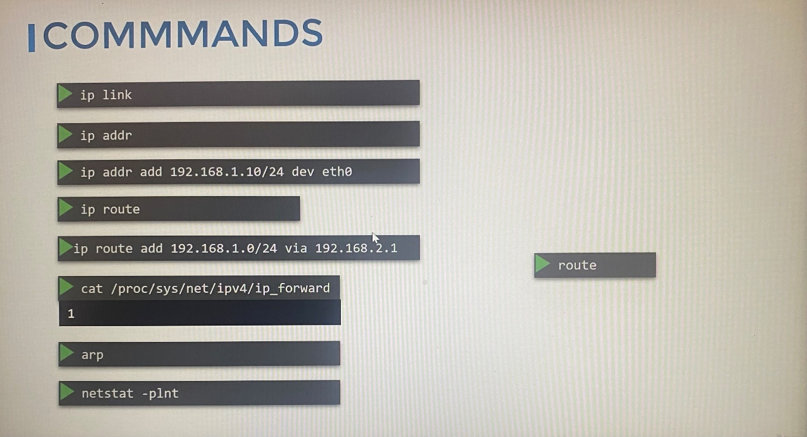

netstat - -help ; check all commands available on netstat

netstat -l ; display listening server sockets

netstat -aon ; display active connection on windows

netstat -npl | grep -i scheduler ; listening connection of scheduler, -i is for case insensitive

netstat -npa | grep -i etcd ; to search client connections established to etcd server

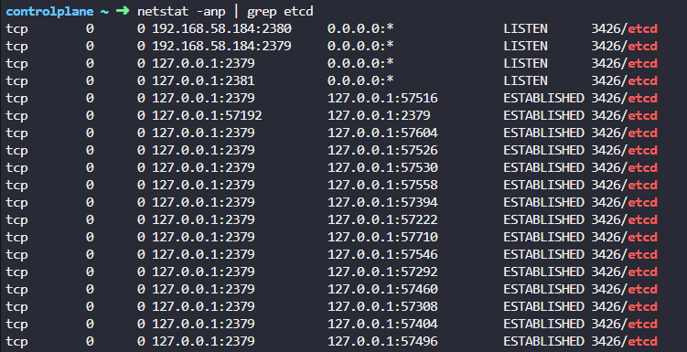

netstat -npa | grep -i etcd | grep -i 2379 | wc -l ; count the established connection from etcd server and from the particular port

netstat -nplt ; Active Internet connections (only servers) with state, local address with port, PID/program name

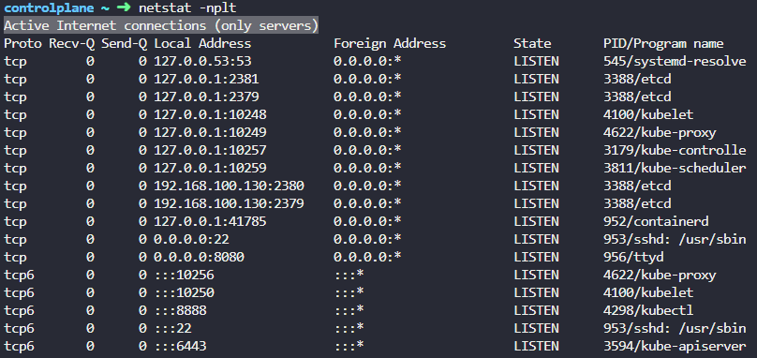

2379 is the port of ETCD to which all control plane components connect to. 2380 is only for etcd peer-to-peer connectivity when you have multiple controlplane nodes

**Pod networking**

Make sure firewall and NSGs are correctly configured for controlplane components to connect each other.

Networking at pod layer should solve following challenges, hence it comes with this networking model.

***Networking model***

A networking model that needs to develop that uses for pod networking is able to make the following requirements.

- Every pod should have an IP address

- Every pod should be able to communicate with every other pod in same node

- Every pod should be able to communicate with every other pod on other nodes using the same IP address without NAT

Network solution : weaveworks, flannel, cilium, VMware NSX, calico

If there are multiple nodes in the cluster, to make communication between pods, Kubernetes creates network namespaces for the containers and attach them to the bridge network.

1. Create bridge network for each node - ***ip link add v-net-0 type bridge***

2. Bring the bridge network up - ***ip link set dev v-net-0 up***

3. Choose unique network for each bridge network in nodes

4. Set an ip address from each subnet to bridge interface in each node - ***ip address add 10.244.1.1/24 dev v-net-0***

When we create a container every time, setting the ip address from the subnet chose to container will be made by using the script **net-script.sh**, this script includes the steps following.

1. Create veth pair

2. Attach veth pair ends to the network namespace and to the bridge

3. Assign ip address to veth interfaces at network namespace

4. Add route at network namespace point to the default gateway(bridge interface on the host)

5. Bring the veth interfaces up on network namespace

The script get IP address assigns for container with some IPAM solution.

*Default gateway IP we add either manage by ourselves or store those information some database.

This script should run each nodes whenever a container creates so that we copy the same script to other nodes and run the script to assign IP addresses to connect containers to internal network. Now we have achieved assigning unique IP address to pods and communicating pods each other within node.

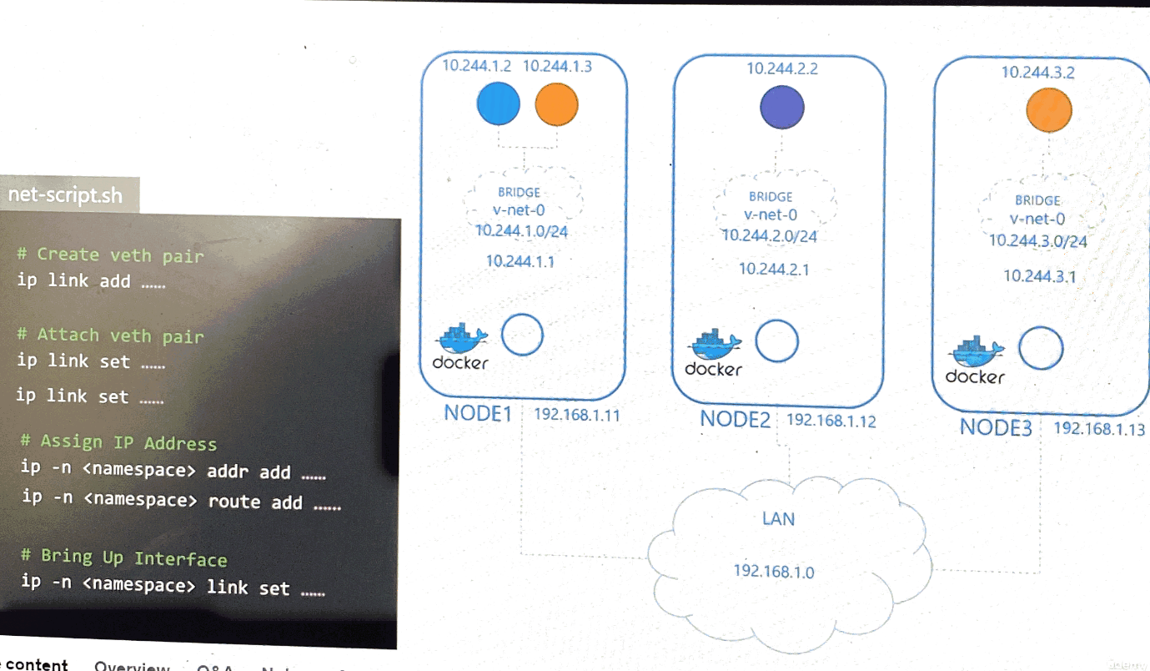

To communicate pods between nodes, we must add routes on each node to reach IP address in each pod in nodes through IP address on node.

ip route add 10.244.2.2 via 192.168.1.12

Instead of having to configure routes on each node, a better solution is to do that using a router if you have one in your network and point all hosts to use that as the default gateway. That way you can easily manage routes to all networks in the routing table on the router.

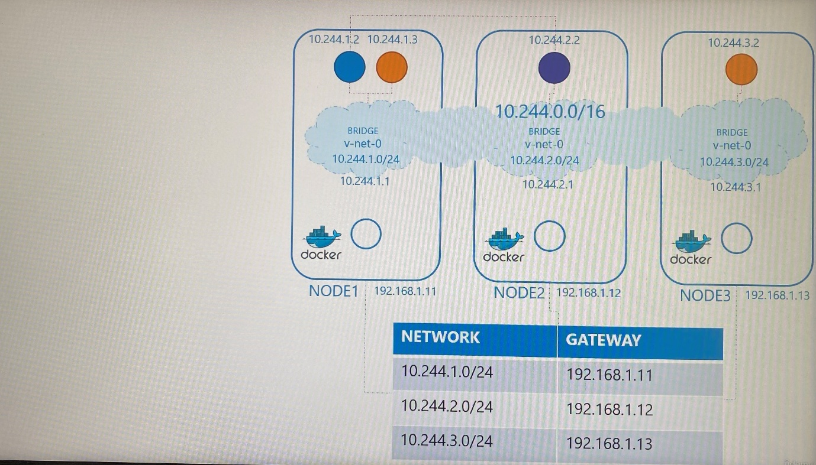

When the cluster grows with pods, executing the script manually and adding routes for each pod is not scalable. That’s where CNI comes to tell Kubernetes that this is how you should call a script as soon as create a container. We need to modify the script to meet CNI standards such as adding container to the network and deleting container interface from the network and freeing IP address.

Container runtime in each node is responsible creating containers. Container runtime looks at CNI configuration and pass as command line arguments when it is run and identifies the script name. Then look the script in /opt/cni/bin directory and executes the script with add command. The script take care the rest.

Container runtime> /etc/cni/net.d/net-script.conflist > /opt/cni/bin/net-script.sh> ./net-script.sh add <container name> <namespace ID>

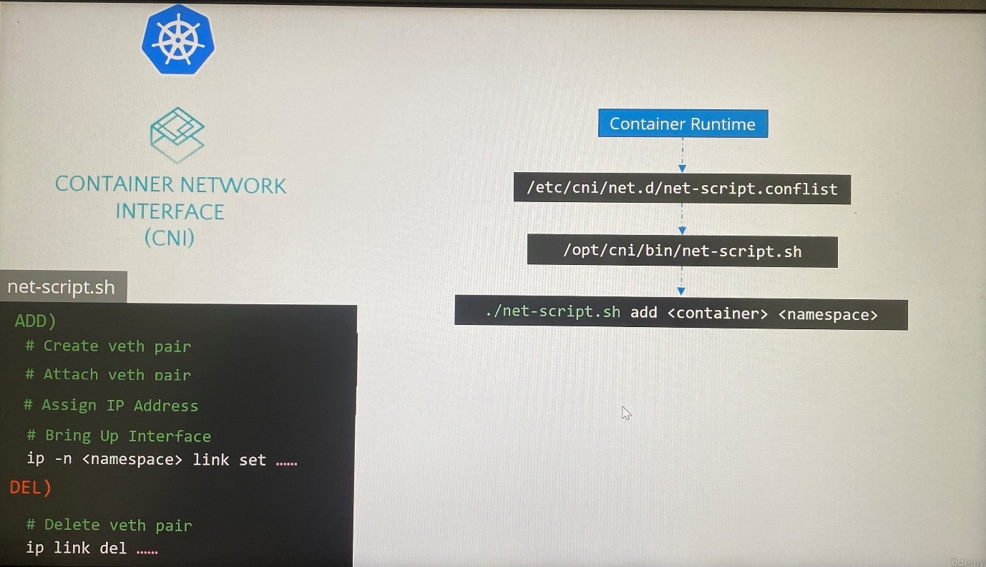

**CNI in Kubernetes**

The CNI plugin must be invoked by the component(container runtime such as ContainerD, cri-o) within Kubernetes that is responsible for creating containers because the container runtime must then invoke the appropriate network plugin after the container is created.

CNI plugin is configured in Kubelet service on each node in the cluster

ps -aux | grep kubelet ; view kubelet options including container runtime endpoint value in kubernetes

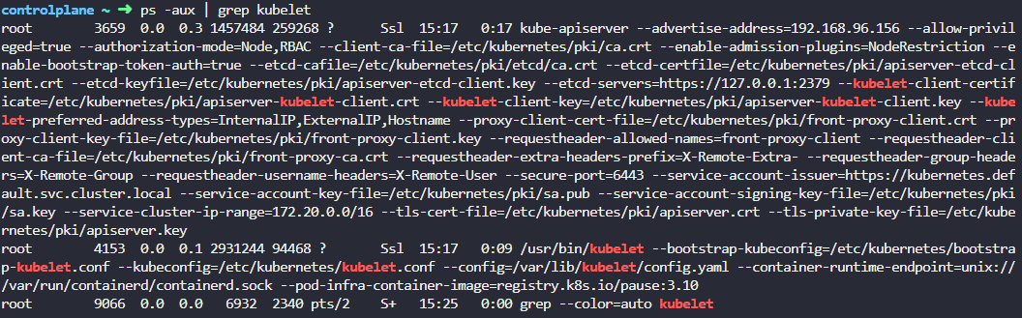

ps -aux | grep kubelet | grep network ; view kubelet options related to network

All network plugins are installed in the directory **/opt/cni/bin**

ls /opt/cni/bin ; directory where container runtime finds the CNI plugin installed

ls /etc/cni/net.d ; this directory has multiple plugin configuration files that are responsible for configuring each plugin.

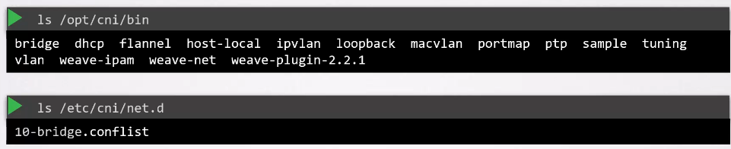

This sis where container runtime find out which plugin to be used. If there are multiple files, it will choose alphabetical order.

These configuration files specify what binary executable file in /opt/cni/bin will be run by kubelet after a container and associated namespace are created

isGateway - define whether the bridge interface should get an IP address assigned to act as gateway

ipMasq - IP masquerade defines if a NAT rule should be added

ipam - ip address management for bridge interface. It defines subnet, type - [host-local/dhcp], routes

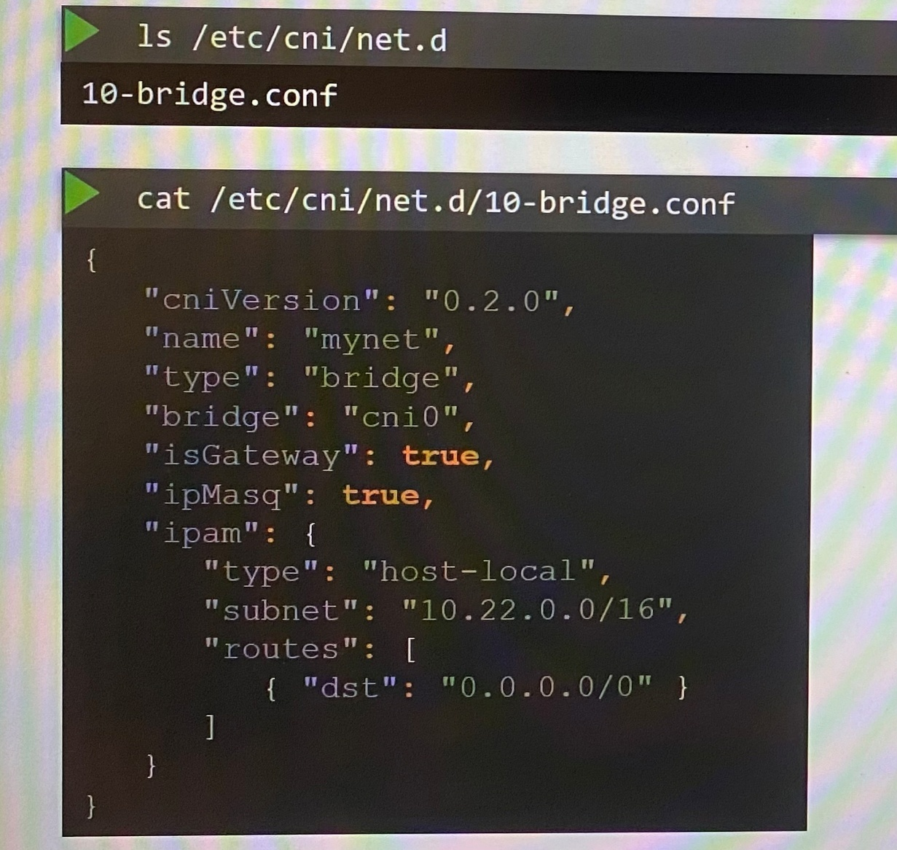

**Weaveworks(CNI)**

As we set up routing table manually where we mapped what networks are on what hosts. The packets are routed based on the details in routing table. This method is suitable for small environment. This method is not practical for larger environment that have hundreds of nodes and pods in the cluster which is where you need to get creative solution.

When weaveworks CNI plugins deploy on the cluster, it deploys an agent or service on each node. To communicate each other to exchange information regarding nodes, networks and pods within agents, each peer or agent stores topology of entire setup. That way agent knows pods and their IP addresses on each nodes.

Weave creates its own bridge on the nodes and names it as **WEAVE** and assign ip address to each network.

Note that single pod can attach to multiple bridge such weave bridge, docker bridge. What path a packet takes to reach its destination depends on the route configured on the container. Weave make sure that pods gets the correct route configured to reach the agent, and the agent then takes care of other pods.

When a packet is sent from one pod to another on another node, Weave intercepts the packet and identifies that it's on a separate network, it then encapsulates this packet into a new one with new source and destination and sends it across the network. Once on the other side, the other Weave agent retrieves the packet, decapsulates it, and routes the packet to the right pod.

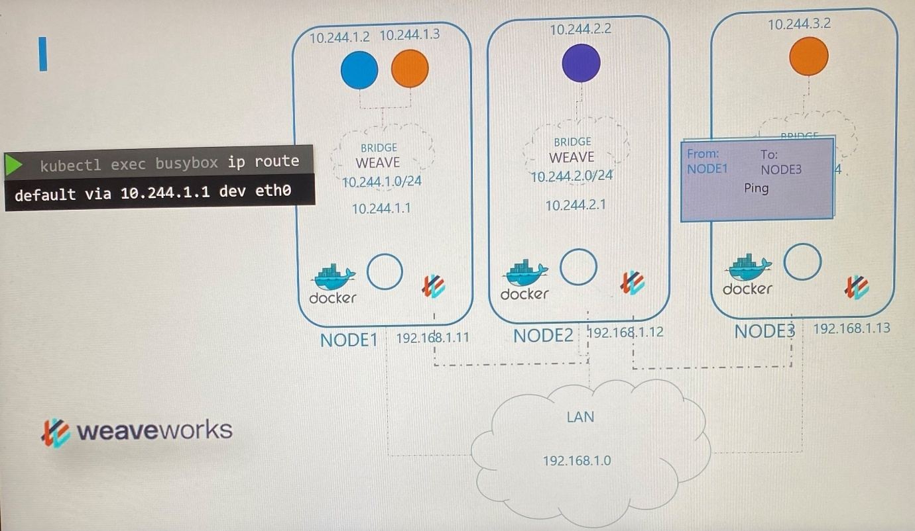

***Deploy weave***

Weave and weave peers can be deployed as services or daemons on each node in the cluster manually or if Kubernetes is already deployed, weave peers can be deployed as pods in the namespace kube-system in the cluster.

Once the base Kubernetes system is ready, with nodes and networking configured correctly between the nodes, deploy weave as follows.

kubectl apply -f “<https://cloud.weave.works/K8s/net?k8s-version=$(kubectl> version | base64 | tr -d ‘\n’)” ; deploy all necessary components of weave where weave peers deploy as daemonsets, it creates for serviceaccount, cluster role, cluster role binding, role and role binding.

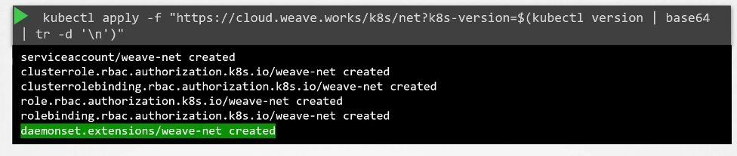

***Weave peers***

If you deploy the cluster with kubeadm tool and weave plugin, you can see the weave peers as pods deployed on each node.

The weave manifest file is located in /root/weave

kubectl get pods -n kube-system ; show all the weave peers if you deploy cluster with kubeadm tool

kubectl logs <weave peer pod name> -n kube-system ; show logs on the pods

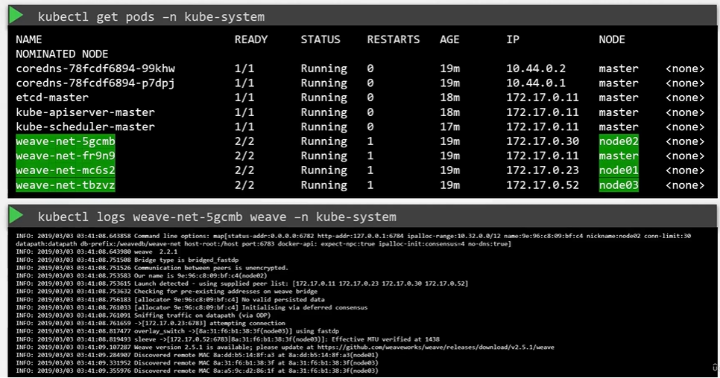

-----------------------weave-daemonset-k8s.yaml -------------------------------

apiVersion: v1

kind: List

items:

- apiVersion: v1

kind: ServiceAccount

metadata:

name: weave-net

labels:

name: weave-net

namespace: kube-system

- apiVersion: rbac.authorization.k8s.io/v1

kind: ClusterRole

metadata:

name: weave-net

labels:

name: weave-net

rules:

- apiGroups:

- ''

resources:

- pods

- namespaces

- nodes

verbs:

- get

- list

- watch

- apiGroups:

- extensions

resources:

- networkpolicies

verbs:

- get

- list

- watch

- apiGroups:

- 'networking.k8s.io'

resources:

- networkpolicies

verbs:

- get

- list

- watch

- apiGroups:

- ''

resources:

- nodes/status

verbs:

- patch

- update

- apiVersion: rbac.authorization.k8s.io/v1

kind: ClusterRoleBinding

metadata:

name: weave-net

labels:

name: weave-net

roleRef:

kind: ClusterRole

name: weave-net

apiGroup: rbac.authorization.k8s.io

subjects:

- kind: ServiceAccount

name: weave-net

namespace: kube-system

- apiVersion: rbac.authorization.k8s.io/v1

kind: Role

metadata:

name: weave-net

namespace: kube-system

labels:

name: weave-net

rules:

- apiGroups:

- ''

resources:

- configmaps

resourceNames:

- weave-net

verbs:

- get

- update

- apiGroups:

- ''

resources:

- configmaps

verbs:

- create

- apiVersion: rbac.authorization.k8s.io/v1

kind: RoleBinding

metadata:

name: weave-net

namespace: kube-system

labels:

name: weave-net

roleRef:

kind: Role

name: weave-net

apiGroup: rbac.authorization.k8s.io

subjects:

- kind: ServiceAccount

name: weave-net

namespace: kube-system

- apiVersion: apps/v1

kind: DaemonSet

metadata:

name: weave-net

labels:

name: weave-net

namespace: kube-system

spec:

# Wait 5 seconds to let pod connect before rolling next pod

selector:

matchLabels:

name: weave-net

minReadySeconds: 5

template:

metadata:

labels:

name: weave-net

spec:

initContainers:

- name: weave-init

image: 'weaveworks/weave-kube:2.8.1'

command:

- /home/weave/init.sh

env:

securityContext:

privileged: true

volumeMounts:

- name: cni-bin

mountPath: /host/opt

- name: cni-bin2

mountPath: /host/home

- name: cni-conf

mountPath: /host/etc

- name: lib-modules

mountPath: /lib/modules

- name: xtables-lock

mountPath: /run/xtables.lock

readOnly: false

containers:

- name: weave

command:

- /home/weave/launch.sh

**env:**

**- name: IPALLOC_RANGE**

**value: 10.32.1.0/24**

- name: INIT_CONTAINER

value: "true"

- name: HOSTNAME

valueFrom:

fieldRef:

apiVersion: v1

fieldPath: spec.nodeName

image: 'weaveworks/weave-kube:2.8.1'

readinessProbe:

httpGet:

host: 127.0.0.1

path: /status

port: 6784

resources:

requests:

cpu: 50m

securityContext:

privileged: true

volumeMounts:

- name: weavedb

mountPath: /weavedb

- name: dbus

mountPath: /host/var/lib/dbus

readOnly: true

- mountPath: /host/etc/machine-id

name: cni-machine-id

readOnly: true

- name: xtables-lock

mountPath: /run/xtables.lock

readOnly: false

- name: weave-npc

env:

- name: HOSTNAME

valueFrom:

fieldRef:

apiVersion: v1

fieldPath: spec.nodeName

image: 'weaveworks/weave-npc:2.8.1'

#npc-args

resources:

requests:

cpu: 50m

securityContext:

privileged: true

volumeMounts:

- name: xtables-lock

mountPath: /run/xtables.lock

readOnly: false

hostNetwork: true

dnsPolicy: ClusterFirstWithHostNet

hostPID: false

restartPolicy: Always

securityContext:

seLinuxOptions: {}

serviceAccountName: weave-net

tolerations:

- effect: NoSchedule

operator: Exists

- effect: NoExecute

operator: Exists

volumes:

- name: weavedb

hostPath:

path: /var/lib/weave

- name: cni-bin

hostPath:

path: /opt

- name: cni-bin2

hostPath:

path: /home

- name: cni-conf

hostPath:

path: /etc

- name: cni-machine-id

hostPath:

path: /etc/machine-id

- name: dbus

hostPath:

path: /var/lib/dbus

- name: lib-modules

hostPath:

path: /lib/modules

- name: xtables-lock

hostPath:

path: /run/xtables.lock

type: FileOrCreate

priorityClassName: system-node-critical

updateStrategy:

type: RollingUpdate

controlplane ~ ➜ kubectl apply -f /root/weave/weave-daemonset-k8s.yaml

serviceaccount/weave-net created

clusterrole.rbac.authorization.k8s.io/weave-net created

clusterrolebinding.rbac.authorization.k8s.io/weave-net created

role.rbac.authorization.k8s.io/weave-net created

rolebinding.rbac.authorization.k8s.io/weave-net created

daemonset.apps/weave-net created

**Note CNI Weave**

Important Update: -

Before going to the CNI weave lecture, we have an update for the Weave Net installation link. They have announced the end of service for Weave Cloud.

To know more about this, read the blog from the link below: -

<https://www.weave.works/blog/weave-cloud-end-of-service>

As an impact, the old weave net installation link won’t work anymore: -

kubectl apply -f "[https://cloud.weave.works/k8s/net?k8s-version=$(kubectl version | base64 | tr -d '\n')](https://cloud.weave.works/k8s/net?k8s-version=$(kubectl%20version%20|%20base64%20|%20tr%20-d%20'\n'))"

Instead of that, use the below latest link to install the weave net: -

kubectl apply -f <https://github.com/weaveworks/weave/releases/download/v2.8.1/weave-daemonset-k8s.yaml>

Reference links: -

<https://www.weave.works/docs/net/latest/kubernetes/kube-addon/#-installation>

<https://github.com/weaveworks/weave/releases>

**IP address management(IPAM)- Weave**

This covers how virtual bridge network in the nodes assign IP subnets, how assign IP address to pods, where these information stored and who is responsible for ensuring there are no duplicate IP is assigned

CNI plugin that the network solution provider is responsible to manage the IP subnets on each node for pods without conflicting by storing list of IPs in a file(ip-list.txt). We have necessary code in the script where it defines command line arguments to retrieve free IP from that file place on each host and manage the IPs parts of node.

# Retrieve Free IP from file

ip = get_free_ip_from_file()

CNI comes with two built-in plugin(***DHCP*** and ***host-local)*** by outsourcing the coding on the script.

Host-local - managing the IP address locally on each host. We should invoke this plugin through the script or can our script dynamic to support different kind of plugin.

# Invoke IPAM host-local plugin

ip = get_free_ip_from_host_local()

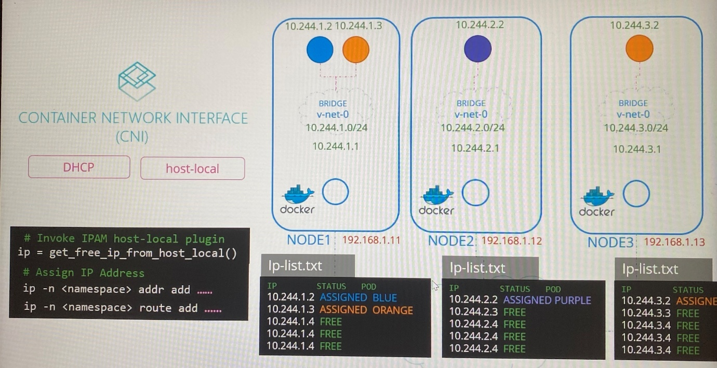

The CNI plugin configuration file- /etc/cni/net.d/net-script.conf has section to specify the type of plugin, subnet and routes to be used. These details can be read from script to invoke the appropriate plugin instead hard coding it to use host local every time.

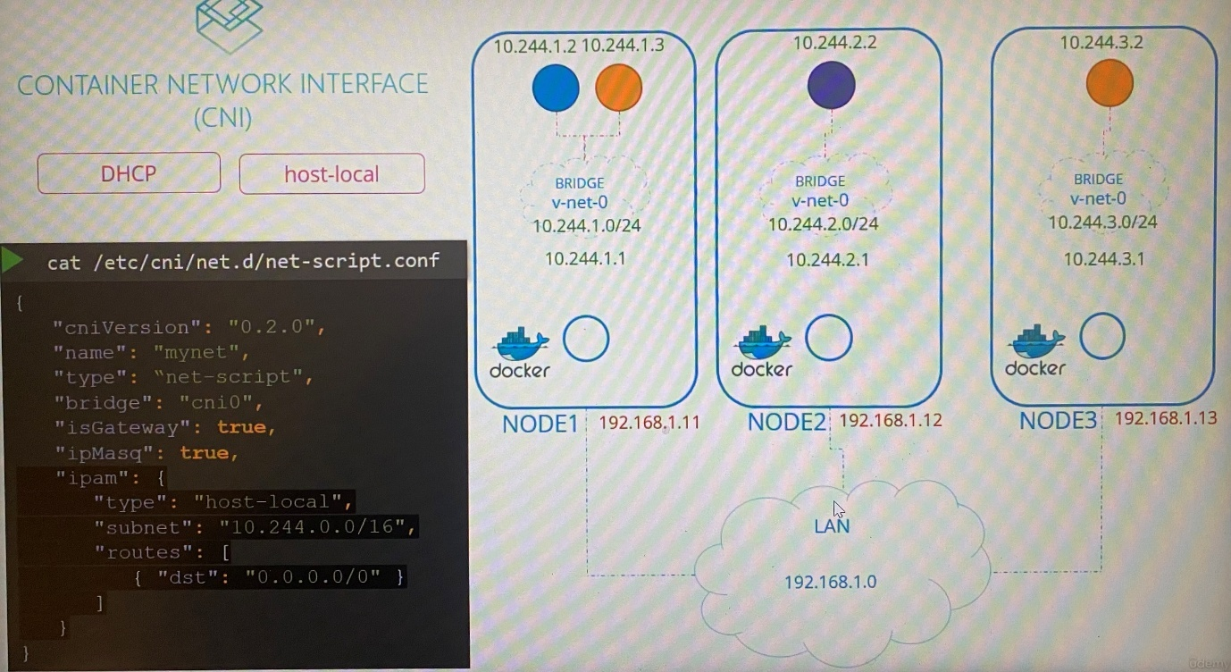

Different network solution providers do the IPAM function differently.

Weaveworks by default allocates IP address from the range 10.32.0.0/12(10.32.0.1 > 10.47.255.254). From this range, one portion equally assign to each node.(10.32.0.0/16, 10.38.0.0/16, 10.44.0.0/16)

Check logs on the container in order to check the ip address assigned.

kubectl logs -n kube-system <pod name> ; ipalloc-range shows ip range assign for pods

kubectl exec <pod name> - - route -n

kubectl exec <pod name> - - ip route ; check the default gateway for the pod

kubectl exec it <pod name> - - curl -m 5 <pod ip address>

**Service Networking**

- Service networking uses when a pod need access to another pod on different nodes in the cluster because we rarely configure pods to communicate directly with other pods

- While pod is hosted on a node, a service for the pod is hosted across the cluster and it is not bound to a node. That service is only accessible within the cluster. This type of service is called ***ClusterIP*** which has ip address

- If a pod need to access from outside the cluster, the service we create is called ***NodePort*** which is act same as ClusterIP. Additionally, NodePort service expose pod application for request come from outside the cluster on a port from all node in the cluster

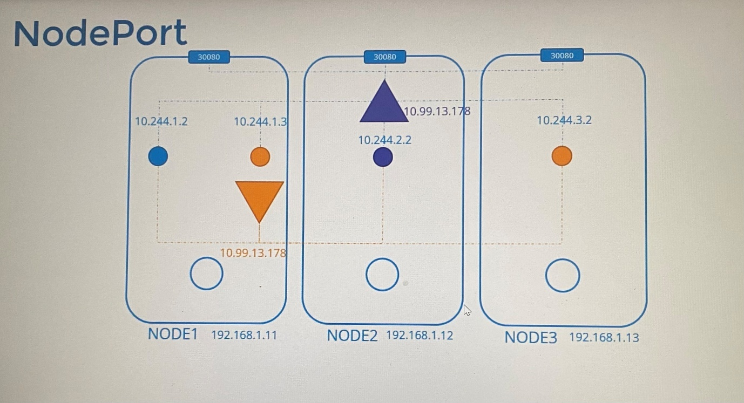

-Kubernetes node runs a kubelet process which is responsible for creating pods based on the changes communicates by kube-api server. Then Kubelet invoke CNI plugin to configure networking for that pod.

-Similarly kube-proxy watches the changes in the cluster through Kube API server, Kube proxy get action when every time a new service is to be created.

-There is no server or service really listening on the IP of the service. Thus, service is a virtual object that run across the cluster. Services are not created or assigned on nodes. Unlike pods, services have no processes, namespaces or interfaces. So how service get IP address??

- When service object is created, it is assigned ip address from predefined range with the combination of port through Kube-proxy. Then kube-proxy running on each node get those ip address and creates forwarding rule on each node by calling that any traffic coming to ip address of the service should forward to ip address of the pod. Note that the service has combination of IP address and port. Whenever service created or deleted , the kube-proxy creates or deletes these rules.

-Thus, when a pod tries to reach the IP of the service, it is forwarded to the pod's IP address

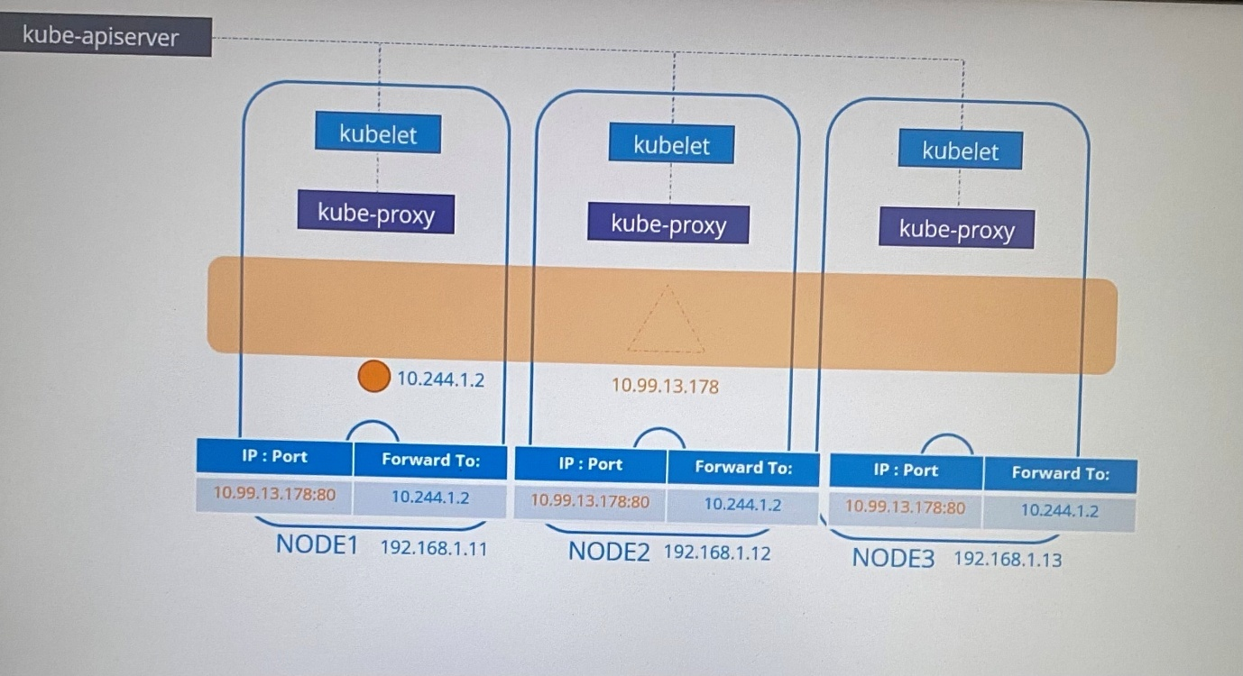

- To create these rules, Kube-proxy supports different ways such as ***userspace*** where kube proxy listen on ports for each service and proxies connect to the pods by creating ***ipvs*** rules or ***iptables*** which is default option

- Set the proxy-mode when configure kube-proxy service. If this is not set, by default it gets iptables

kube-proxy - -proxy-mode [userspace | iptables | ipvs ] …

- IP range assign for services is specified in kube-apiserver server with the option called ***service-cluster-ip-range***

kube-api-server - -service-cluster-ip-range ipNet (Default: 10.0.0.0/24)

ps -aux | grep kube-api-server ; check the option ***service-cluster-ip-range*** in kube-api-server where it shows the service cluster ip range

*The ip ranges of pods and services shouldn’t be overlapped with same ip range

iptables -L -t nat | grep db-service ; check all rules for services are created by kube-proxy in iptables as dnat rule

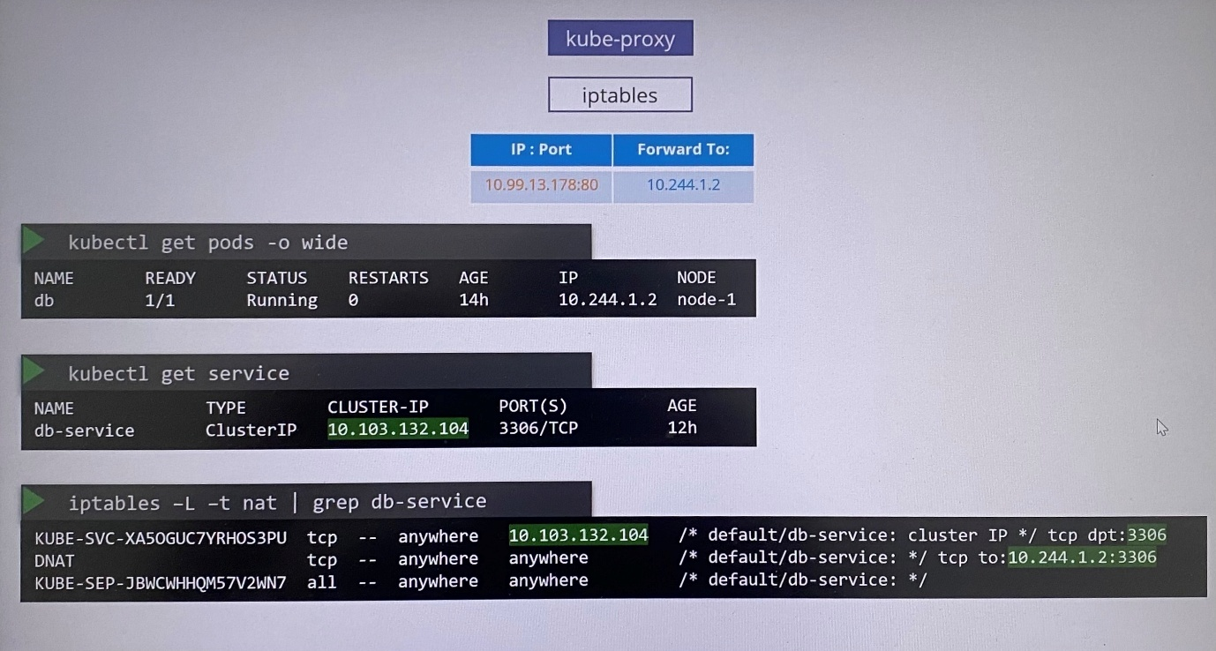

cat /var/log/kube-proxy.log ; create logs by kube-proxy it shows what proxy mode they use

To check range of IP addresses configured for PODs on this cluster

Controlplane ~ ➜ kubectl logs weave-net-wmgpt weave -n kube-system

INFO: 2025/01/17 05:25:26.353097 Command line options: map[conn-limit:200 datapath:datapath db-prefix:/weavedb/weave-net docker-api: expect-npc:true http-addr:127.0.0.1:6784 ipalloc-init:consensus=1 **ipalloc-range:10.244.0.0/16** metrics-addr:0.0.0.0:6782 name:32:84:f5:06:55:2b nickname:node01 no-dns:true no-masq-local:true port:6783]

To check range of IP addresses configured for services in this cluster

controlplane ~ ➜ cat /etc/kubernetes/manifests/kube-apiserver.yaml | grep service-cluster-ip-range

- --service-cluster-ip-range=10.96.0.0/12





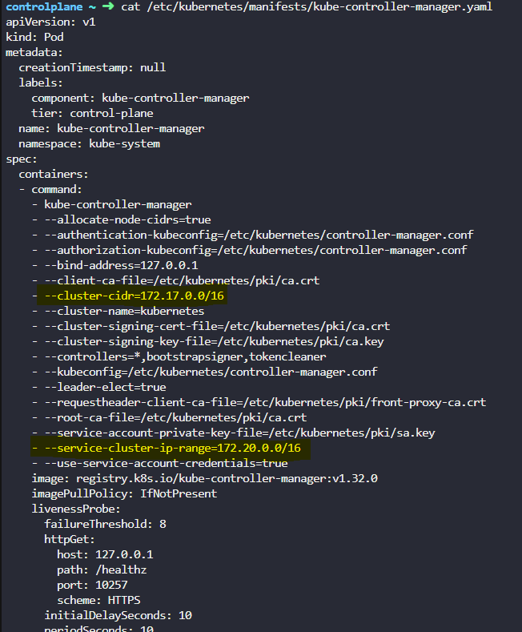

To check type of proxy is the kube-proxy configured to use

controlplane ~ ➜ kubectl logs kube-proxy-6744l kube-proxy -n kube-system

I0117 05:24:58.954679 1 server_linux.go:66] "Using iptables proxy"

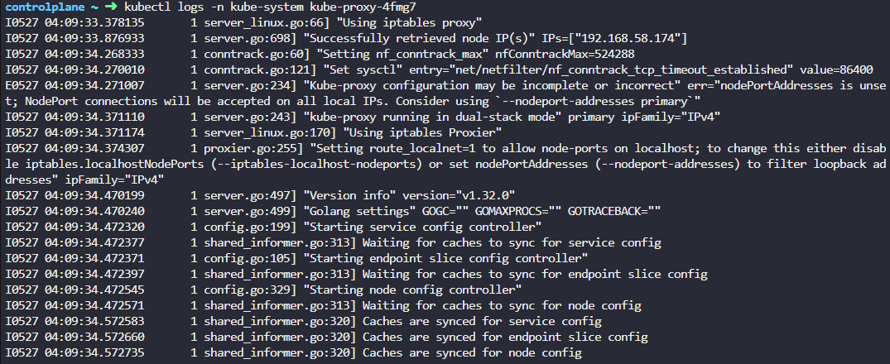

**DNS in Kubernetes**

-Kubernetes deploys a bult-in DNS server by default when setup the cluster. If you setup Kubernetes manually, then you do it by yourself.

Kubernetes uses DNS server ***CoreDNS*** for DNS resolution.

When a service is created, the Kubernetes DNS service(***CoreDNS*** ) creates a DNS record for the service that maps service name to the IP address.

If a pod needs to access another pod using DNS, the DNS record created for the service will be used to reach by the pod so that all service and pods should be in same namespace. If destination pod is in another namespace, you should use FQDN such as (hostname.namespace.type.root)

curl <http://web-service>( hostname of the service) ; any pod within same namespace in the cluster can reach a service using o service name

If destination pod is in another namespace, DNS server creates subdomain for the namespace.

All pods and services for a namespace are thus grouped together into a Subdomain in the name of eachnamespace.“DB-service.dev”

curl <http://web-service.apps> (hostname of the service, name of the namespace)

All the services for a namespace are further grouped together into a Subdomain in the name of the namespace and and type SVC. “DB-service.dev.svc.cluster.local”

curl <http://web-service.apps.svc> (hostname of the service, name of the namespace, type SVC)

*FQDN for service*

hostname.namespace.type.root > ip address

web-service.apps.svc.cluster.local > ip address

- DNS records for the name of pods are not by default created by DNS service. But we can enable it explicitly but it doesn’t create pod name instead create a name record similar to IP address replacing . with -

10.244.2.5 > 10-243-2-5

*FQDN for pod*

hostname.namespace.type.root > ip address

10-243-2-5.apps.pod.cluster.local > ip address

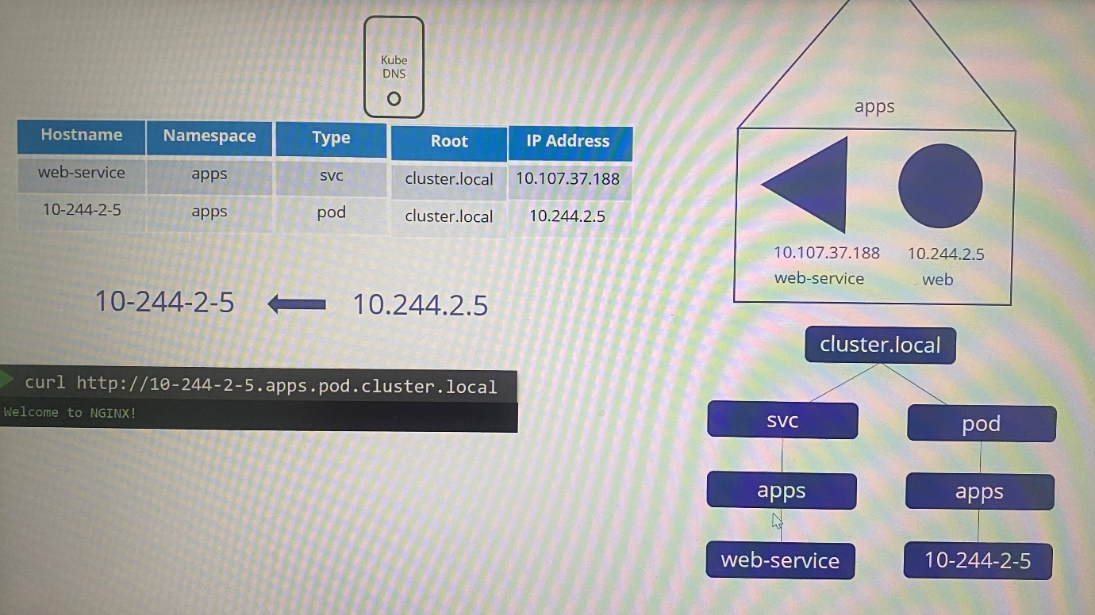

**CoreDNS in Kubernetes**

Prior to Kubernestes 1.12, the DNS server implemented by Kubernetes was known as kube-dns.

In Kubernetes version 1.12 or later, recommended DNS server for Kubernetes is CoreDNS.

CoreDNS is implemented as pod in kube-system namespace which deployed as two pods for redundancy as part of ReplicaSet within deployment. In the pod runs ./CoreDNS executable

CoreDNS needs configuration file that is located /etc/coredns. The number of plugins configured in Corefile.

cat /etc/coredns/Corefile

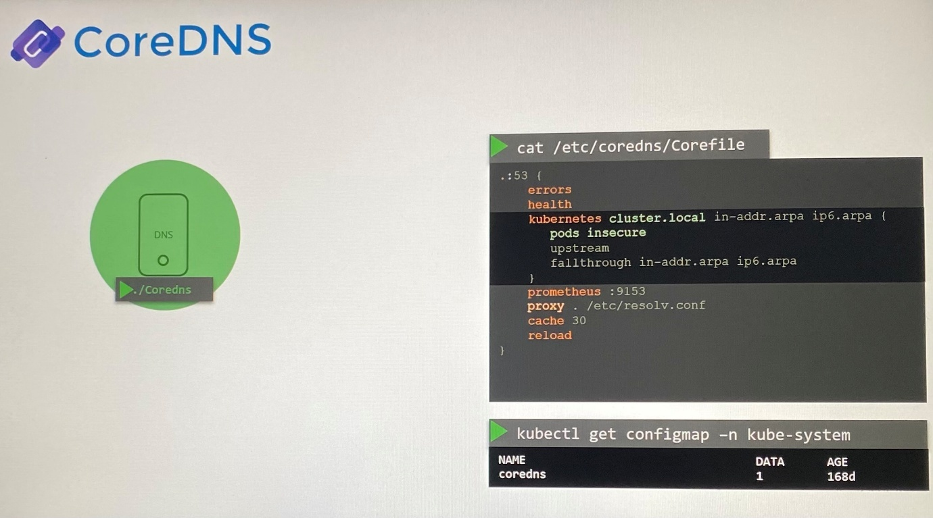

This file includes,

-The plugins are configured for handling errors, reporting health, monitoring metrics, cache and proxy.

-Top level domain of the cluster is set in Kubernetes plugin. All the records in CoreDNS servers are felt under root domain **cluster.local**

In Kubernetes plugin, there are multiple options .The pods option is for creating a record for pods by converting the IPs into the dashed format(10-20-5-11). This is disabled by default but it can be enabled with this entry.

-Any record that the DNS server can't resolve is forwarded to the nameserver specified in /etc/resolv.conf in the CoreDNS pod using proxy plugin in Corefile

proxy ./etc/resolv.conf

This Corefile is passed into the CoreDNS pod by using configmap object(coredns). You can modify these configuration by editing config map object.

Every time a pod or service is created in the cluster, it adds a record into the CoreDNS database.

When we deploy CoreDNS solution, it creates a service to make it other components can connect to which is called kube-dns. The IP address of this service is configured as the name server on pods in the cluster.

Name server configuration on pods(/etc/resolv.conf) is set up once pods are created by kubelet automatically. If you check config file of the kubelet(/var/lib/kubelet/config.yaml), ip address of coreDNS can be shown.

cat /var/lib/kubelet/config.yaml ; check kubelet configuration file which includes clusterDNS and clusterDomain

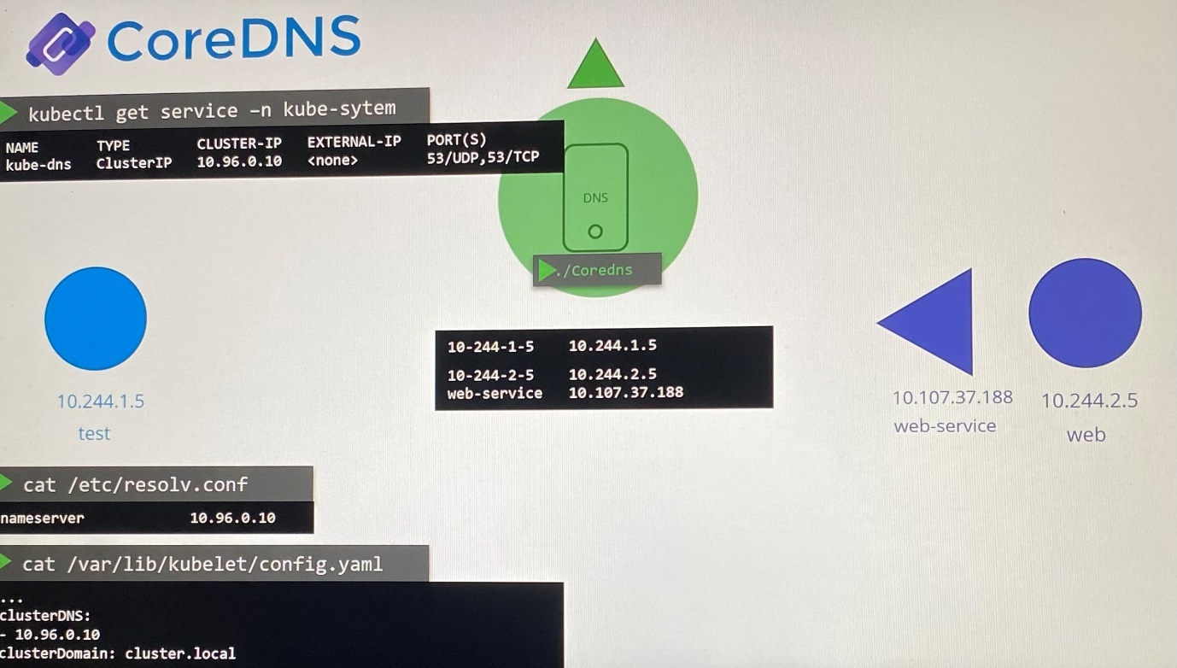

You can resolve service pods or service with following DNS entries

curl <http://web-service>

curl <http://web-service.default>

curl <http://web-service.default.svc>

curl <http://web-service.default.svc.cluster.local>

host web-service ; check search entry for service similar to nslookup using curl or host, it returns FQDN of web service

/etc/resolv.conf on pod has search entry as follows which allows to resolve with any DNS where it appends search entries.

cat /etc/resolv.conf

nameserver 10.96.0.10

search default.svc.cluster.local svc.cluster.local cluster.local

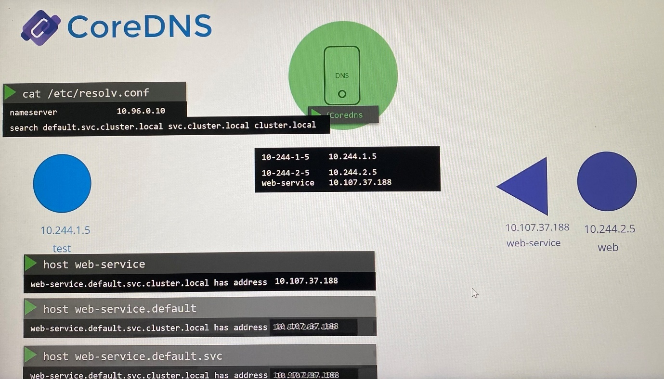

However, it only have search entries for service. You can't reach a pod the same way. Instead, you need to specify full FQDN of the pod to resolve DNS for the pod.

host 10-244-2-5.default.pod.cluster.local

kubectl exec <pod name> - -nslookup <podname.namespace> ; if you need to resolve DNS of a pod from another pod

Inspect the Args field of the coredns deployment or pods, and check the path used in CoreDNS configuration file where it should have volumeMount /etc/coredns from config volume

controlplane ~ ✖ kubectl describe configmaps coredns -n kube-system

Name: coredns

Namespace: kube-system

Labels: <none>

Annotations: <none>

Data

====

Corefile:

----

.:53 {

errors

health {

lameduck 5s

}

ready

kubernetes cluster.local in-addr.arpa ip6.arpa {

pods insecure

fallthrough in-addr.arpa ip6.arpa

ttl 30

}

prometheus :9153

forward . /etc/resolv.conf {

max_concurrent 1000

}

cache 30

loop

reload

loadbalance

}

BinaryData

====

Events: <none>

controlplane ~ ➜ kubectl exec test -- curl web-service

% Total % Received % Xferd Average Speed Time Time Time Current

Dload Upload Total Spent Left Speed

0 0 0 0 0 0 0 0 --:--:-- --:--:-- --:--:-- 0 This is the HR server!

100 24 0 24 0 0 24000 0 --:--:-- --:--:-- --:--:-- 24000

If one pod or deployment need to access another pod in different namespace, specify the hostname of service attached to the pod with namespace in environment variable.

spec:

containers:

- env:

- name: DB_Host

value: ***mysql.payroll***

- name: DB_User

value: root

- name: DB_Password

value: paswrd

--------------------------------------------------------------------------------------------------------

Examtips:

Inspect the Args field of the coredns deployment and check the file ***Corefile*** used.

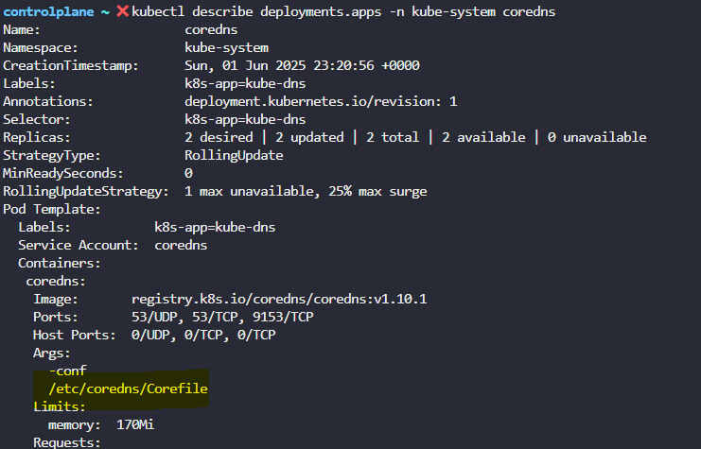

kubectl exec -it frontend -- curl -m 5 <BACKEND-POD-IP>

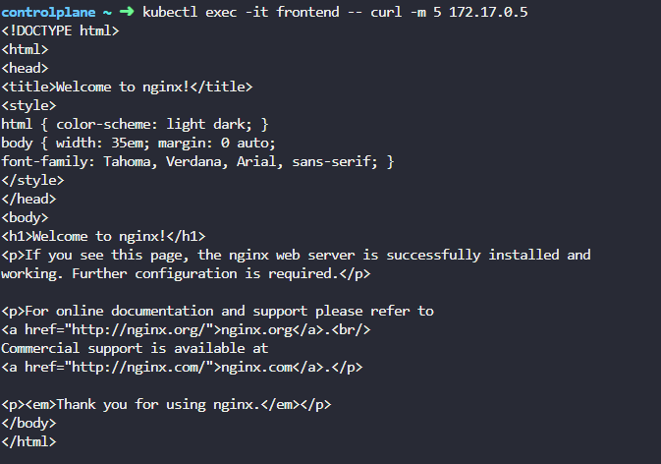

**Ingress**

If we deploy an application as deployment, we make the application accessible from outside the cluster by using NodePort service with the combination of any IP of nodes in the cluster and high numbered port of the node specified in the service (<http://IP_address_of_node:port>). However, NodePort service can only allocate high numbered port range in 30,000-32,767

Instead of using IP address to access the application, we point DNS name to IP address of the node.

<http://my-online-store.com:38080>

To avoid users to remember port number along with DNS, we bring additional layer that is reverse proxy server between DNS server and the cluster to redirect web traffic to NodePort service without specifying the port in the URL.

Proxy server revises web traffic from DNS server to NodePort service with the custom port.

For on-premise K8s cluster,

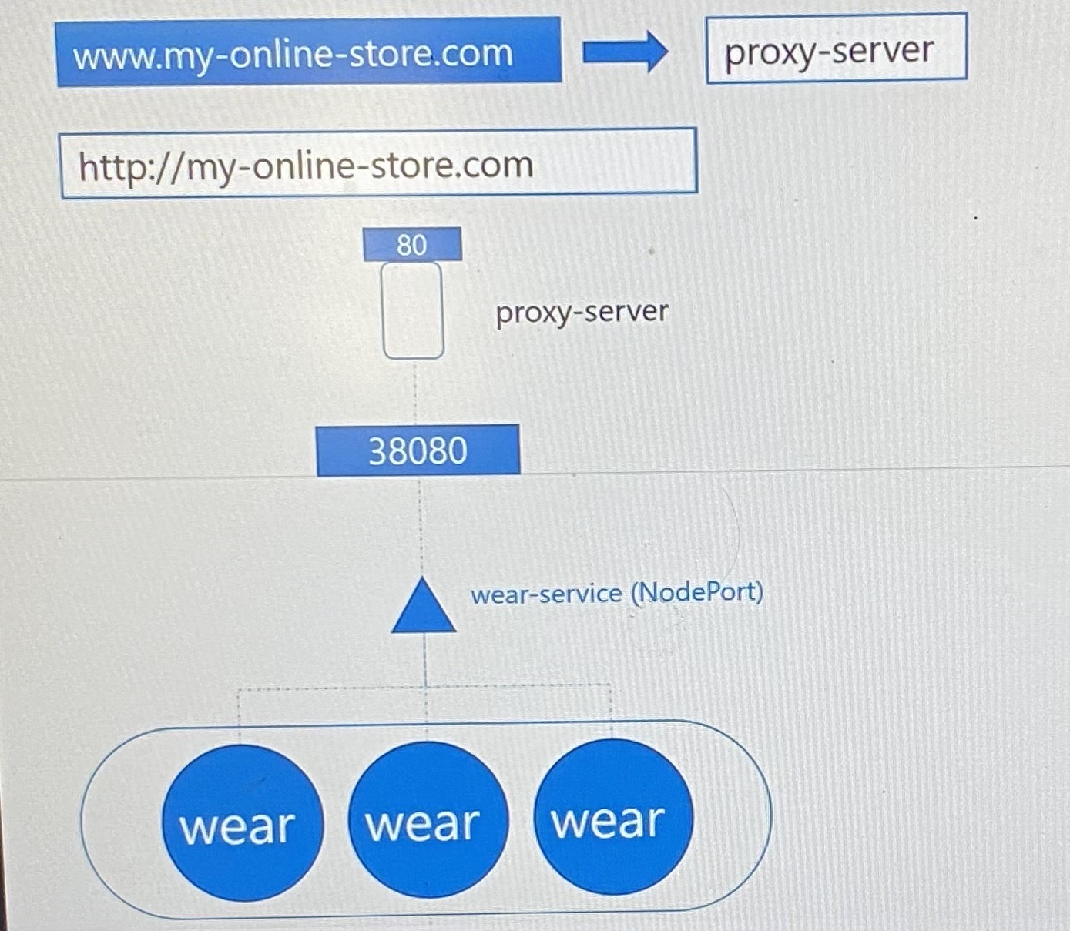

For cloud based K8 cluster,

When Kubernetes creates a service that is the type LoadBalancer that provision high numbered port on node for service and send request to cloud platform to provision a network load balancer as reverse proxy server to direct traffic to the LoadBalancer service. The cloud platform then automatically deploy a load balancer configured to route traffic to the service ports on all the nodes and return its information to Kubernetes.

The load balancer has external IP, then we set the DNS to point to that IP so that users can access the application through URL.

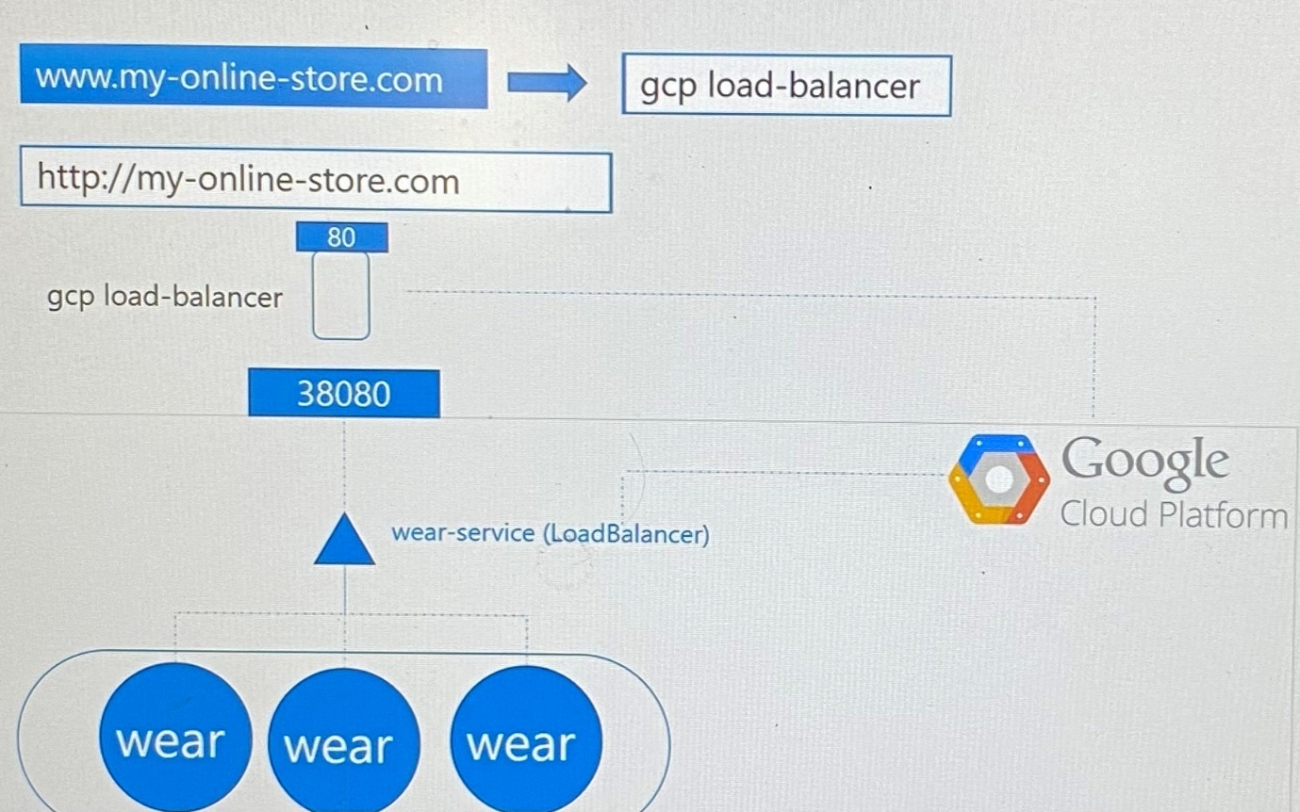

Let consider you deploy another application in the same cluster by sharing the same cluster resources that needs to be accessed externally with https:my-online-store.com/video. Thus LoadBalancer service will implement another network load balancer in cloud platform to route traffic to backend pods. Further, you need to deploy another load balancer that can redirect traffic to load balancers based on URL path. So you would have extra burden as well your cloud bill will inversely affected when number of load balancers increase. Every time you introduce new service, you have to reconfigure the Load Balancer to route traffic based on path to new service.

Finally you also need to enable SSL for the application which can be configured at different levels either application level or load balancer level or proxy server level. You don't need developers to develop to handle SSL with additional code.

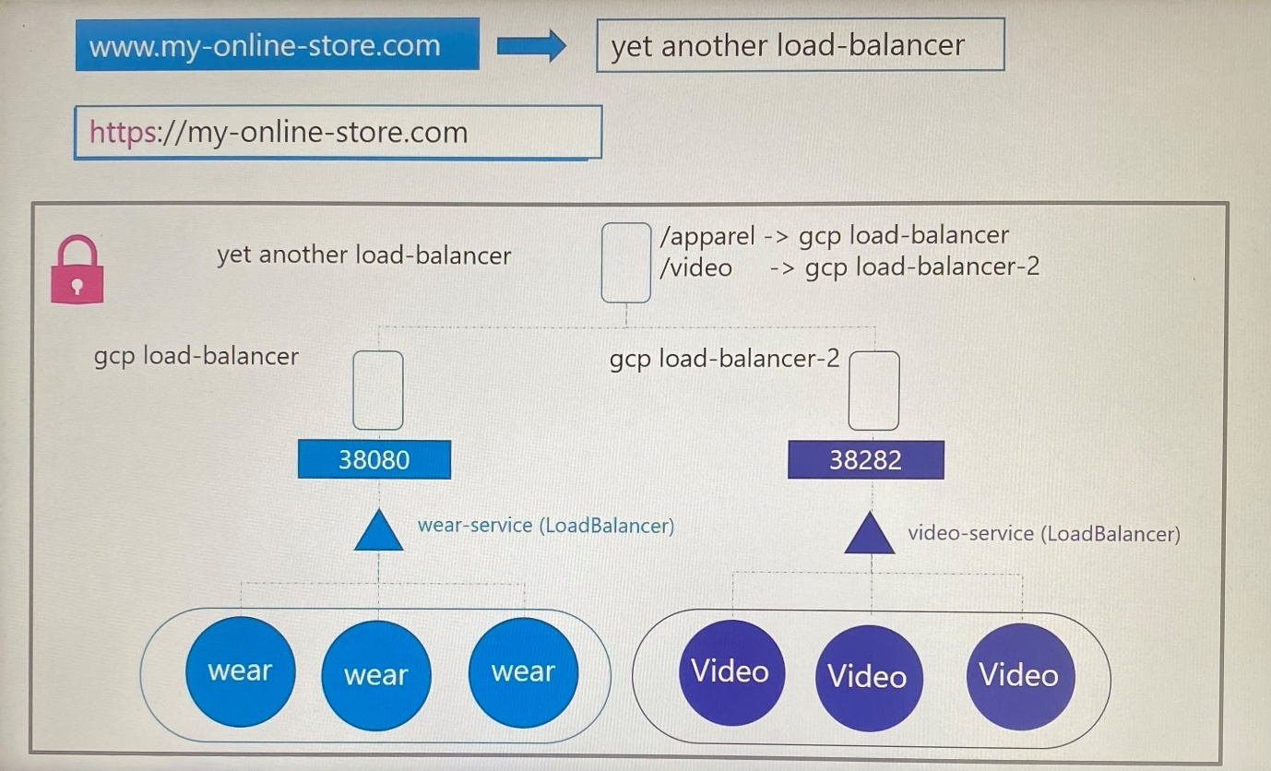

Configuring your firewall rules for each new service and provisioning cloud native load balancer need different individuals in different teams. How if you want it to be configured from one place with minimal maintenance as long as the application scales.

How if all these load balancing configurations could handle within the cluster using another Kubernetes definition file that live along with other application deployment files, that’s where ingress comes in which helps to configure ***to route traffic to different services within the cluster based on the URL path and implement SSL security*** as well.

Ingress is a layer 7 load balancer built in to the Kubernetes cluster that can be configured using native Kubernetes primitives, like other objects in Kubernetes. Even with ingress, you still need to expose it to make it accessible outside the cluster by publishing Ingress as a NodePort service or cloud native LoadBalancer service. But this is one-time configuration. Going forward, you are going to perform all load balancing of SSL and URL based routing configurations on the ingress controller.

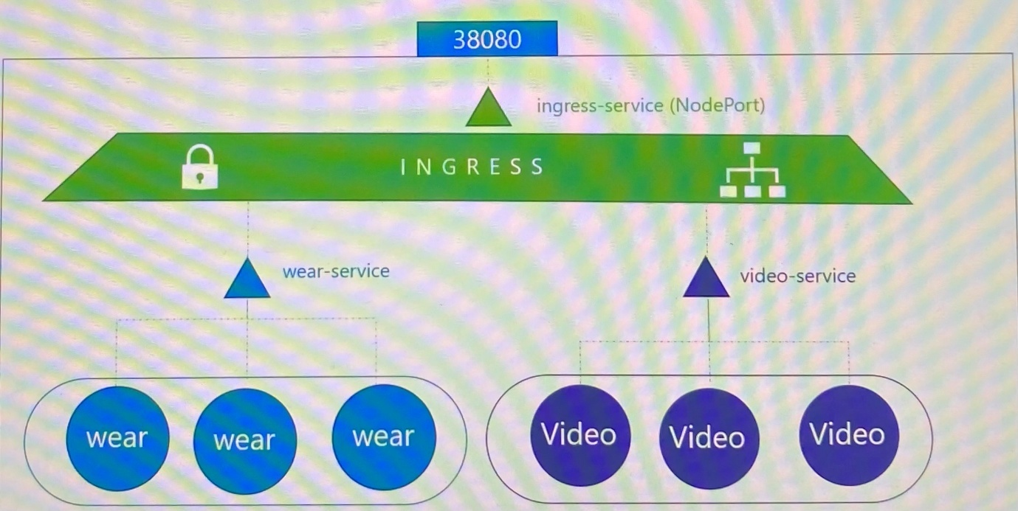

Deploy

The solution you deploy is called is ***Ingress controller*** that act as layer 7 load balancer where configuration involves configuring SSL certificates, defining URL based routes etc.

Kubernetes doesn't come with an Ingress controller by default. We use these solutions to implement ingress controller such as GCP HTTP(S) Load Balancer(GCE), NGINX, Contour, HAPROXY, traefik and Istio. **GCE** and **NGINX** are currently being supported and maintained by Kubernetes project.

Configure

The set of rules configure are called as ***Ingress resources.*** Ingress resources are created using definition files such as pod, deployment and services.

***Ingress controller***

-Kubernetes cluster does not come with an ingress controller by default

-Ingress controller have additional intelligence built in to monitor Kubernetes cluster for new definitions or ingress resources and configure the underlying NGINX server when something has changed

Here we consider deploying ingress controller from nginx solution.

We deploy a deployment with the specific image(NGINX), one replica and pod definition template for ingress controller. Pod template has following specifications in spec section.

***In args***

-Within the image, the nginx program is stored at location /nginx ingress controller which the path specify in **args**, you must pass that as command to start the nginx controller service.

-NGINX has set of configuration options such as path to store the logs, keepalive threshold, SSL settings, session timeout. In order to decouple these configuration from the nginx controller image, you must create ConfigMap object and pass that in using **args** even though configmaps does not have entries at some point. With creating blank configmaps object and passing it make easy to modify configuration in the future.

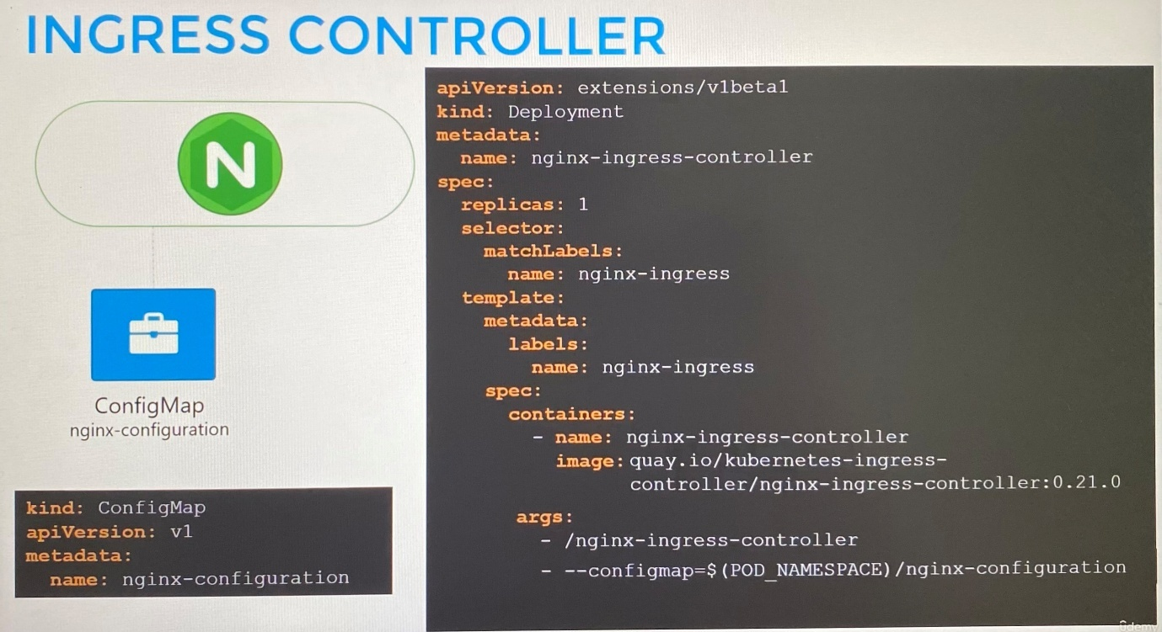

***In env***

-You must pass the environment variables that carries the pod name and pod namespace that is deployed to. The nginx service requires these to read the configuration data from within the pod.

***In ports***

-Specify the ports use by ingress controller which happens to be port 80 and 443.

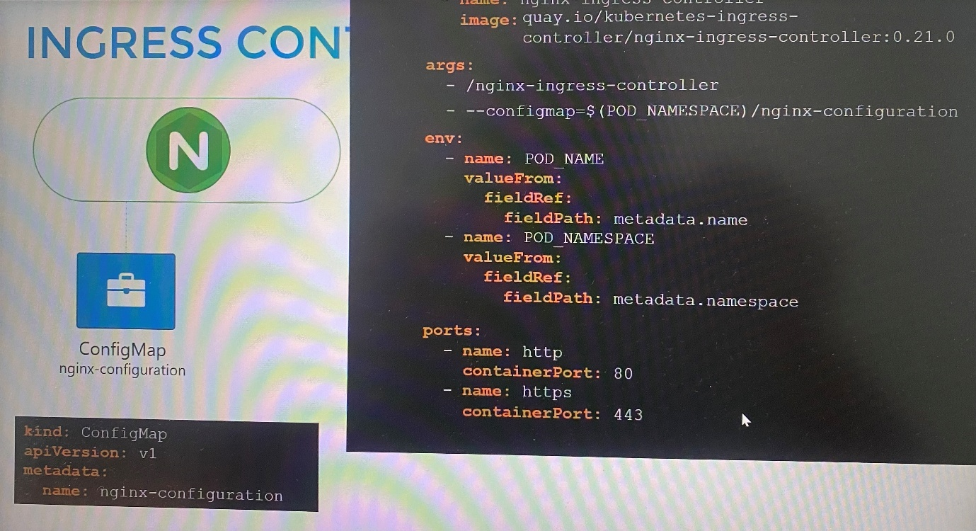

Then we need a service to expose ingress controller to external world where we creates NodePort service and link it to the deployment using selector.

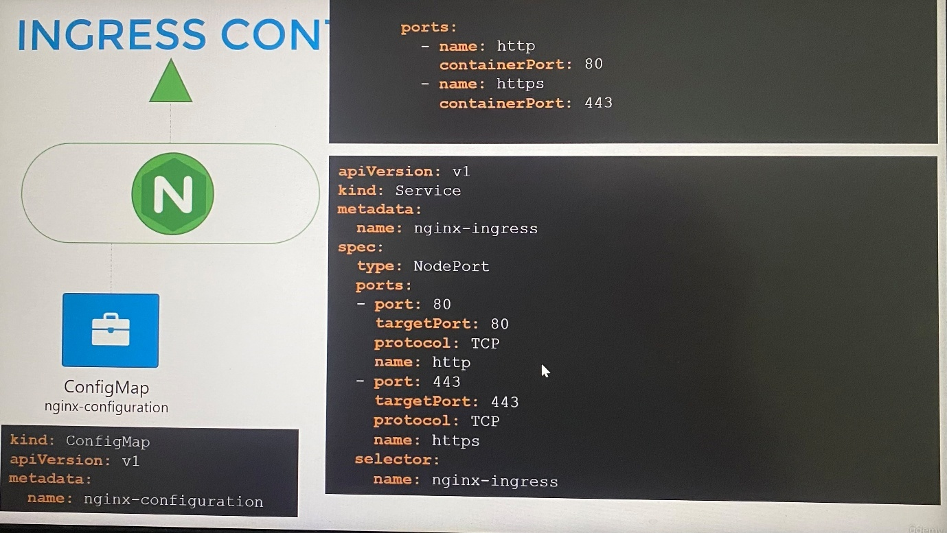

These ingress controllers have additional intelligence built in to them to monitor the Kubernetes cluster for new definition or ingress resources and configure the underlying nginx server accordingly so that Ingress controller needs a service account with right set of permissions where a service account with the correct Roles, ClusterRoles and RoleBindings.

Summary:

-A deployment with nginx ingress controller image

-A service to expose the pods in deployment

-A ConfigMap to feed nginx configuration data

-A service account with the correct permissions to access all of these objects

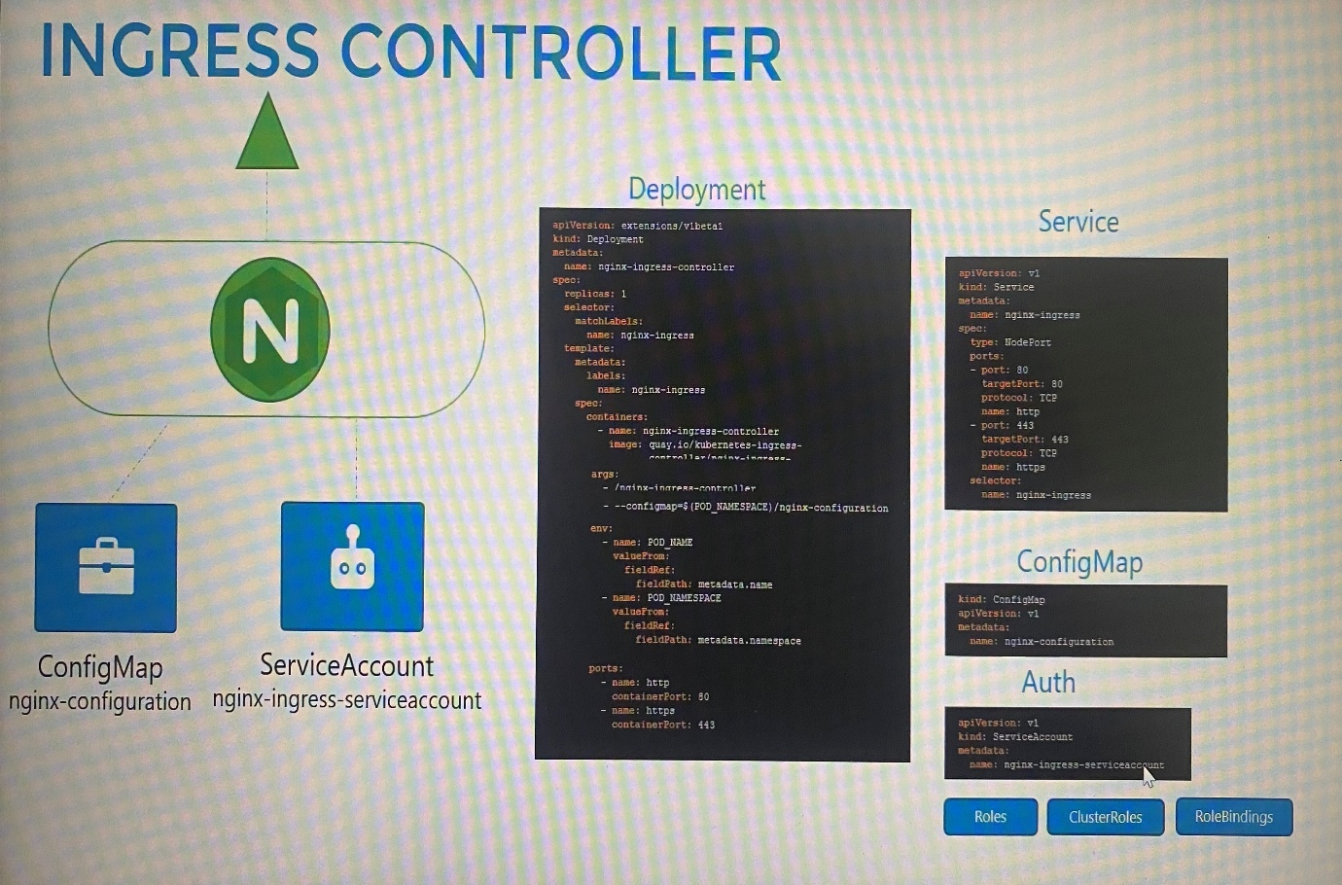

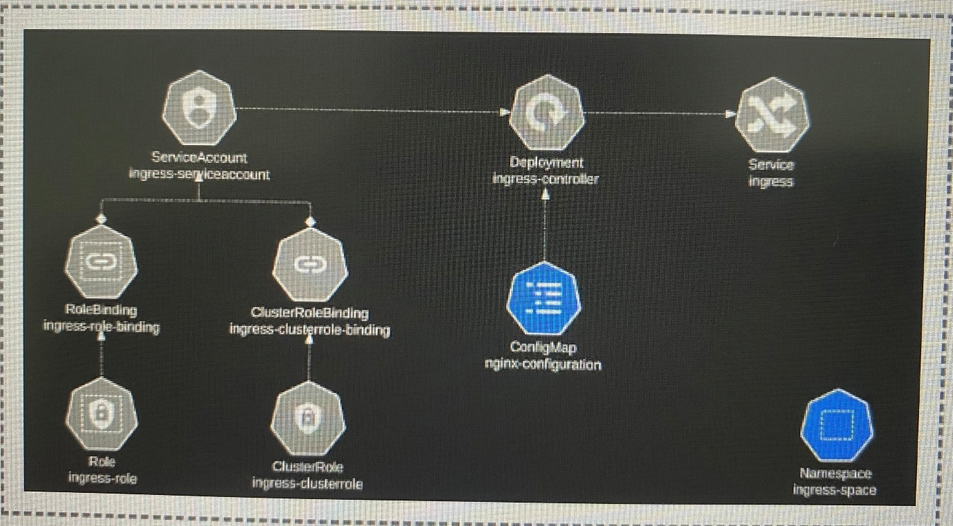

***Ingress resources***

An ingress resource is a set of rules and configurations applied on the ingress controller. These are the use cases to configure rules.

Forward all incoming traffic to a single application

Route traffic to different application based on the URL( [www.my-online-store.com/wear](http://www.my-online-store.com/wear) or [www.my-online-store.com/watch](http://www.my-online-store.com/watch))

Route traffic based on the domain name( wear.my-online-store.com or watch.my-online-store.com)

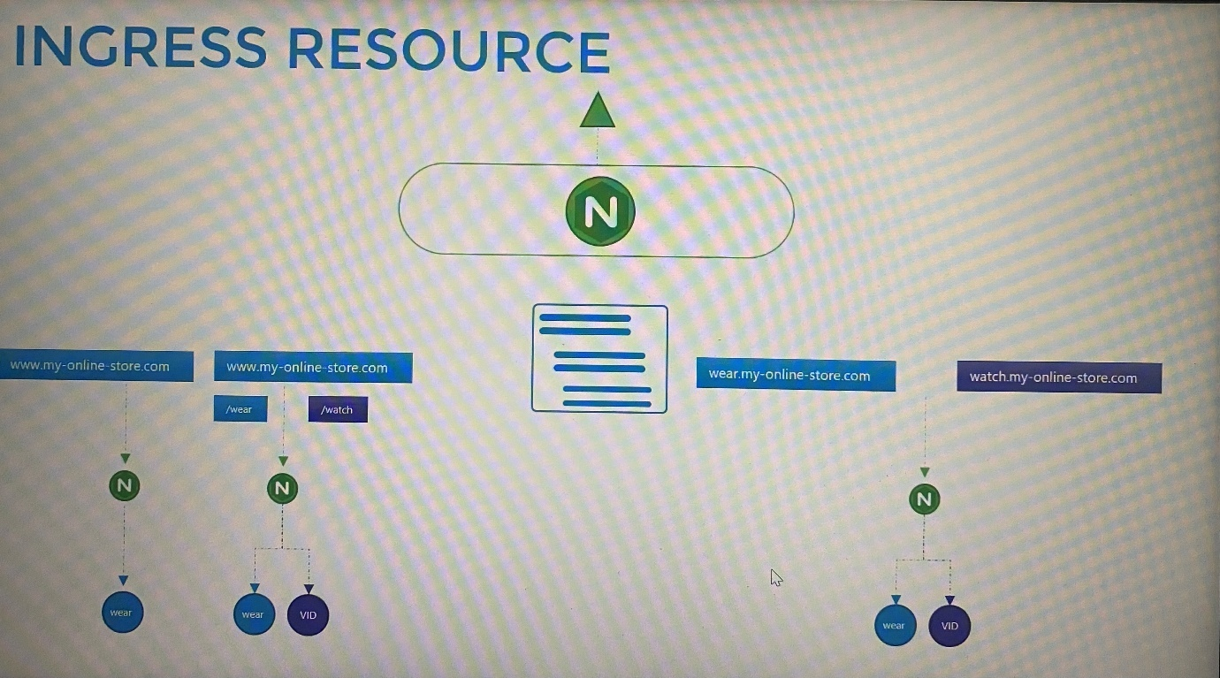

-Ingress resource is created with Kubernetes definition file

***Use Case 1 - Route traffic to a single application***

------Ingress-wear.yaml--------------------

apiVersion: networking.k8s.io/v1

kind: Ingress

metadata:

name: ingress-wear

spec:

backend:

serviceName: wear-service

servicePort: 80

kubectl create -f Ingress-wear.yaml

kubectl get ingress ; list the ingress created

-If it is single backend, you can only specify the service name and port. Then you don't really have any rules

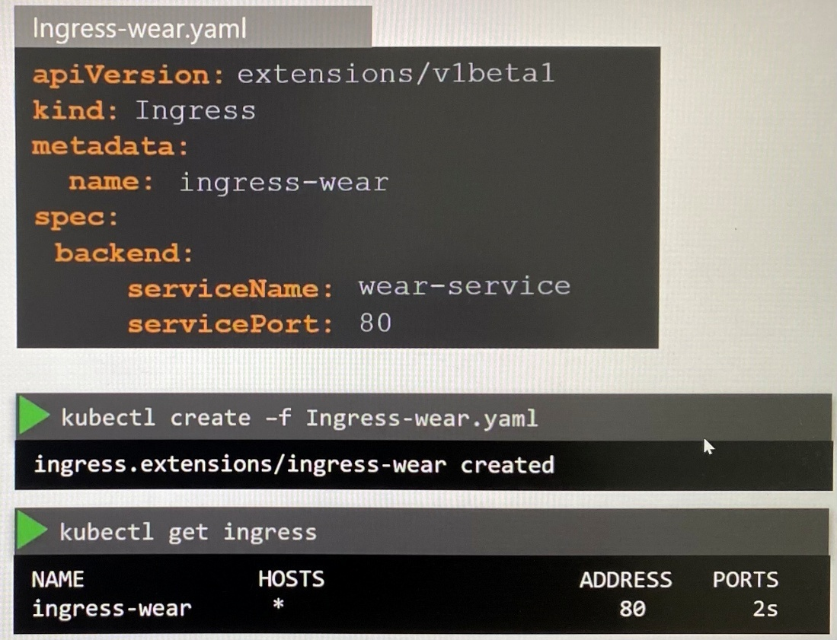

*Ingress resource -Rules*

We use rules when you want route traffic based on different conditions. Examples;

-Create one rule for traffic originating for each domain or hostname, within each rule you have different paths to route traffic based on the URL

***Use Case 2- Route traffic based on URL path***

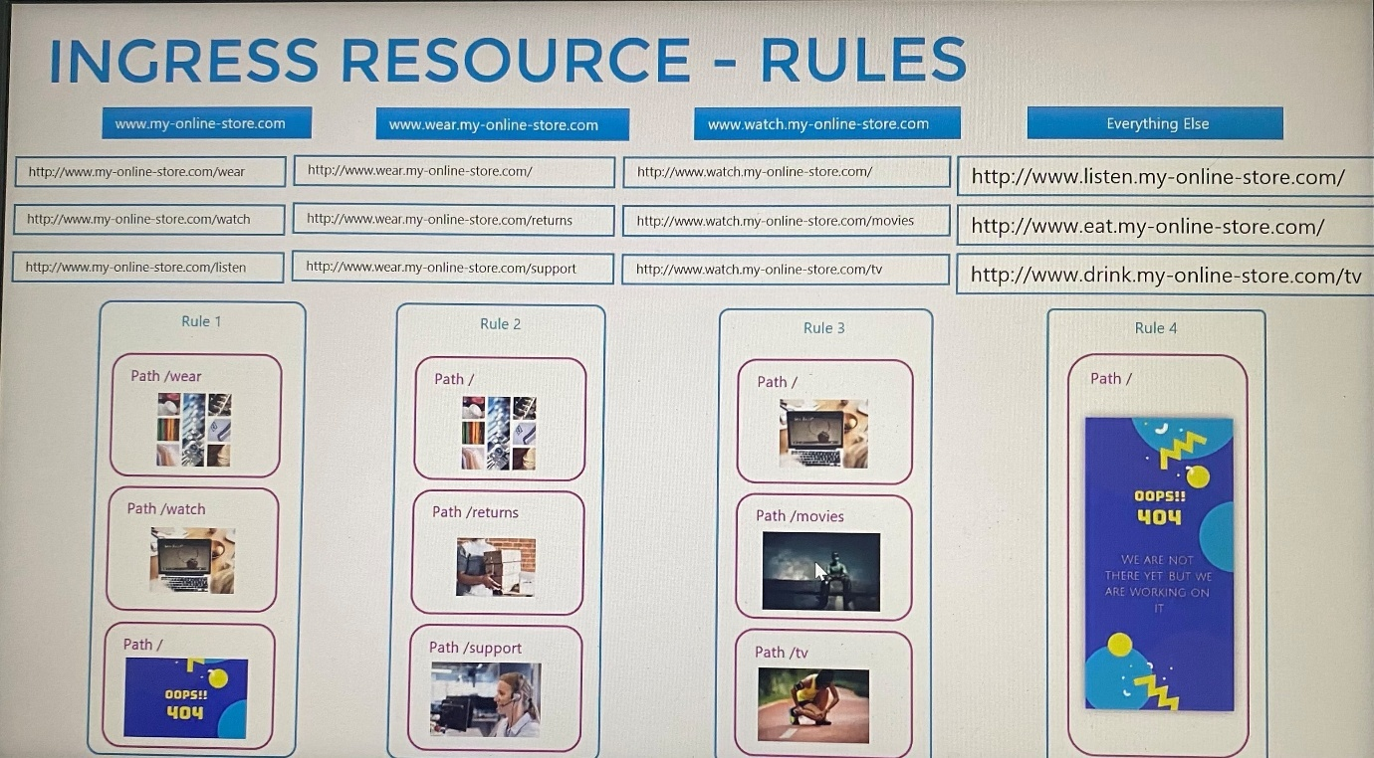

-Our requirement here is to handle all traffic coming to my-online-store.com and route them based on the URL path. You have rules at the top of each host or domain name, under rules we have one item for the domain which is an HTTP rule in which we specify different paths. Paths is an array of multiple items, one path for each URL.

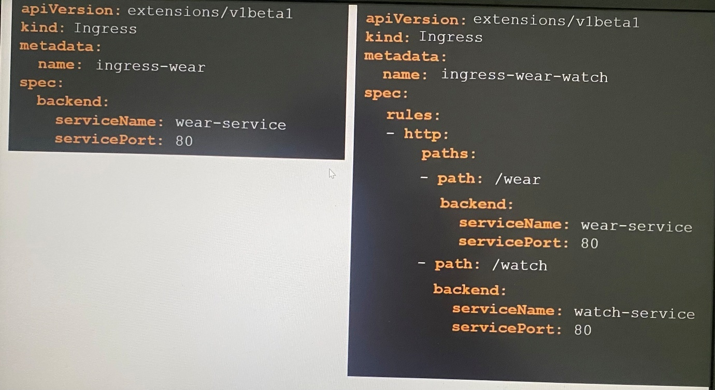

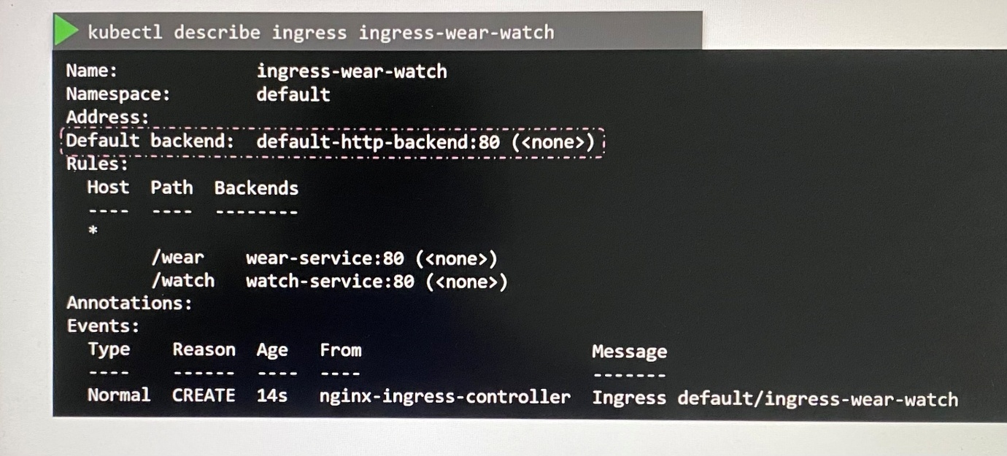

If an user tries to access a URL that does not match any of these rules, then the user is directed the service specified as the default backend.(default-http-backend). You must deploy a such a service to display this 404 not found error message.

***Use Case 3 - Route traffic based on domain name/host name***

- We have two domain names, we create two rules, one for each domain

-To split traffic by domain name, we use the host field as array. The host field in each rule matches the specified value, with the domain name used in the request URL.

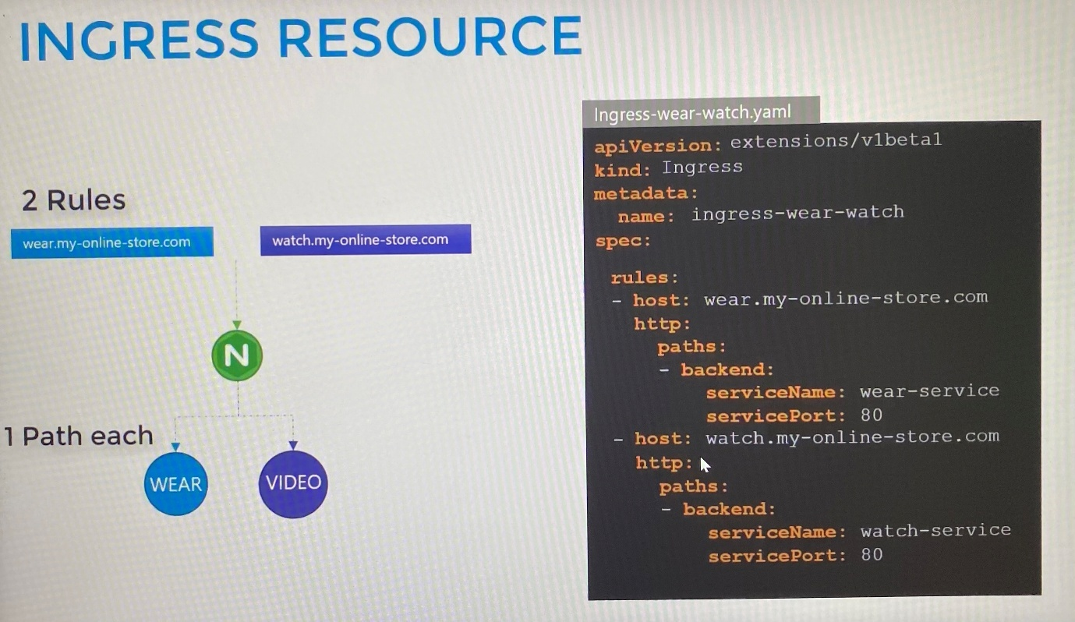

-All traffic from these domain names will be routed to the appropriate backend, irrespective of the URL path. You can still have multiple paths specifications in each of these host to handle different URL paths.

* means any hosts are applicable for ingress resource

Default backend shows the user traffic directs to which backend if any path doesn't match

As best practice, we create ingress resource in same namespace that has backend services and deployments

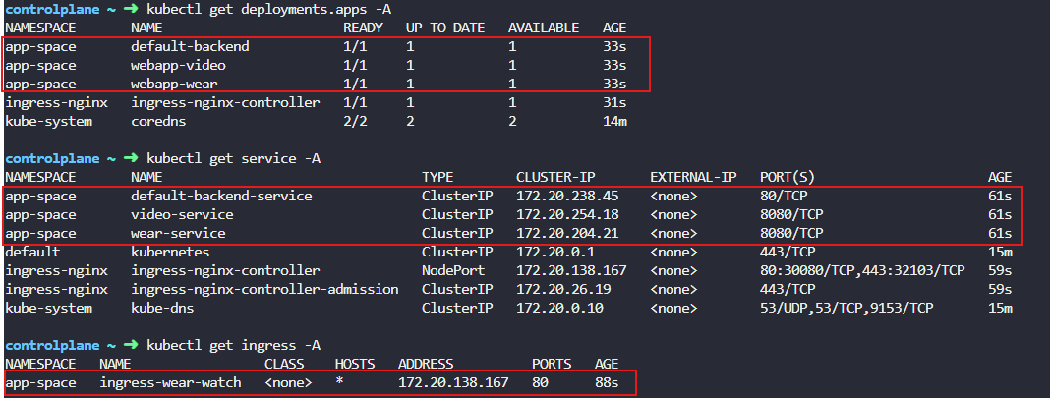

**Imperative method to create ingress:**

kubectl create ingress NAME --rule=host/path=service:port[,tls[=secret]] [options]

controlplane ~ ✖ kubectl create ingress ingress-pay -n critical-space --rule="/pay=pay-service:8282"

ingress.networking.k8s.io/ingree-pay created

If no specific host for ingress resource, leave host section rule option.

**If no response to path specified, check the logs on pod in the deployment that application is hosted.

Also check the logs on ingress controller pod, if the HTTP error is **308 Permanent redirects** which rewrite target, check the error on the browser is ERR_TOO_MANY_REDIRECTS which SSL redirects(redirects HTTP to HTTPS, it is related to configure ***rewrite target*** and ***SSL redirects***

**annotations:**

**nginx.ingress.kubernetes.io/rewrite-target: /**

**nginx.ingress.kubernetes.io/ssl-redirects: "false"**

controlplane ~ ➜ kubectl logs webapp-pay-6888bbb889-454fh -n critical-space

* Serving Flask app 'app' (lazy loading)

* Environment: production

WARNING: This is a development server. Do not use it in a production deployment.

Use a production WSGI server instead.

* Debug mode: off

* Running on all addresses.

WARNING: This is a development server. Do not use it in a production deployment.

* Running on <http://172.17.0.11:8080/> (Press CTRL+C to quit)

172.17.0.9 - - [24/Jan/2025 04:39:47] "GET /pay HTTP/1.1" 404 -

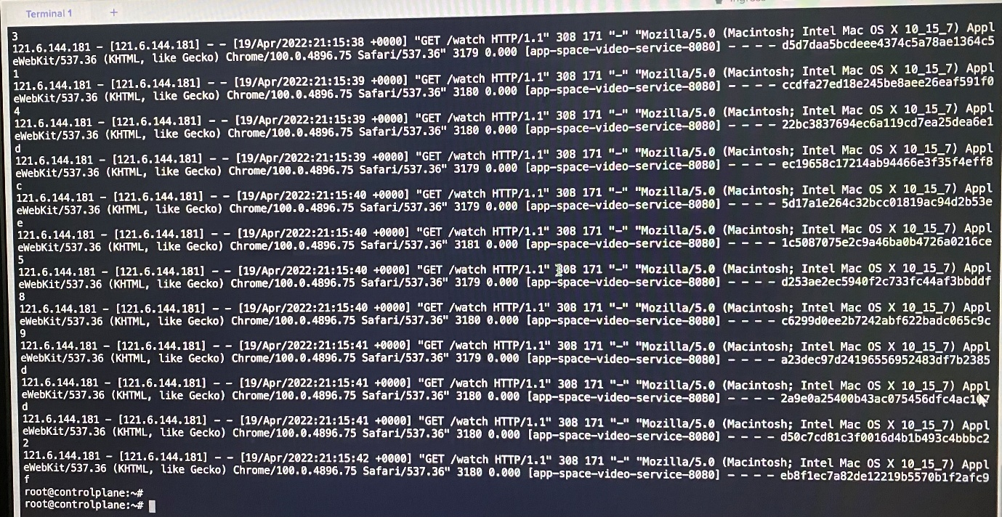

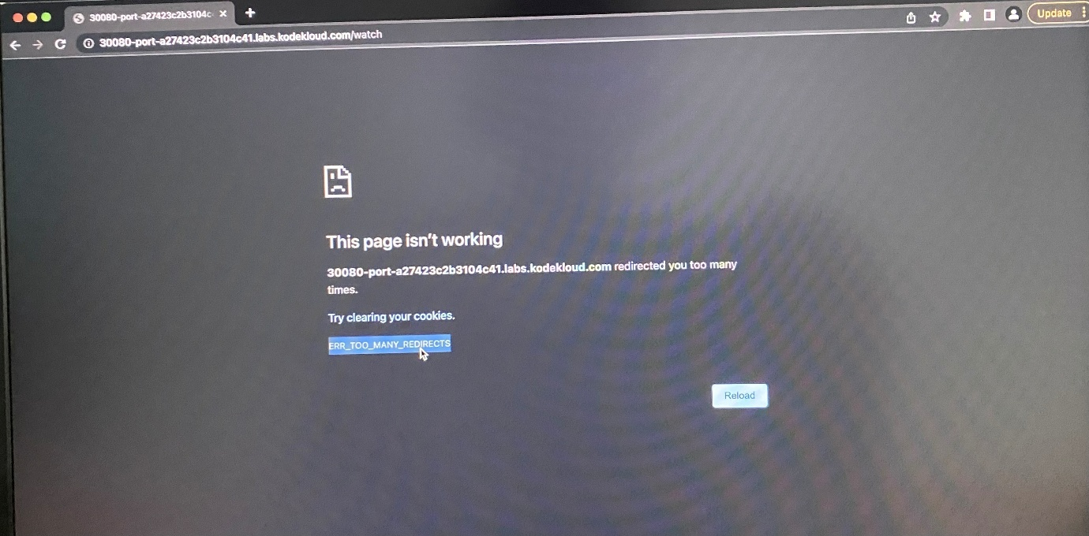

Without the rewrite-target option, this is what would happen:

http://<ingress-service>:<ingress-port>/watch --> http://<watch-service>:<port>/watch

http://<ingress-service>:<ingress-port>/wear --> http://<wear-service>:<port>/wear

Notice watch and wear at the end of the target URLs. The target applications are not configured with /watch or /wear paths. They are different applications built specifically for their purpose, so they don't expect /watch or /wear in the URLs. And as such the requests would fail and throw a 404 not found error.

To fix that we want to "ReWrite" the URL when the request is passed on to the watch or wear applications. We don't want to pass in the same path that user typed in. So we specify the rewrite-target option. This rewrites the URL by replacing whatever is under rules->http->paths->path which happens to be /pay in this case with the value in rewrite-target. This works just like a search and replace function.

For example: replace(path, rewrite-target)

In our case: replace("/path","/")

apiVersion: networking.k8s.io/v1

kind: Ingress

metadata:

creationTimestamp: "2025-01-24T04:39:01Z"

generation: 1

name: ingree-pay

namespace: critical-space

resourceVersion: "3861"

uid: e834c375-7a4a-46af-8d5a-63c4eb574cd5

**annotations:**

**nginx.ingress.kubernetes.io/rewrite-target: /**

spec:

rules:

- http:

paths:

- backend:

service:

name: pay-service

port:

number: 8282

path: /pay

pathType: Exact

status:

loadBalancer:

ingress:

- ip: 172.20.31.162

--------------------------------------------------------------

apiVersion: networking.k8s.io/v1

kind: Ingress

metadata:

annotations:

nginx.ingress.kubernetes.io/rewrite-target: /

nginx.ingress.kubernetes.io/ssl-redirect: "false"

creationTimestamp: "2025-01-24T00:43:58Z"

generation: 1

name: ingress-wear-watch

namespace: app-space

resourceVersion: "1113"

uid: d02f2db4-6700-4115-9c82-af7afc4eb1f2

spec:

rules:

- http:

paths:

- backend:

service:

name: wear-service

port:

number: 8080

path: /wear

pathType: Prefix

- backend:

service:

name: video-service

port:

number: 8080

path: /watch

pathType: Prefix

status:

loadBalancer:

ingress:

- ip: 172.20.228.167

controlplane ~ ➜ kubectl describe ingress ingress-wear-watch -n app-space

Name: ingress-wear-watch

Labels: <none>

Namespace: app-space

Address: 172.20.228.167

Ingress Class: <none>

Default backend: <default>

Rules:

Host Path Backends

---- ---- --------

*

/wear wear-service:8080 (172.17.0.4:8080)

/watch video-service:8080 (172.17.0.5:8080)

Annotations: nginx.ingress.kubernetes.io/rewrite-target: /

nginx.ingress.kubernetes.io/ssl-redirect: false

Events:

Type Reason Age From Message

---- ------ ---- ---- -------

Normal Sync 87s (x2 over 87s) nginx-ingress-controller Scheduled for sync

**Article: Ingress**

In this article, we will see what changes have been made in previous and current versions in Ingress.

Like in apiVersion, serviceName and servicePort etc.

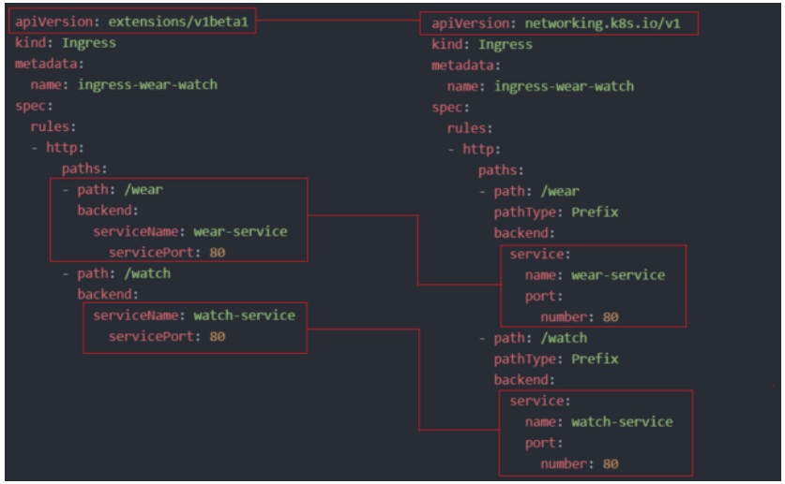

Now, in k8s version 1.20+ we can create an Ingress resource from the imperative way like this:-

**Format : kubectl create ingress <ingress-name> --rule="host/path=service:port"**

**Example : kubectl create ingress ingress-test --rule="wear.my-online-store.com/wear*=wear-service:80"**

Find more information and examples in the below reference link:-

<https://kubernetes.io/docs/reference/generated/kubectl/kubectl-commands#-em-ingress-em>-

References:-

<https://kubernetes.io/docs/concepts/services-networking/ingress>

<https://kubernetes.io/docs/concepts/services-networking/ingress/#path-types>

**Ingress - Annotations and rewrite-target**

Different ingress controllers have different options that can be used to customise the way it works. NGINX Ingress controller has many options that can be seen here [Introduction - Ingress-Nginx Controller](https://kubernetes.github.io/ingress-nginx/examples/). I would like to explain one such option that we will use in our labs. The Rewrite target option. [Rewrite - Ingress-Nginx Controller](https://kubernetes.github.io/ingress-nginx/examples/rewrite/)

Our *watch* app displays the video streaming webpage at http://<watch-service>:<port>/

Our *wear* app displays the apparel webpage at http://<wear-service>:<port>/

We must configure Ingress to achieve the below. When user visits the URL on the left, his request should be forwarded internally to the URL on the right. Note that the /watch and /wear URL path are what we configure on the ingress controller so we can forwarded users to the appropriate application in the backend. The applications don't have this URL/Path configured on them:

http://<ingress-service>:<ingress-port>/watch --> http://<watch-service>:<port>/

http://<ingress-service>:<ingress-port>/wear --> http://<wear-service>:<port>/

Without the rewrite-target option, this is what would happen:

http://<ingress-service>:<ingress-port>/watch --> http://<watch-service>:<port>/watch

http://<ingress-service>:<ingress-port>/wear --> http://<wear-service>:<port>/wear

Notice watch and wear at the end of the target URLs. The target applications are not configured with /watch or /wear paths. They are different applications built specifically for their purpose, so they don't expect /watch or /wear in the URLs. And as such the requests would fail and throw a 404 not found error.

To fix that we want to "ReWrite" the URL when the request is passed on to the watch or wear applications. We don't want to pass in the same path that user typed in. So we specify the rewrite-target option. This rewrites the URL by replacing whatever is under rules->http->paths->path which happens to be /pay in this case with the value in rewrite-target. This works just like a search and replace function.

For example: replace(path, rewrite-target)

In our case: replace("/path","/")

apiVersion: extensions/v1beta1

kind: Ingress

metadata:

name: test-ingress

namespace: critical-space

annotations:

nginx.ingress.kubernetes.io/rewrite-target: /

spec:

rules:

- http:

paths:

- path: /pay

backend:

serviceName: pay-service

servicePort: 8282

In another example given here, this could also be:

replace("/something(/|$)(.*)", "/$2")

apiVersion: extensions/v1beta1

kind: Ingress

metadata:

annotations:

nginx.ingress.kubernetes.io/rewrite-target: /$2

name: rewrite

namespace: default

spec:

rules:

- host: rewrite.bar.com

http:

paths:

- backend:

serviceName: http-svc

servicePort: 80

path: /something(/|$)(.*)

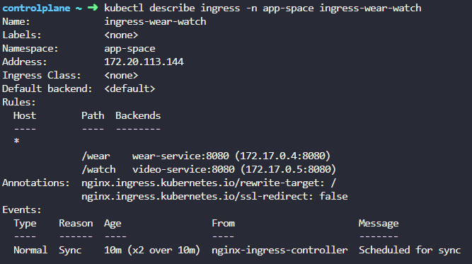

-------------------------------------------------------------------------------------------------------------

apiVersion: apps/v1

kind: Deployment

metadata:

labels:

app.kubernetes.io/component: controller

app.kubernetes.io/instance: ingress-nginx

app.kubernetes.io/managed-by: Helm

app.kubernetes.io/name: ingress-nginx

app.kubernetes.io/part-of: ingress-nginx

app.kubernetes.io/version: 1.1.2

helm.sh/chart: ingress-nginx-4.0.18

name: ingress-nginx-controller

namespace: ingress-

spec:

minReadySeconds: 0

revisionHistoryLimit: 10

selector:

matchLabels:

app.kubernetes.io/component: controller

app.kubernetes.io/instance: ingress-nginx

app.kubernetes.io/name: ingress-nginx

template:

metadata:

labels:

app.kubernetes.io/component: controller

app.kubernetes.io/instance: ingress-nginx

app.kubernetes.io/name: ingress-nginx

spec:

containers:

- args:

- /nginx-ingress-controller

- --publish-service=$(POD_NAMESPACE)/ingress-nginx-controller

- --election-id=ingress-controller-leader

- --watch-ingress-without-class=true

- --default-backend-service=app-space/default-http-backend

- --controller-class=k8s.io/ingress-nginx

- --ingress-class=nginx

- --configmap=$(POD_NAMESPACE)/ingress-nginx-controller

- --validating-webhook=:8443

- --validating-webhook-certificate=/usr/local/certificates/cert

- --validating-webhook-key=/usr/local/certificates/key

env:

- name: POD_NAME

valueFrom:

fieldRef:

fieldPath: metadata.name

- name: POD_NAMESPACE

valueFrom:

fieldRef:

fieldPath: metadata.namespace

- name: LD_PRELOAD

value: /usr/local/lib/libmimalloc.so

image: registry.k8s.io/ingress-nginx/controller:v1.1.2@sha256:28b11ce69e57843de44e3db6413e98d09de0f6688e33d4bd384002a44f78405c

imagePullPolicy: IfNotPresent

lifecycle:

preStop:

exec:

command:

- /wait-shutdown

livenessProbe:

failureThreshold: 5

httpGet:

path: /healthz

port: 10254

scheme: HTTP

initialDelaySeconds: 10

periodSeconds: 10

successThreshold: 1

timeoutSeconds: 1

name: controller

ports:

- name: http

containerPort: 80

protocol: TCP

- containerPort: 443

name: https

protocol: TCP

- containerPort: 8443

name: webhook

protocol: TCP

readinessProbe:

failureThreshold: 3

httpGet:

path: /healthz

port: 10254

scheme: HTTP

initialDelaySeconds: 10

periodSeconds: 10

successThreshold: 1

timeoutSeconds: 1

resources:

requests:

cpu: 100m

memory: 90Mi

securityContext:

allowPrivilegeEscalation: true

capabilities:

add:

- NET_BIND_SERVICE

drop:

- ALL

runAsUser: 101

volumeMounts:

- mountPath: /usr/local/certificates/

name: webhook-cert

readOnly: true

dnsPolicy: ClusterFirst

nodeSelector:

kubernetes.io/os: linux

serviceAccountName: ingress-nginx

terminationGracePeriodSeconds: 300

volumes:

- name: webhook-cert

secret:

secretName: ingress-nginx-admission

---

apiVersion: v1

kind: Service

metadata:

creationTimestamp: null

labels:

app.kubernetes.io/component: controller

app.kubernetes.io/instance: ingress-nginx

app.kubernetes.io/managed-by: Helm

app.kubernetes.io/name: ingress-nginx

app.kubernetes.io/part-of: ingress-nginx

app.kubernetes.io/version: 1.1.2

helm.sh/chart: ingress-nginx-4.0.18

name: ingress-controller

namespace: ingress-nginx

spec:

ports:

- port: 80

protocol: TCP

targetPort: 80

nodeport: 30080

selector:

app.kubernetes.io/component: controller

app.kubernetes.io/instance: ingress-nginx

app.kubernetes.io/name: ingress-nginx

type: NodePort

---------------------------------------------------------------------------------------------------------

**Gateway API**

With Ingress, two services share the same ingress resource. What if each service was managed by different team or organization. In such case, the underlying Ingress resource is still a single resource, which can only be managed by one team at a time. Ingress can pose following challenges and limitations.

-No multi-tenancy

-No namespace isolation

-No RBAC for features

-No Resource isolation

-Only supports HTTP based rules such as host matching or path matching

Ingress has no native support for followings instead they all must be configured by ingress controllers itself.

-TCP/UDP routing

-Traffic splitting/weighting

-Header manipulation

-Authentication

-Rate limiting

-Redirects

-Rewriting

-Middleware

-Websocket support

-Custom error pages

-Session affinity

-Cross-origin resource sharing (CORS)

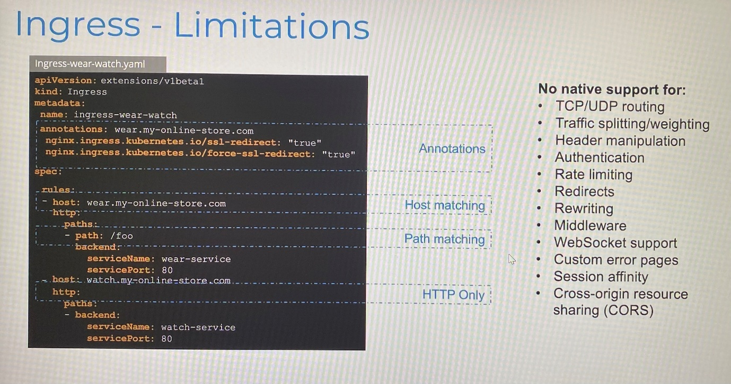

These configurations such as SSL redirect, CORS are passed to controllers using complex annotations specified in Ingress. The challenge is that these configurations are very specific to the underlying controllers we use such as NGINX or traefik for the same use case. Further Kubernetes itself is not aware of these settings and it can't validate whether the settings are correct or wrong

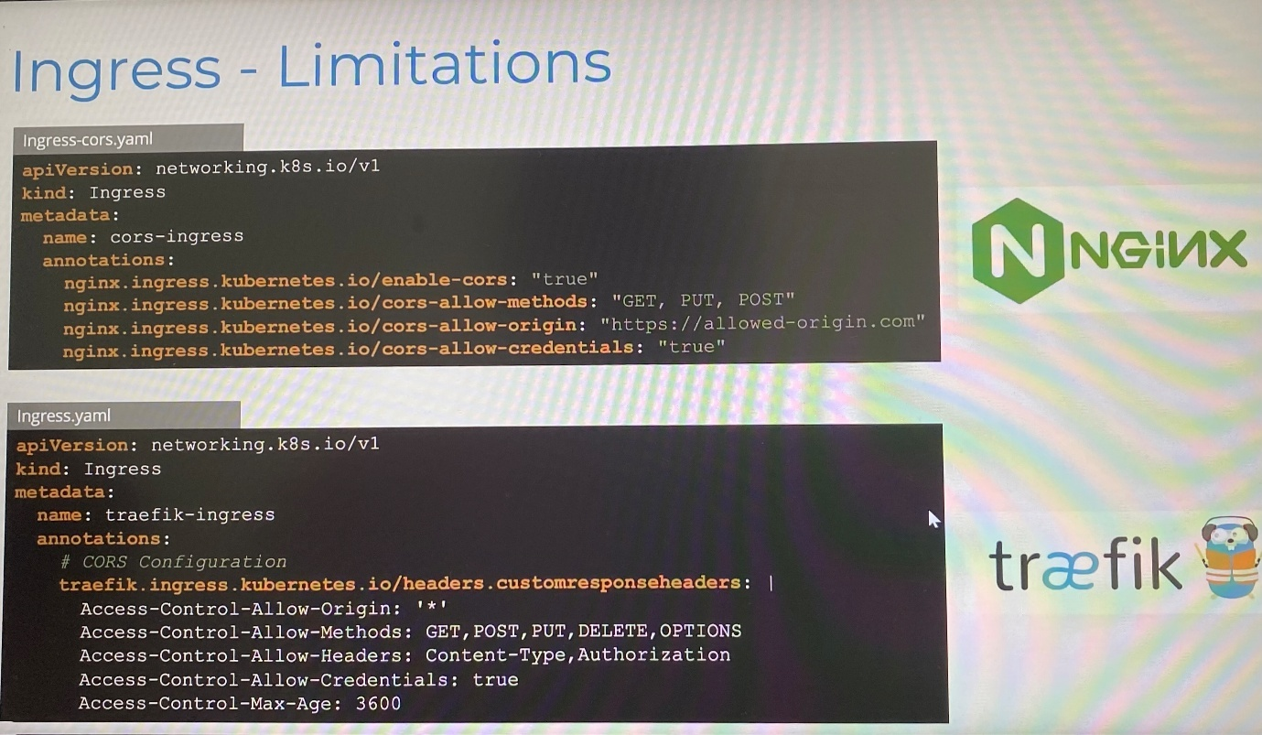

That's where Gateway APIs come in. Gateway API is an official Kubernetes project focused on L4 and l7 routing. This projects represents next generation of Kubernetes Ingress, Load Balancing, Service Mesh APIs.

Gateway APIs introduces three separate objects that are managed by sperate team by providing different teams to access same infrastructure while maintaining control by the owners of the infrastructure.

**Team name**

**Object name**

**Functions**

Infrastructure Providers

GatewayClass

Define underlying network infrastructure such as NGINX, Traefik or other load balancers

Cluster Operators

Gateway

Configure gateway which are instances of the GatewayClass

Application Developers

HTTPRoute, TCPRoute, GRPCRoute

Create HTTPRoute or other objects

The Gateway resource is used to define an instance of a Gateway API implementation. It acts as an entry point for traffic into the cluster. GatewayClass defines a type of Gateway(i.e., the controller and its capabilities), but does not create an actual Gateway instance. To actually deploy a Gateway that routes traffic, you must create a Gateway resource.

Deploy controller for gateway

-------gateway-class.yaml------------------------

apiVersion: gateway.networking.k8s.io/v1

kind: GatewayClass

metadata:

name: example-class

spec:

controllerName: example.com/gateway-controller

Deploy gateway object

---------gateway.yaml-------------------------

apiVersion: gateway.networking.k8s.io/v1

kind: Gateway

metadata:

name: example-gateway

spec:

gatewayClassName: example-class ; specify the gateway class created

listeners:

- name: http

protocol: HTTP

port: 80

Deploy HTTPRoute rule

---------http-route.yaml-------------------------

apiVersion: gateway.networking.k8s.io/v1

kind: HTTPRoute

metadata:

name: example-httproute

spec:

parentRefs:

- name: example-gateway ; specify the gateway instance we defined

hostnames:

- "[www.example.com](http://www.example.com)"

rules:

- matches:

- path:

type: PathPrefix

value: /login

backendRefs:

- name: example-svc

port: 8080

In this example, the HTTP traffic from gateway example-gateway with the host header set [www.example.com](http://www.example.com) and the request path specified as login will be routed to service example-svc on port 8080.

The **allowedRoutes** field in a Gateway listener determines which namespaces and types of Routes (like HTTPRoute, TCPRoute, etc.) are allowed to attach to that Gateway.

By default, only Routes in the same namespace as the Gateway can attach.

Setting namespaces.from: All allows Routes from all namespaces to attach.

You can also restrict which kinds of Routes can attach using the kinds field.

This enables fine-grained access control and safe multi-tenant routing.

spec:

listeners:

- name: http

port: 80

protocol: HTTP

allowedRoutes:

namespaces:

from: All # Allows Routes from all namespaces to attach

kinds:

- group: gateway.networking.k8s.io

kind: HTTPRoute

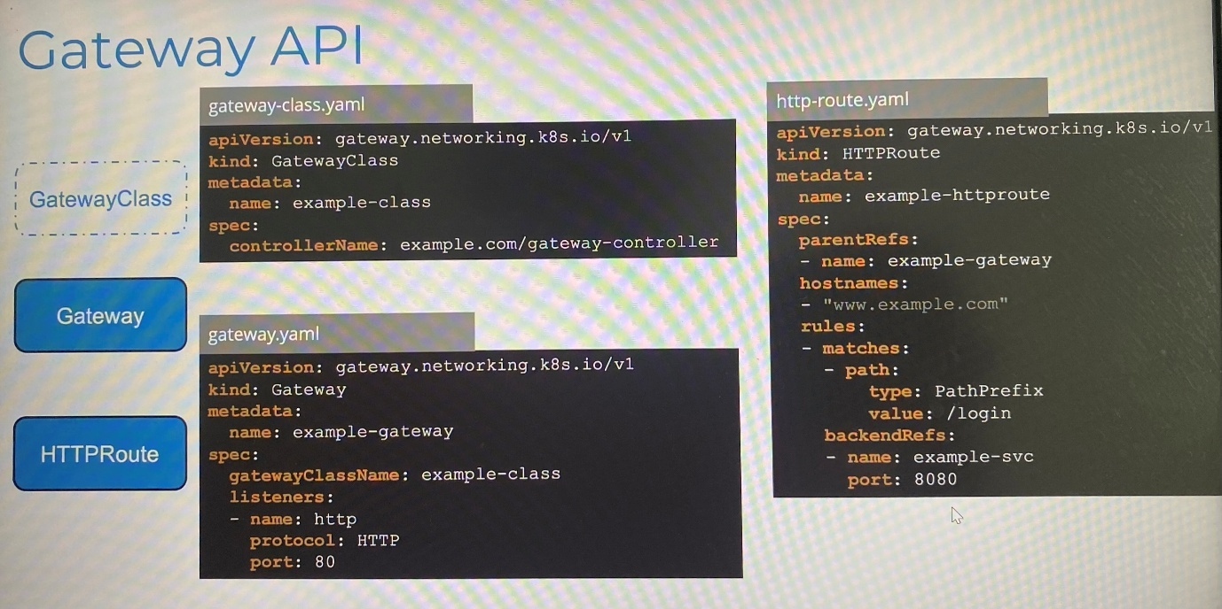

Some of additional route options available are TCPRoute, UDPRoute, TLSRoute and GRPCRoute.

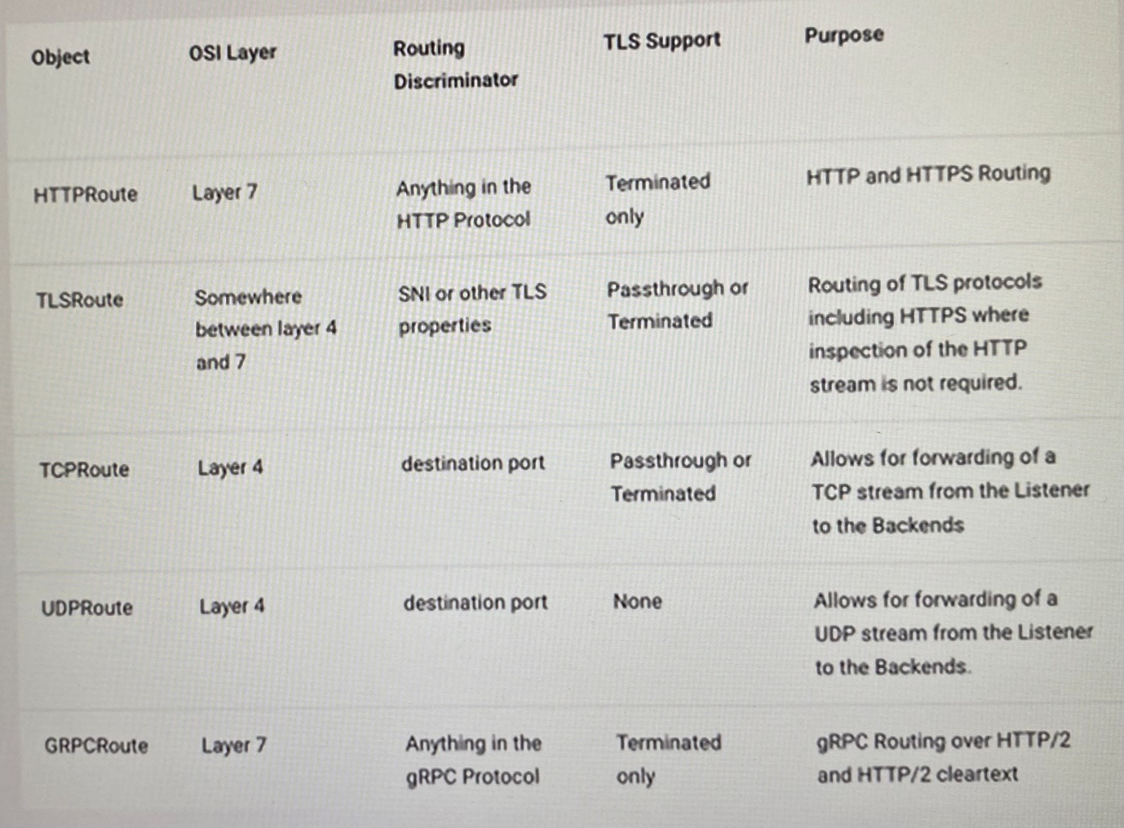

***Ingress vs Gateway API***

*With ingress, the basic TLS configuration specifies in spec.tls[].secretName section and ensure all traffic uses HTTPS by redirecting HTTP to HTTPS using NGINX specific annotation. But it won't work for other Ingress controllers.

*With Gateway API, it is more declarative and structured approach, no annotations needed. The **listeners** section shows setting HTTPS endpoint on port 443, **tls** configuration is explicit with the **mode** Terminate showing terminating TLS at the gateway, **certificateRefs** refers tls-secret, **allowRoutes** specifies the kind of routes can attach to listener such as HTTPRoute

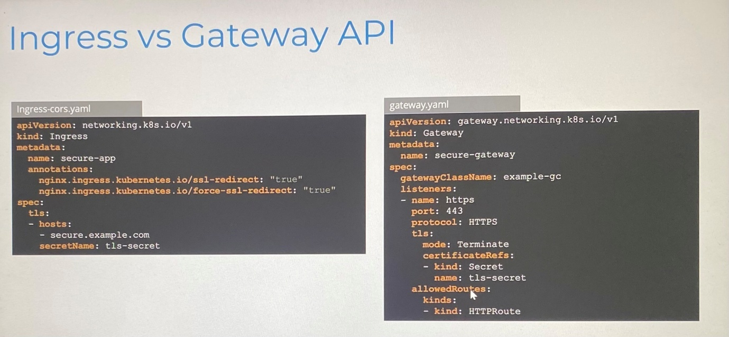

*With Ingress, we configure canary deployment to route 20% traffic to secondary Ingress and remaining 80% traffic automatically routes to the primary ingress by using NGINX annotations. But other controllers might not understand these annotations.

*With Gateway API, all configuration is visible in one place, no hidden primary configuration needed. In the **backendRefs** section, traffic split is explicitly defined between services with percentage. No annotations needed and these configuration work with any controller.

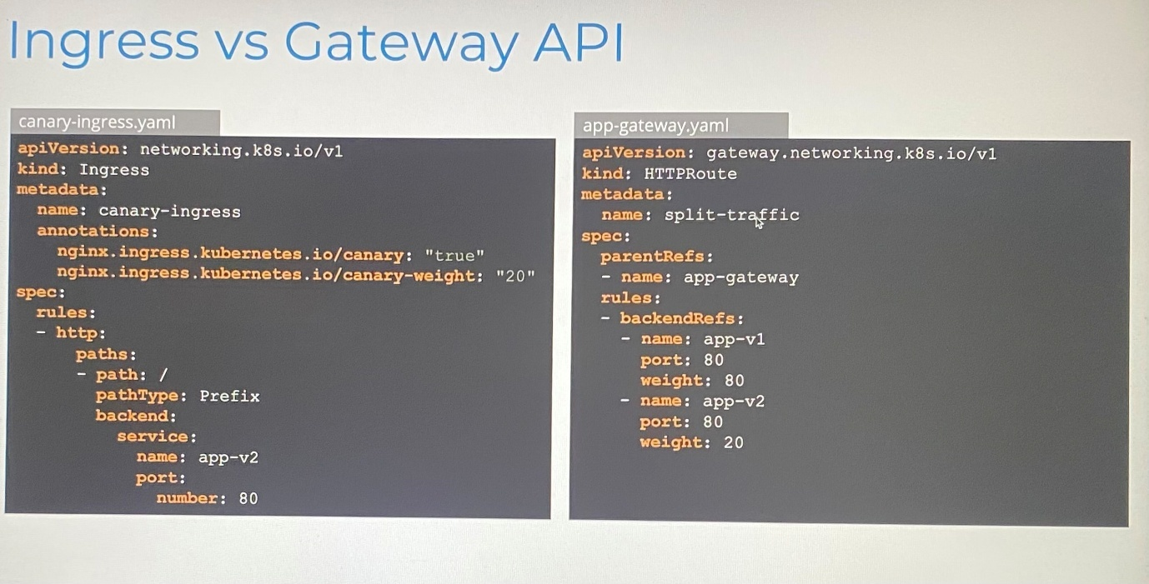

*Complex controller-specific annotations needed for CORS settings whereas no annotations needed with Gateway API. CORS headers are explicitly defined using **responseHeaderModifier** filter. The configuration is more readable and self documenting

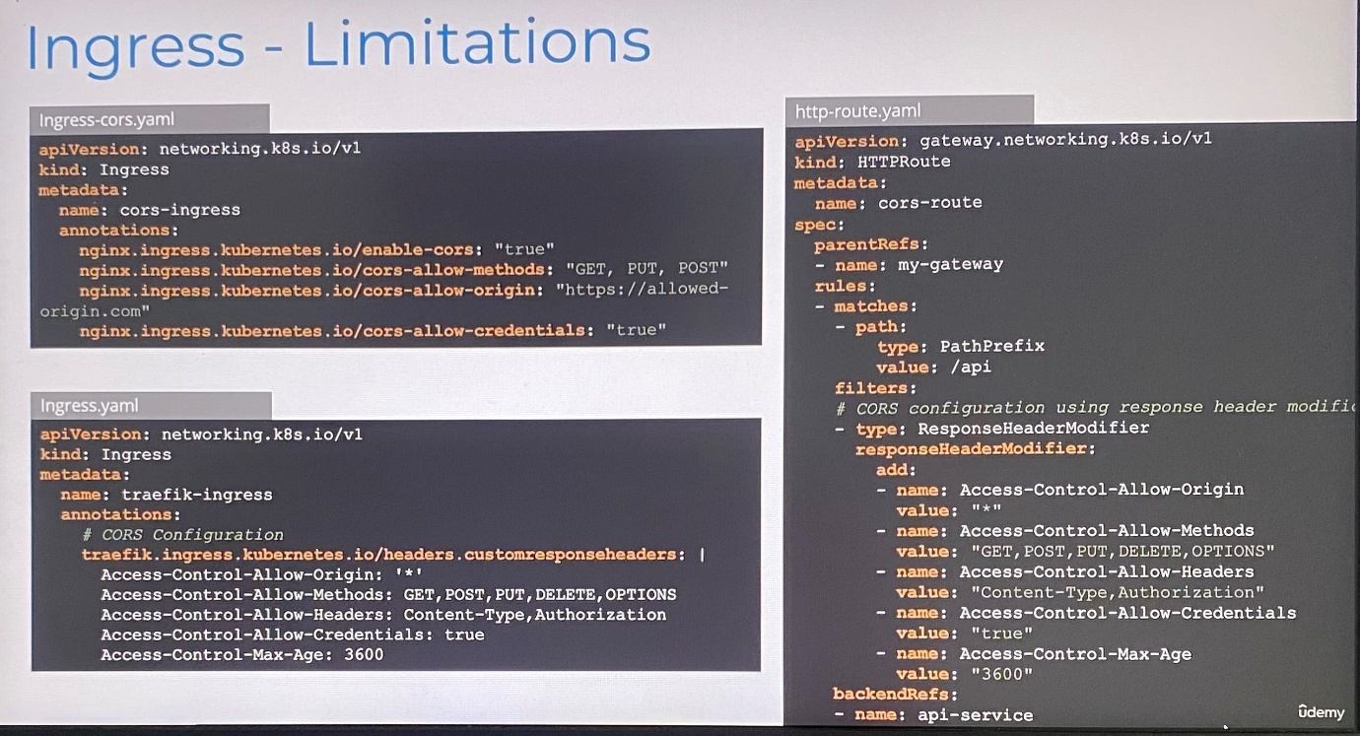

*Most controllers have implemented Gateway API and on the way to implement it. Amazon EKS, Azure Application Gateway for Containers, Contour, Easegress, Envoy Gateway, Google Kubernetes Engine, HAProxy Kubernetes Ingress Controller, Istio, Kong, Kuma, NGINX Gateway Fabric, Traefik Proxy

**Kubernetes Gateway API: A Practical Guide Using NGINX**

This guide introduces the Kubernetes **Gateway API**, a modern and extensible approach to managing ingress and traffic routing in Kubernetes. While we'll be using the **NGINX Gateway Controller** for demonstration, the concepts and APIs are **implementation-agnostic** and apply across different **Gateway API**-compatible controllers.

📚 Official Docs: [**gateway-api.sigs.k8s.io**](https://gateway-api.sigs.k8s.io/)

1. Installing **Gateway API** with NGINX

The **Gateway API** defines custom resources, but a controller is needed to implement them. For this demo, we’ll use the **NGINX Gateway Controller**, which supports all standard **Gateway API** resources.

To install the **NGINX Gateway Controller**, run the following commands:

kubectl kustomize "<https://github.com/nginx/nginx-gateway-fabric/config/crd/gateway-api/standard?ref=v1.6.2>" | kubectl apply -f -

kubectl kustomize "<https://github.com/nginx/nginx-gateway-fabric/config/crd/gateway-api/experimental?ref=v1.6.2>" | kubectl apply -f -

helm install ngf oci://ghcr.io/nginx/charts/nginx-gateway-fabric --create-namespace -n nginx-gateway

What this does:

Installs the **NGINX Gateway Controller**, along with the **Gateway API Custom Resource Definitions** (CRDs) and related resources.

🔗 [**NGINX Gateway Fabric Reference**](https://docs.nginx.com/nginx-gateway-fabric/installation/installing-ngf/helm/)

2. **GatewayClass** Definition

A **GatewayClass** defines a set of Gateways that are implemented by a specific controller. Think of it as a blueprint that tells Kubernetes which controller will manage the Gateways.

Purpose

Decouples Gateway configuration from the actual implementation: This allows you to define Gateways without worrying about the underlying controller.

Supports multiple gateway implementations in a single cluster: For example, you can have both NGINX and Istio Gateways in the same Kubernetes cluster.

Here’s an example of a **GatewayClass**:

apiVersion: gateway.networking.k8s.io/v1

kind: GatewayClass

metadata:

name: nginx

spec:

controllerName: nginx.org/gateway-controller

Explanation:

**controllerName**: This must match the **name** expected by your controller (e.g., **nginx.org/gateway-controller** for NGINX). It tells Kubernetes which controller will manage Gateways of this class.

🔗 **[GatewayClass Reference](https://gateway-api.sigs.k8s.io/api-types/gatewayclass/)**

3. Configuring **HTTP** Gateway and Listener

A Gateway is a Kubernetes resource that defines how traffic enters your cluster. It specifies the protocols, ports, and routing **rules** for incoming traffic.

Here’s an example of a Gateway that listens for **HTTP** traffic:

apiVersion: gateway.networking.k8s.io/v1

kind: Gateway

metadata:

name: nginx-gateway

namespace: default

spec:

gatewayClassName: nginx

listeners:

- name: http

protocol: HTTP

port: 80

allowedRoutes:

namespaces:

from: All

Explanation:

**gatewayClassName**: Refers to the **GatewayClass** (e.g., nginx) that will manage this Gateway.

**listeners**: Defines how the Gateway listens for traffic.

**name**: A unique **name** for this listener.

**protocol**: Specifies that this listener will handle **HTTP** traffic.

**port**: The **port** number on which the Gateway will listen for **HTTP** traffic.

**allowedRoutes**: Specifies which namespaces can define routes for this Gateway. Here, **from: All** allows routes from all namespaces.

This configuration sets up a Gateway to handle **HTTP** traffic on **port** 80 and forward it to the appropriate backend services.

4. **HTTP** Routing

An **HTTPRoute** defines how **HTTP** traffic is forwarded to Kubernetes services. It works in conjunction with a Gateway to route requests based on specific **rules**, such as matching paths or headers.

Here’s an example of an **HTTPRoute**:

apiVersion: gateway.networking.k8s.io/v1

kind: HTTPRoute

metadata:

name: basic-route

namespace: default

spec:

parentRefs:

- name: nginx-gateway

rules:

- matches:

- path:

type: PathPrefix

value: /app

backendRefs:

- name: my-app

port: 80

Explanation:

**parentRefs**: Links this route to a specific Gateway (e.g., **nginx-gateway**).

**rules**: Defines how traffic is routed.

**matches**: Specifies the conditions for matching traffic.

**path**: Matches requests with a specific path prefix (e.g., **/app**).

**backendRefs**: Specifies the backend **service** (e.g., **my-app**) and **port** (e.g., **80**) to which the traffic should be forwarded.

This configuration routes all requests with the path prefix **/app** to **my-app** **service** on **port** **80**.

[**HTTP Routing Guide**](https://gateway-api.sigs.k8s.io/guides/http-routing/)

5. **HTTP** Redirects and Rewrites

Redirects and rewrites are powerful tools for modifying incoming requests before they reach the backend **service**.

Example: **HTTP** to **HTTPS** Redirect Redirects are used to force traffic to a different scheme (e.g., **HTTP** to **HTTPS**). Here’s an example:

Example: **HTTP** to **HTTPS** Redirect

apiVersion: gateway.networking.k8s.io/v1

kind: HTTPRoute

metadata:

name: https-redirect

namespace: default

spec:

parentRefs:

- name: nginx-gateway

rules:

- filters:

- type: RequestRedirect

requestRedirect:

scheme: https

Explanation:

**filters**: Defines additional processing for requests.

**type: RequestRedirect**: Specifies that this filter will redirect requests.

**requestRedirect.scheme**: Redirects all **HTTP** requests to **HTTPS**.

This configuration ensures that all incoming **HTTP** traffic is redirected to **HTTPS**, improving security.

🔗 [**HTTP Redirects Guide**](https://gateway-api.sigs.k8s.io/guides/http-redirect-rewrite/)

Example: Path Rewrite

Rewrites modify the request path before forwarding it to the backend. Here’s an example:

apiVersion: gateway.networking.k8s.io/v1

kind: HTTPRoute

metadata:

name: rewrite-path

namespace: default

spec:

parentRefs:

- name: nginx-gateway

rules:

- matches:

- path:

type: PathPrefix

value: /old

filters:

- type: URLRewrite

urlRewrite:

path:

replacePrefixMatch: /new

backendRefs:

- name: my-app

port: 80

Explanation:

**matches.path**: Matches requests with the path prefix **/old**.

**filters.type: URLRewrite**: Specifies that this filter will rewrite the URL.

**replacePrefixMatch: /new**: Replaces the **/old** prefix with **/new**.

**backendRefs**: Forwards the modified request to **my-app** **service** on **port** **80**.

This configuration rewrites requests from **/old** to **/new** before sending them to the backend.

🔗 [**HTTP Rewrite Guide**](https://gateway-api.sigs.k8s.io/guides/http-redirect-rewrite/)

6. **HTTP** Header Modification

You can modify **HTTP** headers in requests or responses to add, set, or remove specific headers.

Here’s an example:

apiVersion: gateway.networking.k8s.io/v1

kind: HTTPRoute

metadata:

name: header-mod

namespace: default

spec:

parentRefs:

- name: nginx-gateway

rules:

- filters:

- type: RequestHeaderModifier

requestHeaderModifier:

add:

x-env: staging

backendRefs:

- name: my-app

port: 80

Explanation:

**filters.type: RequestHeaderModifier**: Specifies that this filter will modify request headers.

**add.x-env**: Adds a custom header (x-env) with the value staging.

**backendRefs**: Forwards the modified request to the my-app **service** on **port** 80.

This configuration is useful for adding **metadata** to requests, such as environment-specific headers.

🔗 [**HTTP Header Guide**](https://gateway-api.sigs.k8s.io/guides/http-header-modifier/)

7. **HTTP** Traffic Splitting

Traffic splitting allows you to distribute traffic between multiple backend services. This is often used for canary deployments or A/B testing.

Here’s an example:

apiVersion: gateway.networking.k8s.io/v1

kind: HTTPRoute

metadata:

name: traffic-split

namespace: default

spec:

parentRefs:

- name: nginx-gateway

rules:

- backendRefs:

- name: v1-service

port: 80

weight: 80

- name: v2-service

port: 80

weight: 20

Explanation:

**backendRefs**: Specifies the backend services and their weights.

**weight: 80**: Sends 80% of traffic to v1-**service**.

**weight: 20**: Sends 20% of traffic to v2-**service**.

This configuration splits traffic between two services, with most traffic going to v1-**service**.

🔗 [**HTTP Traffic Splitting Guide**](https://gateway-api.sigs.k8s.io/guides/traffic-splitting/)

8. **HTTP** Request Mirroring

Request mirroring allows you to send a copy of incoming requests to a secondary **service** for testing or analysis, without affecting the primary **service**.

Here’s an example:

apiVersion: gateway.networking.k8s.io/v1

kind: HTTPRoute

metadata:

name: request-mirror

namespace: default

spec:

parentRefs:

- name: nginx-gateway

rules:

- filters:

- type: RequestMirror

requestMirror:

backendRef:

name: mirror-service

port: 80

backendRefs:

- name: my-app

port: 80

Explanation:

**filters.type: RequestMirror**: Specifies that this filter will mirror requests.

**requestMirror.backendRef**: Points to the secondary **service** **mirror-service** that will receive the mirrored requests.

**backendRefs**: Forwards the original request to the primary **service** **my-app**.

This configuration is useful for testing new services or analyzing traffic patterns without impacting production.

🔗 [**HTTP Traffic Request Guide**](https://gateway-api.sigs.k8s.io/guides/http-request-mirroring/)

9. **TLS** Configuration

**TLS** (Transport Layer Security) is used to encrypt traffic between clients and servers, ensuring secure communication. In Kubernetes, you can terminate **TLS** traffic at the Gateway level by using a certificate stored in a Kubernetes **Secret**. This means the Gateway will handle decrypting the traffic before forwarding it to backend services.

**Example: TLS Termination**

The following example demonstrates how to configure a Gateway to terminate **TLS** traffic:

apiVersion: gateway.networking.k8s.io/v1

kind: Gateway

metadata:

name: nginx-gateway-tls

namespace: default

spec:

gatewayClassName: nginx

listeners:

- name: https

protocol: HTTPS

port: 443

tls:

mode: Terminate

certificateRefs:

- kind: Secret

name: tls-secret

allowedRoutes:

namespaces:

from: All

Explanation:

**protocol**: Specifies that this listener will handle **HTTPS** traffic.

**tls.mode**: Indicates that the Gateway will terminate the **TLS** connection (decrypt the traffic).

**certificateRefs**: Points to a Kubernetes **Secret** (e.g., **tls-secret**) that contains the **TLS** certificate and private key.

**allowedRoutes**: Configures which namespaces can define routes for this Gateway. Here, from: All allows routes from all namespaces.

This setup is commonly used for secure communication between clients and the Gateway, while backend services receive unencrypted traffic.

🔗 [**TLS Configuration Guide**](https://gateway-api.sigs.k8s.io/guides/tls/)

10. **TCP**, **UDP**, and Other Protocols

The **Gateway API** supports more than just **HTTP** traffic. You can configure Gateways to handle protocols like **TCP**, **UDP**, and even **gRPC**. This flexibility makes it suitable for a wide range of applications, such as databases, DNS servers, and microservices.

**TCP** Example

**TCP** is a connection-oriented **protocol** often used for applications like databases. The following example shows how to configure a Gateway for **TCP** traffic:

apiVersion: gateway.networking.k8s.io/v1

kind: Gateway

metadata:

name: tcp-gateway

namespace: default

spec:

gatewayClassName: nginx

listeners:

- name: tcp

protocol: TCP

port: 3306

allowedRoutes:

namespaces:

from: All

Explanation:

**protocol**: Specifies that this listener will handle **TCP** traffic.

**port**: The **port** number for the listener, commonly used for MySQL databases.

**allowedRoutes**: Allows routes from all namespaces to use this Gateway.

This configuration is ideal for exposing database services to external clients.

**UDP** Example

**UDP** is a connectionless **protocol** often used for DNS or streaming applications. Here’s an example of a Gateway configured for **UDP** traffic:

apiVersion: gateway.networking.k8s.io/v1

kind: Gateway

metadata:

name: udp-gateway

namespace: default

spec:

gatewayClassName: nginx

listeners:

- name: udp

protocol: UDP

port: 53

allowedRoutes:

namespaces:

from: All

Explanation:

**protocol**: Specifies that this listener will handle **UDP** traffic.

**port**: The **port** number for the listener, commonly used for DNS services.

**allowedRoutes**: Allows routes from all namespaces to use this Gateway.

This setup is useful for exposing DNS services or other **UDP**-based applications.

**gRPC** Example

**gRPC** is a high-performance RPC (Remote Procedure Call) framework often used in microservices. The **Gateway API** supports **gRPC** by using **HTTPRoute** resources. Here’s an example:

apiVersion: gateway.networking.k8s.io/v1

kind: HTTPRoute

metadata:

name: grpc-route

namespace: default

spec:

parentRefs:

- name: nginx-gateway

rules:

- matches:

- method:

service: my.grpc.Service

method: GetData

backendRefs:

- name: grpc-service

port: 50051

Explanation:

**method.service**: Specifies the **gRPC** **service** **name** (e.g., **my.grpc.Service**).

**method.method**: Specifies the **gRPC** **method** to match (e.g., **GetData**).

**backendRefs**: Points to the backend **service** (**grpc-service**) and its **port** **50051**.

This configuration routes **gRPC** requests to the appropriate backend **service**, enabling seamless communication between microservices.

Conclusion

The **Gateway API** enables expressive, structured routing with features like header rewrites, traffic splits, and **protocol** flexibility. Starting with **HTTP** basics lays a strong foundation before incorporating advanced protocols like **TLS** and **TCP**. This ensures a smooth, secure, and scalable ingress strategy in your Kubernetes clusters.

**Important Note about CNI and CKA Exam**

An important tip about deploying Network Addons in a Kubernetes cluster.

 In the upcoming labs, we will work with Network Addons. This includes installing a network plugin in the cluster. While we have used weave-net as an example, please bear in mind that you can use any of the plugins which are described here:

<https://kubernetes.io/docs/concepts/cluster-administration/addons/>

<https://kubernetes.io/docs/concepts/cluster-administration/networking/#how-to-implement-the-kubernetes-networking-model>

In the CKA exam, for a question that requires you to deploy a network addon, unless specifically directed, you may use any of the solutions described in the link above.

However, the documentation currently does not contain a direct reference to the exact command to be used to deploy a third-party network addon.

The links above redirect to third-party/vendor sites or GitHub repositories, which cannot be used in the exam. This has been intentionally done to keep the content in the Kubernetes documentation vendor-neutral.

NOTE: In the official exam, all essential CNI deployment details will be provided.

----------------------------------------------------------------------------------------------------

To use the Gateway API, a controller is required. In this lab, we will install NGINX Gateway Fabric as the controller. Follow these steps to complete the installation:

Install the Gateway API resources

kubectl kustomize "<https://github.com/nginx/nginx-gateway-fabric/config/crd/gateway-api/standard?ref=v1.5.1>" | kubectl apply -f -

Deploy the NGINX Gateway Fabric CRDs

kubectl apply -f <https://raw.githubusercontent.com/nginx/nginx-gateway-fabric/v1.6.1/deploy/crds.yaml>

Deploy NGINX Gateway Fabric

kubectl apply -f <https://raw.githubusercontent.com/nginx/nginx-gateway-fabric/v1.6.1/deploy/nodeport/deploy.yaml>

Verify the Deployment

kubectl get pods -n nginx-gateway

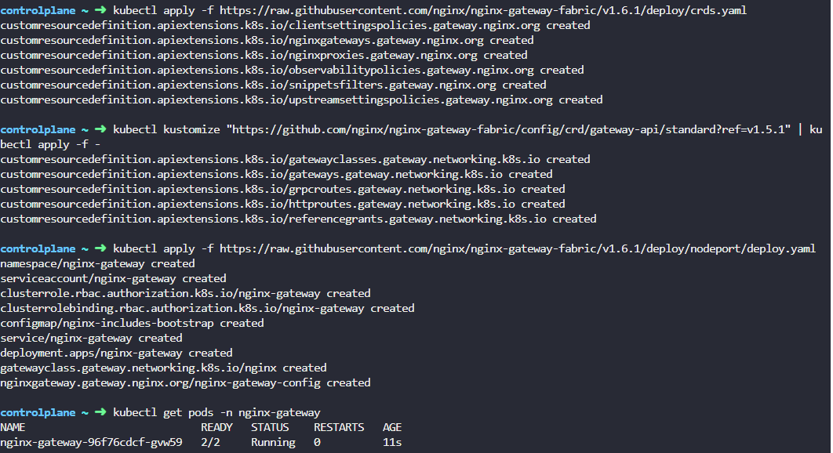

View the nginx-gateway service

kubectl get svc -n nginx-gateway nginx-gateway -o yaml

Update the nginx-gateway service to expose ports 30080 for HTTP and 30081 for HTTPS

kubectl patch svc nginx-gateway -n nginx-gateway --type='json' -p='[

{"op": "replace", "path": "/spec/ports/0/nodePort", "value": 30080},

{"op": "replace", "path": "/spec/ports/1/nodePort", "value": 30081}

]'

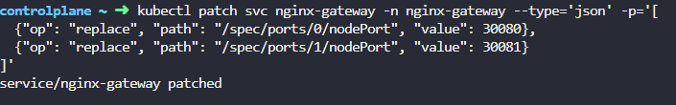

Create Gateway instance

apiVersion: gateway.networking.k8s.io/v1

kind: Gateway

metadata:

name: nginx-gateway

namespace: nginx-gateway

spec:

gatewayClassName: nginx

listeners:

- name: http

protocol: HTTP

port: 80

allowedRoutes:

namespaces:

from: All

A new pod named frontend-app and a service called frontend-svc have been deployed in the default namespace. Expose the service on the / path by utilizing an HTTPRoute named frontend-route

apiVersion: gateway.networking.k8s.io/v1

kind: HTTPRoute

metadata:

name: frontend-route

namespace: default

spec:

parentRefs:

- name: nginx-gateway

namespace: nginx-gateway

sectionName: http

rules:

- matches:

- path:

type: PathPrefix

value: /

backendRefs:

- name: frontend-svc

port: 80